O-30A PARALLEL BLOCK

Question Card:
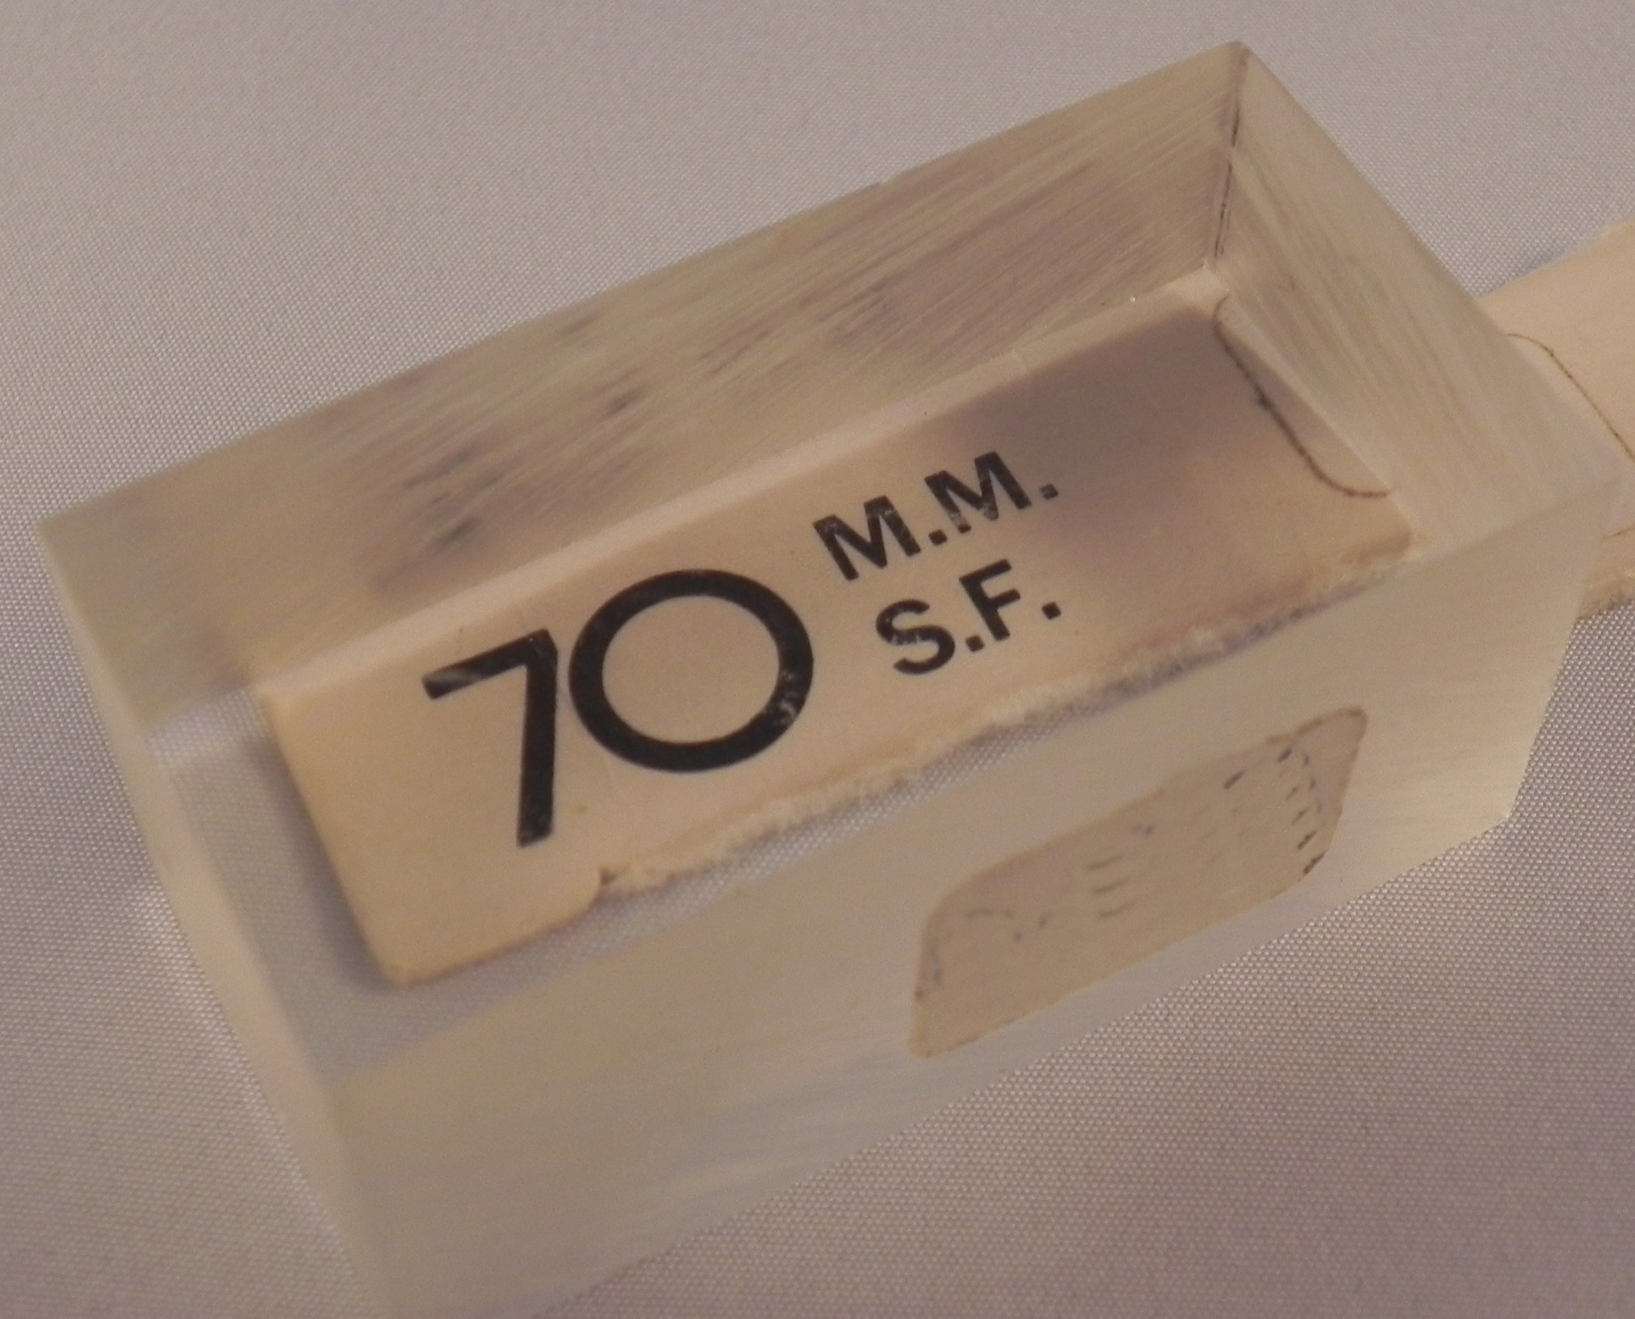
Look at some printing through the parallel block from various orientations. Explain.

Materials:

Parallel sided glass or Plexiglas block. (At least 1/2 inch thick)
Printed material

Introductory Statements:

When viewing objects through a transparent material, what you see will be altered. For anyone that has gone spear fishing, you will know that the fish is not located where you think it is. This is due to the bending (refraction) of light. Here you will be able to explore what happens when you look at an object through a parallel block of Plexiglas. This situation is similar to looking at fish in the water.

Procedure:

a. Place the block on some printing. Look at the printing through the block from straight overhead. Does the printing appear the same as that not seen through the block?
b. Move your head and again contrast the printing seen through the block with that not seen through the block. What do you observe?
c. Keeping your eye fixed, slowly rotate the block while continuing to look through the block at the printing. What do you observe?

Results:

When looking straight down through the block at the printing, what you see should appear closer than the printing not seen through the block. Light rays leaving the block are bent away from each other and thus travel to each eye in a different direction than they were traveling in the water. The eye, not knowing that the rays have been bend sees the printing as an extension of the bent rays.The net result is that the printing appears closer to the eye and slightly larger than the printing not seen through the plastic.

When the surface of the block is not parallel to the plane of the printing, there is shifting of all printing that is seen through the block. This again is due to the refraction of light that occurs at both surfaces as the light passes through the block.

