Matter and Its Changes

For Students of Baldwin Wallace College

Spring Semester 2009

Monday – Wednesday
10:00 – 11:15 am
Room 6
Wilker Hall

Faculty

Richard Heckathorn

This manual was the result of scanning, formatting and editing by
Richard D. Heckathorn

14665 Pawnee Trail
Middleburg Hts, OH 44130-6635

440-826-0834

from

OPERATION PHYSICS, a program to improve physics teaching' and learning, in upper elementary and middle schools, Is funded by the National Science Foundation, Grant #TEI-8751216.
MATTER AND ITS CHANGES

WORKSHOP LEADER'S TOPIC INFORMATION
MATTER AND ITS CHANGES

This module approaches matter from its macroscopic properties and its microscopic particulate nature. The first subtopic, Properties of Matter, focuses on the physical properties of matter which are observable and measurable. Mass, volume and density are stressed as common physical properties of 0 forms of matter. States of Matter proceeds from macroscopic changes of state to microscopic models that explain the changes.

The Particulate Nature of Matter delves further into the microscopic world in an attempt to clarify some of the ideas which lead to misunderstanding matter's properties and changes. Concepts from the first three subtopics are related through concept maps and diagrams.

Changes in Matter contrasts physical and chemical changes and combines many of the preceding concepts. A unifying theme in several of the activities is energy. The integral relationship between matter and energy is exhibited throughout the module.

MATTER AND ITS CHANGES MATRIX 1

I. Properties Of Matter

A. Matter is anything that has inertia (mass) and takes up space (volume).

1A1D 11 1. How to Weigh "Nothing" Demo L 5 min.
1A2D 13 2. What Is Matter? Demo/Disc. L 10 min.
1A3 15 3. How Does Air Take Up Space? Lab L/U 45 min.
1A4D 21 4. Using Air to Move Water Demo/Disc. L/U 15 min.
1A5 23 5. How Can You Determine that Air Has Mass? Lab L 15 min.

B. Many properties of matter can be observed with the senses. Examples include color, hardness, odor, and shape.

1B1D 25 1. What am Properties of Some Classroom Objects? Disc. L 10 min.
1B2 27 2. What are Some Properties Of Matter? Lab L/U 30 min.
1B3 29 3. Is One Property Enough? Lab L/U 30 min.
1B4D 33 4. Special Properties Demo L/U 30 min.
1B5D 35 5. Properties of Matter Overhead L/U 5 min.
1B6 36 6. Some Physical Properties of Matter Overhead L/U 10 min.

C. The general physical properties of matter can usually be observed and measured.

1C1 37 1. Measuring Volume Lab L/U 15 min.
1C2 39 2. Measuring Mass Lab L/U 30 min.
1C3 41 3. You Can't Judge a Package by Its Cover Overhead/Disc. L/U 10 min.
1C4D 43 4. What is Density? Demo/Disc L/U 20 min.
1C 5 45 5. How Can the Densities of Various Objects be Determined? Lab U 45 min.
1C6 49 6. What is the Relationship Between the Density of a Liquid Lab U 50 min.
and the Density of a Solid Floating in a Liquid?

D. Discussion

1D1F 53 1. Focus On Physics: Properties of Matter Disc.

MATTER AND ITS CHANGES MATRIX 2

II. States of Matter

A. Ordinary matter exists in three states: solid, liquid, and gas (vapor). The change from one state to another involves energy.

2A1 57 1. States of Matter Overhead L 5 min.
2A2D 59 2. Is it Solid, Liquid, or "Soliquid?" Demo. L/U 15 min.
2A3 61 3. What Happens to the Molecules of a Solid When They Are Heated? Demo/Disc. L/U 15 min.
2A4 63 4. What Changes Occur When Ice Melts? Lab L/U 15 min.
1A5 65 5. What Changes Occur When Water Freezes? Lab L/U 60 min.
2A6D 67 6. Are Water Molecules Stationary or in Motion? Demo/Disc. L/U 30 min.
2A7 69 7. Is Evaporation the Same as Boiling? Lab L/U 45 min.
2A8 71 8. Are All Frozen Solids "Cold" and All Boiling Liquids "Hot?" Lab U 45 min.
2A9D 75 9. The Physical States of Three Substances Overhead U 10 min.

B. The states of matter differ due to Or behavior of their particles Changes in state are due to changing motion of their particles.

2B1D 77 1. Are Molecules of Solid at Rest? Demo/Disc. L/U 5 min.
2B 2D 78 2. How Does a Liquid Become a Solid? Demo/Disc. L/U 5 min.
2B3D 79 3. What Happens to the Molecules as Additional Energy is Supplied Demo/Disc L/U 5 min
to a Solid?
2B4D 80 4. What Happens to the Molecules as Additional Energy is Supplied Demo/Disc. L/U 5 min.
to the Melting Phase?
2B5D 81 5. What Happens to the Molecules as Additional Energy is Supplied Demo/Disc. L/U 5 min.
to a Liquid?
2B6D 82 6. What Happens to the Molecules After They Break Free? Demo/Disc. L/U 5 min.
2B7D 83 7. Diffusion of Gases Demo/Disc. L/U 5 min.
2B8D 84 8. Molecular Motion in a Gas Demo/Disc. L/U 5 min.
2B9D 85 9. Molecules in Three States of Matter Overhead L/U 5 min.
2B10 86 10. Movement of Molecules Overhead L/U 5 min.
2B11 87 11. Molecular Motion and Change of State Lab L/U 20 min.

C.

2C1F 89 1. Focus On Physics: States of Matter Disc.

MATTER AND ITS CHANGES MATRIX 3

III. The Particulate Nature of Matter

A. MICROscopic models of particle behavior are developed to account for the MACROscopic behavior of matter.

3A1F 93 1. Focus On Physics: What are Models Disc.
3A2 95 2. Developing a Model Lab L/U 15 min.
3A3D 97 3. Probing Matter Demo/Disc. L/U 20 min.
3A4 99 4. What Color are Copper Atoms? Lab L/U 20 min.
3A5D 101 5. What Do Atoms and Molecules Look Like? Disc. L/U 15 min.
3A6D 103 6. What Happens to Air Molecules in a Flask When Some are Removed? Demo/Disc. L/U 30 min.
3A7 105 7. Modeling Matter Elements, Compounds and Mixtures Lab L/U 30 min.
3A8 109 8. Elements, Compounds and Mixtures Overhead L/U 15 min.
3A9 111 9. Constructing a Concept Map Lab L/U 30 min.
3A10 112 10. Matter Concept Map Overhead L/U 10 min.
3A11 113 11. Matter and Particles Overhead L/U 10 min.

B.
3B1F 115 1. Focus On Physics: Some Basic Particles of Matter Disc.

IV. Changes in Matter

A. In a chemical change, a new substance with new properties is formed. In a physical change, although certain properties may change, no new substances form.

4A1 119 1. Some Physical Changes Overhead L/U 10 min.
4A2 120 2. Some Chemical Changes Overhead L/U 10 min.
4A3 121 3. Physical or Chemical? Lab L/U 45-60 min.
4A4 125 4. Particle View of a Chemical Reaction Overhead/Disc. L/U 20 min.
4A5 127 5. Which Is Correct? Overhead L/U 15 min.

B. In both physical and chemical changes, mass is conserved and energy is involved.

4B1 129 1. Changes In Matter - Does Mass Change? Lab L/U 20 min.
4B2 131 2. Changes in Matter. What Energy Is Involved? Lab U 45 min,.
4B3 133 3. Heat Transfer in Physical Changes Lab L/U 20 min.
4B4 135 4. Is There an Energy Change in Chemical Reaction? Lab U 50 min.

C.
4C1 139 1. Focus On Physics: Changes In Matter Disc.

A1 141 Oobleck, Glurch, Slime
A2 143 Happy and Un-Happy Balls
A3 145 Black Box – Doris Simonis
A4 147 Imagineering
A5 149 Current Energy Race
A6 151 Petals Around the Rose
A7 152 Making a Baric Sense Set
A7 153 Conceptual Physics Cans
MATTER AND ITS CHANGES MATERIALS LIST

APPARATUS
air pistons, 2
aquarium
balance, equal-arm
balance,
triple beam or cent-o-gram
ball and ring set
battery jar
beakers, 250 mL, 30 mL, 800 mL, 1 L
“black boxes” (IPS equipment)
burner, Bunsen (with connector)
cubes, metal samples for density tests
conductivity tester or components
cylinders, graduated: 10, 50, 100, 250 mL, 1 L
droppers, medicine
dropper pipets (Beral pipets, plastic)
evaporating dish, porcelain
file, triangular metal
flask, Dewar, with carrier
flask, I-Liter, side-arm (for vacuum)
glasses, drinking
hot plate, variable setting
magnifiers
molecule model kit
mortars and pestles (clean)
pens, transparency projection, multi-color
Petri dishes, plastic or glass
projector, overhead
pump, vacuum (hand-operated)
rulers, metric 30 cm
spatula, metal or plastic
thermometers, Centigrade
tongs, metal
tubes, test (small)
tubing, clear plastic
watch glasses
CHEMICALS
alcohol, isopropyl
alcohol, tertiary butyl (t-butanol)
aluminum, foil or turnings
ammonium hydroxide (aqueous ammonia)
ammonium nitrate
bromthymol blue indicator
calcium chloride
carbon, powdered
copper, foil or turnings
copper sulfate hydrate
corks, assorted sizes
dry ice
glycerin
iron (III) chloride, hydrate
lead nitrate
magnesium sulfate (Epsom salts)
metal strips: copper, aluminum, etc.
nitrogen, liquid
oil, mineral
potassium iodide potassium
hexacyanoferrate (II)
sand, (coarse preferable)
sodium acetate
sodium bicarbonate (baking soda)
sodium carbonate (washing soda)
sodium chloride
sodium thiosulfate
steel wool
sugar
sulfur, powdered
tin, foil or fine mesh
transparencies, plastic
water, distilled and tap
wire, copper (insulated)
wire stripper

MISCELLANEOUS (from home or grocery store)
bags, zip-loc
balloons, equal size and shape
balls (tennis, golf, baseball, superball, “Koosh” ball)
bands, rubber
boxes, cardboard shoe
candies
chalk, various colors
clay, modeling
cooler cornstarch (1 box)
cups, plastic, paper and styrofoam
dowel, wood or plastic, small diameter
fan, electric
food coloring
glue, white
ice
jars, small glass with screw-top lids
markers, washable and permanent
matches
nails
paper towels
pennies, post 1981
pie plate, metal
Plaster of Paris
plastic bags,
food storage
plastic bags, garbage
putty, silly
salt, table
scarf for blindfold
scissors
screw eyes, metal
soda (in bottle with label)
spatula, metal or plastic
starch, laundry
straws, drinking
string
sugar
tape, masking tube, cardboard mailing, for posters
tube, cardboard, from paper towel roll
vinegar (commercial)

MATTER AND ITS CHANGES BIBLIOGRAPHY

BIBLIOGRAPHY

BOOKS

Asimov, Isaac. Great Ideas of Science. New York: Houghton, Mifflin, 1969.
A great book for students.

Baldini, Rudolph. Science Activities for Grade 6-9. West Nyak, New York: Parker Publishing Company, 1973.
A book written for science teachers containing activities that arouse curiosity and stimulate learning.

Best of General Science From Science Teacher’s Workshop. Edited by The Board of Editors of the Science Teacher’s Workshop. West Nyak, New Jersey: Parker Publishing Company, 1972.
Handbook of ready-lo-use demonstrations and experiments illustrating the widest range of subject matter. “Never-fail” experiments.

Blackwelder, Sheila Kyser. Science for All Seasons. Englewood, New Jersey: Prentice Hall, 1979.
Easy to do science experiments, using inexpensive objects. Organized around the seasons, the book provides basic understanding of science concepts.

Brandes, Louis Grant. Science Can Be Fun. Portland, Maine: J. Walsh, Publisher, 1958.
Collections of motivating ideas from teachers, supplementary material for general science classes in grades 7, 8 and 9.

Brown, Bob. 666 Science Tricks and Experiments. Blue Ridge, PA: TAB Books, 1979.
Collection of experiments published in the LA. Times Syndicate. Giant volume of challenging things to do.

Bruce, Guy V. Volume, II: Experiments with Air. Washington, D.C.: National Science Teachers Association, 1950.
A series of practical teaching aids. Very good - may be out of print, but worth trying to find.

Carin, Arthur A., and Robert Sund. Discovery Activities for Elementary School. Columbus, Ohio: Charles E. Merrill Publishing Company, 1980.

Daintith, John. Dictionary of Physics. New York: Harper, 1982.

Reference Book.

DeBruin, Jerry. Creative. Hands-On Science Experiences Using Free and Inexpensive Materials. Carthage, Illinois: Good Apple, Inc., 1980.
Science idea book for grade 4-6. Starter activilies for people of all ages.

DeViti, Alfred and Gerald Krockover. Creative Sciencing: Ideas and Activities for Teachers and Children. Boston: Little, Brown and Company, 1976.
A collection of ideas and activities which can be adapted to any science program.

Mullen, Virginia L. Chemistry Experiments for Children. New York: Dover Publications, Inc., 1962.
Step-by-step instructions for grade school, junior high, and high school students to perform exciting enrichment activities in chemistry.

New Unesco Source Book for Science Teaching. Paris, France: Unesco Press, 1973.

Perkins, Otho and Milton Galembo. Cambridge Work-A-Text: Physical Science. New York: Globe Book Company, 1979.
Combined laboratory manual, textbook and activities book.

Stone, George K. Science Projects You Can Do. Englewood, New Jersey: Prentice Hall, 1963.

Strongin, Herb. Science on a Shoestring. Menlow Park, California: Addison-Wesley Publishing Company, 1976.
Low-cost, hands-on student investigations for elementary science programs.

Vivian, Charles. Science Experiments and Amusements for Children. New York: Dover Publications, Inc., 1963.
73 easy experiments that illustrate important science principles. No special equipment needed.

FILMS

“Conservation of Mass: An Inquiry.” New York: B.F.A., Educational Media (468 Park Avenue South, 10016.)

“Search for Solutions - Modeling.” Bartlesville, Oklahoma: Phillips Petroleum, 1979.

“The Atom.” World of Chemistry Secondary School Project, Educational Film Center, 5101 F Backlick Road, Annendale, Virginia 22003.

“States of Matter.” World of Chemistry Secondary School Project, Educational Film Center, 5101 F Backlick Road, Annendale, Virginia 22003.

JOURNALS

(NSTA) National Science Teacher’s Association, 1742 Connecticut Avenue, NW, Washington, D.C. 20009. Publications for teachers include:

Science and Children………for elementary and middle school teachers and administrators.
The Science Teacher…….for junior and senior high school teachers.
Science Scope…….for middle and junior high (teaching ideas).

“Student Understandings and Misunderstandings of States of Matter and Density Changes.” School Science and Mathematics. Volume 8: December, 1982.

Education Division, American Chemical Society, 1155 Sixteenth Street, NW, Washington, D.C. 20036, Wonder Science “magazine” for elementary students filled with science activities related to “Matter.”

MATTER AND ITS CHANGES 1WL

WORKSHOP LEADER’S PLANNING GUIDE
PROPERTIES OF MATTER

Matter comprises the portion of the universe that is not energy, or, most of what we feel, touch and see. Matter takes up space (volume) and has inertia (mass).

In this subtopic, matter is described through its properties because most classification systems are based on one or more properties. General properties describe all matter, while other, more specific properties describe the type of matter. Physical properties, rather than chemical properties, are the major focus of this subtopic.

Naive Ideas:

1. Gases are not matter because most. are invisible.
2. Gases do not have mass.
3. A “thick” liquid has a higher density than water.
4. Mass and volume, which both describe an “amount of matter,” are the same property. -
5. Air and oxygen are the same gas.
6. Helium and hot air are the same gas.

A MATTER IS ANYTHING THAT HAS INERTIA (MASS) AND TAKES UP SPACE (VOLUME)

1. Demonstration.: How to Weigh “Nothing.”
This demonstration proves that gases have mass.

2. Demonstration/Discussion: What is Matter?
Matter is introduced through the properties of volume and mass.

3. Activity: How Does Air Take Up Space?
This multipart activity is designed to show that air is matter because it occupies space.

4. Demonstration/Discussion: Using Air to Move Water.
This demonstration/discussion reinforces the concept of air occupying space.

5. Activity: How Can You Determine that Air has Mass?
This activity confirms that air has mass.

B. MANY PROPERTIES OF MATTER CAN BE OBSERVED WITH THE SENSES, EXAMPLES INCLUDE COLOR. HARDNESS, ODOR AND SHAPE.

1. Discussion: What are Properties of Some Classroom Objects?
This is a game to practice describing matter by its properties.

2. Activity: What are Some Properties of Matter?
This activity provides practice in naming specific physical properties of matter.

3. Activity: Is One Property Enough?
This activity explores methods of describing additional properties.

4. Demonstration/Discussion : Special Properties
This demonstration/discussion describes some proper-Lies that determine specific uses of materials.

5. Overhead: Properties of Matter
This overhead is a list of several physical properties, as well as some chemical proper-ties of matter. It may be useful as a review of the previous activities.

MATTER AND ITS CHANGES 1WL

WORKSHOP LEADER’S PLANNING GUIDE
PROPERTIES OF MATTER 2

6. Overhead: Some Physical Properties of Matter
This overhead illustrates some properties used to distinguish types of matter.

C. THE GENERAL PHYSICAL PROPERTIES OF MATTER CAN USUALLY BE OBSERVED AND MEASURED.

1. Activity: Measuring Volume
This activity uses two methods to find volumes of objects of various shapes.

2. Activity: Measuring Mass
This activity provides practice in using balances.

3. Overhead/Discussion: You Can’t Judge a Package by its Cover
This overhead/discussion can be used to introduce density.

4. Demonstration/Discussion: What is Density?
This demonstration/discussion is a demonstration of the measurements needed to calculate density.

5. Activity : How Can the Densities of Various Objects be Determined?
This is a comprehensive activity and summary discussion of density.

6. Activity; What is the Relationship Between the Density of a Liquid and the Density of a Solid Floating in a Liquid?
This activity relates density to floating/sinking, compares densities of materials, and could be used with buoyancy concepts (“Forces in Fluids”).

D.

1. Discussion - Focus On Physics: Properties of Matter.

MATTER AND ITS CHANGES 1A1D

HOW TO WEIGH “NOTHING”
(Demonstration)

Materials: an empty glass
a two-pocket scale (or a balance)
dry ice (solid C0₂)

Place an “empty” glass on one side of a two-pocket scale and balance it. Now drop a few lumps of dry ice into an empty pitcher and pour C0₂ gas from the pitcher (dry ice will not harm glass in any way) into the empty glass on the scale. C0₂ gas, although invisible, will pour just like water. The gas, being heavier than air, will displace the air in the glass, causing that side of the scale to go down; but, being absolutely invisible, it appears that you have actually weighed “nothing.”

MATTER AND ITS CHANGES IA2D

WHAT IS MATTER?
(Demonstration/Discussion)

Materials: two glasses
water

1. Take two glasses. Fill one with water and place it on a front desk or table.

2. Observe each glass.
_______________________________________________________________________________________
_______________________________________________________________________________________

3. Describe each glass. What is in each glass?
_______________________________________________________________________________________
_______________________________________________________________________________________

4. Explain. Guide discussion to the fact that all matter, including air takes up space. Explain how solids take up space. Discuss that because matter takes up space, 2 objects cannot be in the same space at the same time (in lap, etc. is not the same space - two persons sitting on a sofa are not sitting in the same space.) Discuss why the level of water in the bathtub rises when someone gets into it.
_______________________________________________________________________________________
_______________________________________________________________________________________
_______________________________________________________________________________________

5. Predict which glass is heavier.
_______________________________________________________________________________________

6. Lead to the idea that all matter has weight by asking such questions as, “Which glass is heavier?” Why?
_______________________________________________________________________________________
_______________________________________________________________________________________

7. Apply the idea from #4 to solids, liquids and gases. (Do solids, liquids and gases have volume and weight?)
_______________________________________________________________________________________
_______________________________________________________________________________________

8 Summarize the idea by writing a definition of MATTER.
_______________________________________________________________________________________
_______________________________________________________________________________________

MATTER AND ITS CHANGES 1A3

HOW DOES AIR TAKE UP SPACE?

Materials: plastic food storage bags and twist ties glass or plastic jug or glass flask (soda bottle)
small piece of modeling clay funnel
(or a one-hole stopper) glass or plastic tumbler
basin or tank of water (air pistons) - 2 per group
bowls or beakers straw
30 cm clear plastic tubing crumpled paper
wax pencil

A. 1. Collect air in a plastic bag: quickly close the bag and tie the end with a twist tic. Place the bag on a table top and balance a book on top of the bag. (See diagram below).

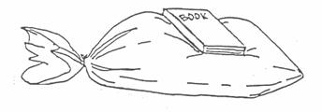

2. Can you see anything in the bag?
__________________________________________________________________________________

3. If something is in the bag, what are the properties of that substance?
__________________________________________________________________________________

4. What substances are between the table top and the book?
__________________________________________________________________________________

5. What is keeping the book from touching the table?
__________________________________________________________________________________

6. What do you think is in the bag?
__________________________________________________________________________________

7. Does that substance take up space?
__________________________________________________________________________________

B. 1. Mold some clay around the neck of a funnel or put funnel into stopper. Press the funnel into the mouth of a jug so that an airtight seal is created. (Use top half of pop bottle with hole in cap as a funnel.)

Can you see anything in the bottle? ________

Might something be there? ________ If so, what? _________________________________________

Write a sentence to explain why you think that there is or is not something in the bottle.
___________________________________________________________________________________
___________________________________________________________________________________

MATTER AND ITS CHANGES 1A3

HOW DOES AIR TAKE UP SPACE? 2

2. Quickly pour water into the funnel. Observe and describe what happens.
__________________________________________________________________________________
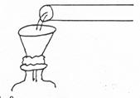
__________________________________________________________________________________

New Photo

3. Does the water go into the bottle? Why?
__________________________________________________________________________________
__________________________________________________________________________________

4. What does this tell you about the bottle?
__________________________________________________________________________________
__________________________________________________________________________________

5. With your finger over the upper end of a straw, insert the straw into the neck of the funnel.
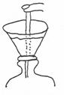

Push the straw down through the funnel filled with water. Remove your finger from the straw. Describe what happens.
__________________________________________________________________________________
__________________________________________________________________________________

6. Continue pouring water into the funnel. Describe what you observe.
__________________________________________________________________________________
__________________________________________________________________________________

7. What kept the water from entering the sealed bottle?
__________________________________________________________________________________

8. In order for the water to enter the bottle, what had to happen to the substance (air) that was inside?
__________________________________________________________________________________
__________________________________________________________________________________
MATTER AND ITS CHANGES 1A3

HOW DOES AIR TAKE UP SPACE? 3

Where did the substance (air) go?
__________________________________________________________________________________
Can two objects occupy the same place at the same time? Explain.
__________________________________________________________________________________
__________________________________________________________________________________

9. Write a summary sentence that explains what you have observed about air.
__________________________________________________________________________________
__________________________________________________________________________________

10. List 3 other common occurrences from your daily life that might be used to illustrate this same idea.

C. 1. Connect two syringes and a piece of 30 cm plastic tubing. (See directions for use of air pistons.) Connect them as shown in the diagram below.
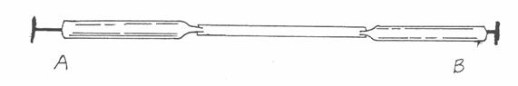

2. Push on the plunger of syringe A. Describe what happens.
__________________________________________________________________________________
__________________________________________________________________________________

3. Push on plunger A, but lightly hold plunger B. Describe what happens.
__________________________________________________________________________________
__________________________________________________________________________________
What can you feel? Why?
__________________________________________________________________________________
__________________________________________________________________________________
4. Why do you think that the second syringe plunger moved?
__________________________________________________________________________________
__________________________________________________________________________________
Open both. Slowly push on both plungers. Describe what happens.
__________________________________________________________________________________
__________________________________________________________________________________
5. What does this show about air?
__________________________________________________________________________________
__________________________________________________________________________________

MATTER AND ITS CHANGES 1A3

HOW DOES AIR TAKE UP SPACE? 4

D. 1. Place a drinking glass in a large clear glass bowl. Fill the glass with water.

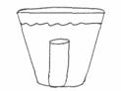
2. Fill the bowl with water until the drinking glass is completely covered. Mark the level of the water in the bowl with a wax pencil. (See diagram below.)

3. Take the drinking glass out of the bowl and empty the water from the drinking glass into the bowl. Mark the level of the water with a wax pencil on the bowl again.

4. Now, turn the drinking glass over and place it, upside down, under the water. Hold the glass under water with one finger pushing down on the bottom of the glass. Be careful not to let any air escape from the glass. Mark the new water level.

5. Did the water level in the bowl change each time?
__________________________________________________________________________________
6. Why?
__________________________________________________________________________________
7. What does this show about air?
__________________________________________________________________________________
__________________________________________________________________________________
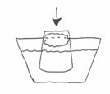
E. 1. Crumple a piece of paper and push it down into the bottom of a clew glass or plastic tumbler. Turn the glass upside down and push it directly into water. Pull it straight out again. Did the paper get wet? ___________

Why or why not? _____________________________________________
___________________________________________________________

What does this show about air?
__________________________________________________________________________________
__________________________________________________________________________________

F. 1. Write one sentence that uses the above activities with air to describe a property of matter.
__________________________________________________________________________________
__________________________________________________________________________________
MATTER AND ITS CHANGES 1A3TN

HOW DOES AIR TAKE UP SPACE?

IDEA: PROCESS SKILLS:

Matter is anything that has mass (inertia) and Observing
takes up space. Air takes up spare; therefore Describing
it is matter. Inferring
LEVEL: LIU DURATION: 45 min.

STUDENT BACKGROUND: Air has some unique properties. We cannot see, smell, or taste it, but
its characteristics and behavior are largely responsible for our weather.
(Students will be familiar with some ideas about air and gases from
studying weather).
Air has no definite shape, but will fill its container. An open paper bag
or bottle cannot be “half full” of air because air will move throughout
the bag.

ADVANCE PREPARATION: Practice all activities beforehand, especially the air syringes.
MANAGEMENT TIPS: A one-hole stopper may be substituted in the neck of the bottle. In that
case, insert the funnel into the stopper. Instead of inserting the straw
into the funnel, try loosening the stopper in the bottle.

RESPONSES TO
SOME QUESTIONS: A. 2. No.
3. Invisible gas. Some may already say that it takes up space.
4. Air, plastic bag.
5. Air is in the plastic bag. This may seem redundant, but this is to emphasize that air is holding up the book.
6. Air.
7. Yes, air takes up space. All gases and all matter take up space (has volume).

B. 1. No, you cannot see anything in the bottle. Yes, something may be in the bottle. Air is matter and, as a gas, fills whatever container it is in.
2. The water stays in the funnel because air is in the bottle and is taking up space there.
3. No. Air takes up space. No two objects can occupy the same space at the same time.
4. Air takes up space, thus the water cannot occupy that space.
5. The water flows into the bottle.
6. Air bubbles come out of the bottle.
7. Air.
8. It had to move. The air left the bottle, so the water could go in. The air went outside of the bottle. No, two objects cannot occupy the same space at the same time.
9. Air takes up space. Matter takes up space, so air is matter
MATTER AND ITS CHANGES 1A3TN

HOW DOES AIR TAKE UP SPACE? 2

C. 2. The second plunger moves outward.

3. The second plunger is hard to hold. You can feel pressure from the air because it is moving from one syringe to the other.

4. The, second syringe plunger moved a little bemuse the air has a limited volume (space) in which to move. When you open both and slowly push on both plungers, this is further illustrated. (Discuss compressibility of gases).

5. Air takes up space. It must be moved in order for another substance to takes its place.

D. 5. Yes.

6. Because air takes up space.

7. The air volume from the glass increased the total volume.

E. 1. No, because the air in the glass prevented the water from reaching it. This shows that air and water both take up space so they cannot occupy the same space at the same time.

POINTS TO EMPHASIZE IN
THE SUMMARY DISCUSSION: Discuss the definition of “property” and “volume.” Review how you
can prove that a solid takes up space, and how you know and can
measure that a gas or a liquid takes up space.

POSSIBLE EXTENSIONS: Children may devise experiments to prove that air takes up space. If air
is trapped in a plastic bag and then compressed so that the air enclosed
is forced out of the neck of the bag and onto the child's face, further
evidence of air's existence is obtained.
Place the end of a medicine dropper in a glass of water. Squeeze the
bulb and observe the bubbles of air. Why does this demonstrate that air
was in the end of the bulb of the dropper?

MATTER AND ITS CHANGES 1A4D

USING AIR TO MOVE WATER
(Demonstration/Discussion)

NOTE: In this demonstration you will transfer air from an air filled container to a water filled container. Practice this beforehand. Colored water makes the transfer more visible.

1. Fill a deep pan or aquarium with water and lower two glasses into it upside down - one full of water and the other full of air, as shown in the diagram below.
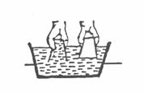

2. Raise the water filled cup so that three fourths of it is out of the water. Now bring the edge of the glass full of air under the edge of the glass of water and slowly tip it as shown in the drawings. Bubbles leaving collect in the water cup.

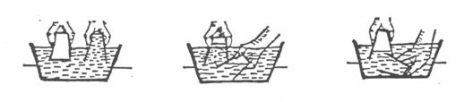

You should have completely transferred the air.

3. Discuss what happened when the air bubbles entered the water-filled cup. Can air and water both be in the same place at the same time? Can air displace water and water displace air?

4. Extension: Find at least two ways to replace the water in a cup with air using only a straw. (Blow into an inverted cup filled with water or drink the water and air replaces it). Water displacement for gas collection ran be discussed.

MATTER AND ITS CHANGES 1A5

HOW CAN YOU DETERMINE THAT AIR HAS MASS?

Materials: 2-liter bottle
Fizz-Keeper (used to pump air into bottle)
Electronic balance or balance that will measure mass to a hundredth of a gram

1. Place the bottle and Fizz-Keeper on the left side of the balance. Add weights to the right side until they are in balance (equilibrium). Optional: The mass is: ____________

2. Use the Fizz-Keeper to increase the pressure inside the bottle. Do so until it becomes hard to push the plunger into the bottle. What have you forced into the bottle?
_____________________________________________________________________________________

3. Place the bottle and Fizz-Keeper back on the left side of the balance. Next add dollar bills to the right side until equilibrium is again established. [Each dollar bill has a mass of 1-gram.] Thus as you add a dollar bill to the right side you can respond, “One dollar of air was added”.
Optional: What is the mass with additional air pumped into the bottle? ____________

4. What does this activity show about air?
_____________________________________________________________________________________

Note…
Many textbooks either describe or ask you to perform the following investigation.

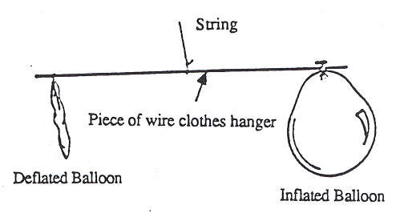
Blow up two balloons, making them equal size. Next take a straight coat hanger of 30 to 40 centimeters in length and tie a piece of string around the center so that it is balanced when suspended by the string. Now tie a balloon to each end of the wire. Adjust the string so that the balloons re evenly balanced. Finally, when the balloons are in perfect balance, pop the air out of one of the balloons. Observe and describe what happens.

It is expected that the end with the deflated balloon will go up indicating that the air that was in the balloon had mass.

Actual experimentation may sometimes reveal this to happen, at other times, the opposite will happen and at other times nothing will change. This being the case, it is unwise to do this experiment.

What is the problem?

Any object when in air is buoyed up by an upward force equal to the weight of the air displaced by the balloon. (You may have found this to be true for objects in water. A rock in water weighs less than when in air). Thus when you deflate the balloon, you let out air that has weight which causes the end with the deflated balloon to rise. The upward buoyant force decreases as the volume of the balloon decreases. This effect would cause the end with the deflated balloon to fall. The final result then depends on which is greater. These two forces, in opposite directions, are nearly identical. Thus, since the end with deflated balloon may not go up, one cannot use this experiment to verify that air has weight or mass.
MATTER AND ITS CHANGES 1A5TN

HOW CAN YOU DETERMINE THAT AIR HAS MASS?

IDEA: PROCESS SKILLS:
Matter is anything that has mass and takes up space. Observing
Communicating
Predicting
Experimenting

LEVEL: L DURATION: 15 min.

STUDENT BACKGROUND: Weight as a measurement will have been discussed in math. (Review and reteach)

ADVANCE PREPARATION:
MANAGEMENT TIPS: 1. Make sure that the two liter bottle has no holes.
2. Check to make sure the Pizz Keeper will pump air into the bottle.

POINTS TO EMPHASIZE IN
THE SUMMARY DISCUSSION: Air does indeed have weight! This is a characteristic of all matter. The
weight of air is due to the gravitational attraction between it and the
earth, The air in a basketball or an automobile tire is much denser than
the air in the atmosphere because it is compressed in a small volume.
A cubic meter of air at standard atmospheric pressure and at standard
temperature at sea level has a mass of about 1.2 kilograms (2.64
pounds.) The mass of a column of air over a surface of one square
meter is about 10,356 kilograms. We do not feel the weight and
pressure of air because we are constantly exposed to it and because there
is air pressure within our bodies which equal the pressure of air upon
us.

POSSIBLE EXTENSIONS: Weight - Suspend various objects from the hook of a spring balance to
illustrate the measurement of gravitational force in terms of the
extension of the calibrated spring. Arrange four or five objects on a
table in order of increasing weights. Weight is measured in newtons
(not kg!).

MATTER AND ITS CHANGES 1B1D

WHAT ARE PROPERTIES OF SOME CLASSROOM OBJECTS?
(Discussion)

1. Review the definition of property or characteristic.

2. Ask. “What can you tell about (point to whatever object you choose)? Discuss several.

3. “How would you describe it (that same item) to someone who had never seen it?”

4. Ask for a volunteer-leader to select an object in the room.

5 The leader gives clues about the object (in properties). .

6. After each clue, the group tries to guess the object.

Encourage use of properties by such questions as, “What is the color of the object?” or “What is the shape of the object?”

7. Have a grab bag (sack with assorted items). Have someone reach into the bag, look at one object, feel it, and list its properties. (Do not take the object from the bag or show the object). Have another try to find the object. Do the activity several times. The task will be more difficult if the items are closely related by properties.

MATTER AND ITS CHANGES 1B2

WHAT ARE SOME PROPERTIES OF MATTER?

Materials: 15 different objects (including a beaker of vinegar, or other liquid which has a strong odor. Examples:
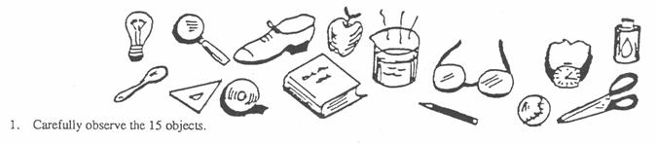
2. Describe each object by stating many properties and record the information in the table. Describe the properties as clearly as possible. Avoid naming the objects or their use.

TABLE

ITEM DESCRIPTION ITEM DESCRIPTION

1. _______________________________________ 9. _______________________________________
2. _______________________________________ 10. _______________________________________
3. _______________________________________ 11. _______________________________________
4. _______________________________________ 12. _______________________________________
5. _______________________________________ 13. _______________________________________
6. _______________________________________ 14. _______________________________________
7. _______________________________________ 15. _______________________________________
8 _______________________________________

3. Have a partner use your list of properties to try to identify each object. Count how many objects your partner can identify from your description. How many could he/she correctly identify?
____________________________________________________________________________________
4. What were some of the properties that seemed to make one description better than another?
____________________________________________________________________________________
____________________________________________________________________________________

MATTER AND ITS CHANGES 1B2TN

WHAT ARE SOME PROPERTIES OF MATTER?

IDEA: PROCESS SKILLS:
The general properties of matter can usually Observing
be observed and measured. Describing
Communicating
Explaining

LEVEL: L/U DURATION: 30 min

STUDENT BACKGROUND: Knowledge of various properties of matter such as color, shape,
hardness, etc.

ADVANCE PREPARATION: 1. Collect objects that exhibit a variety of properties.
2. Store objects in boxes, bags or any convenient containers.

MANAGEMENT TIPS: Keep the objects separate for each group.

RESPONSES TO QUESTIONS 4. Shape, color and weight

POINTS TO EMPHASIZE IN
THE SUMMARY DISCUSSION: Objects differ because they have different properties. Discuss what
properties are most valuable in describing objects. Stress properties as
being different from uses.

Point out that opposite properties are comparative rather than absolute.
An object grouped as small in one pile may be large when placed with
different objects.

POSSIBLE EXTENSIONS: Properties lead to classification activities based upon properties. Put
the 15 objects used in the activity into groups whose objects have
common properties. What does this show you about the importance of
using more than one property when describing a substance?

ALTERNATE ACTIVITY 1: 1. Distribute, containers of objects. Each group must determine the most distinctive property held in common by all objects in the container.
2. Groups share information. The entire group generates a list of physical proper-ties from those observed.
3. Further discussion to name other properties not observed may lead to an extensive list of physical properties of matter.

ALTERNATE ACTIVITY 2: 1. Prior to the activity, participants write a paragraph in which they describe themselves as completely as possible, after which they underline any properties mentioned.

2. Use this as review of “properties,” and to reinforce the concept that more than one property is necessary for adequate description. (Many people have brown hair!)
MATTER AND ITS CHANGES 1B3

IS ONE PROPERTY ENOUGH?

Materials: 5 different kinds of balls (basketball, golf penny
ball, baseball, softball and marble) rubber band
wooden block iron nail
magnet dry cell, 1 1/2 V
switch light bulb (1 1/2 V) and socket
electrical wire

OPTIONAL: Conductivity indicator, Lab-Aids
249 Trade Zone Drive
Ronkonkoma, New York 11779

1. Describe each of the objects.
_______________________________________________________________________________________
_______________________________________________________________________________________

2. Classify the objects into two groups. Reclassify them into two different groups. Classify them 2 more times. Record the classification.
_______________________________________________________________________________________
_______________________________________________________________________________________

3. Is one property enough to describe a substance?
_______________________________________________________________________________________
_______________________________________________________________________________________

How many properties would you have to specify to be able to completely distinguish the objects?
_______________________________________________________________________________________
_______________________________________________________________________________________

4. Examine the samples of iron, wood, rubber and copper. In the table below, describe the physical properties listed and any other properties that you can readily observe.

Sample | Color | Shape | State of Matter | Other Properties
Iron
Block of Wood
Rubber Band
Penny
Glass Marble
MATTER AND ITS CHANGES 1B3
IS ONE PROPERTY ENOUGH? - 2

5. Test each sample for its attraction to a magnet. Record these observations in the following table.

Sample | Attracted to a Magnet | Conducts Electricity
Iron
Wood
Rubber
Copper
Glass Marble

6. Use two fresh dry cells, wires and a lamp to test each sample for its ability to conduct electricity. Set up the materials as shown below.
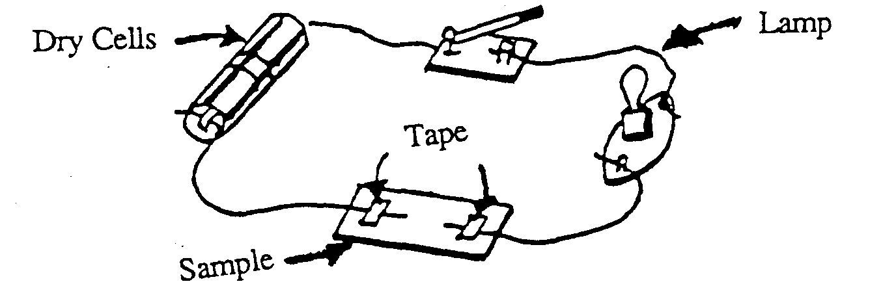

Ensure that the connections are tight. Attach the wires to both ends of the sample. Record the conductivity in the table. (#5)

Suggest a method to test liquids and gases to see if they conduct electricity.
_______________________________________________________________________________________
_______________________________________________________________________________________

7. From your observations, how are iron and copper alike? How are they different?
_______________________________________________________________________________________
_______________________________________________________________________________________

8. What physical properties do wood and rubber have in common?
_______________________________________________________________________________________
_______________________________________________________________________________________

MATTER AND ITS CHANGES 1B3TN

IS ONE PROPERTY ENOUGH?

IDEA: PROCESS SKILLS:

Several properties are needed to describe a substance. Classify
Observe

LEVEL: L/U DURATION: 30 min.

STUDENT BACKGROUND: A general definition of property and some examples of properties.

ADVANCE PREPARATION: Collect the items.

RESPONSES TO
SOME QUESTIONS: 5. Attracted to Conducts
Sample A Magnet? Electricity?

Iron Yes Yes
Wood No No
Rubber No No
Copper No Yes

7. Both are metals. Both conduct electricity; although copper is a much better conductor than iron. Iron is magnetic; copper is not.

POINTS TO EMPHASIZE IN
THE SUMMARY DISCUSSION: Properties are qualities or characteristics that ran be used to describe substances. Properties neither name nor indicate the use of a substance.

Properties are either PHYSICAL or CHEMICAL. Physical properties can be observed without fundamentally changing a substance, whereas chemical properties can only be examined by changing the original substance.

Several properties are often needed to describe OR TO distinguish one substance from another. When physical properties cannot distinguish two substances, their chemical properties must be examined.

POSSIBLE EXTENSIONS: This leads very nicely into classifications by using physical properties.

MATTER AND ITS CHANGES 1B4D

SPECIAL PROPERTIES
(Demonstration/Discussion)

Note: Where needed, wear safety glasses.

1 Dip a piece of blotting paper or a length of dry, paper towel into colored water.

Property: (absorbency)

(This is not a general property of matter).

2. Use a nail to scratch sheets of copper, aluminum and mica. Cut a pane of glass with a glass cutter or test for hardness using a Moh’s scale kit.

Property: (hardness)

3. Break a length of chalk, or smash a length of resin or plastic with a hammer.

Property: (brittleness)

4. Hammer short strips of aluminum, copper or lead on a large piece of iron or other hard metallic support. Hammer a length of electrical solder.

Property: (malleability)

5. Test the following: rubber band, rubber ball, coiled spring, “Koosh” ball and like items. These tend to realm to their original shape after they have bow (stretched), (bent), or (compressed).

Property: (elasticity)

6. Cut a large rubber band and show it as one piece. Hold onto each end and stretch it as far as you can. Then place it into a jar of dry ice for ten minutes. Then remove it (hold both ends with pot holders), and try to stretch it. The band will break in several places. (All elasticity is gone and the band breaks like a glass pane).

Place a tennis ball in a jar of dry ice so that it is completely “immersed” in the material. After sufficient time (about 15 minutes), the tennis ball will freeze into a hard, brittle mass. When thrown to the floor with force, it will shatter. Try the same thing with a frankfurter and when you remove it from the jar, smash it with a hammer. (Alternative: Immerse a carnation in liquid nitrogen).

Property: (brittleness)

7. Take apart a length of insulated copper wire. Pull the thin wire through a hole which is slightly smaller than the diameter of the copper wire to reduce it to a smaller diameter. Heat glass tubing and pull it into a find thread.

Property: (ductility)

THE PROPERTIES OF A SUBSTANCE DETERMINE ITS UTILITY. Often, a substance’s property gives it a specific use.

MATTER AND ITS CHANGES 1B5

PROPERTIES OF MATTER
(Partial List)

PHYSICAL PROPERTIES CHEMICAL PROPERTIES

absorbency flammability
area reaction with water
boiling/condensation point reaction with acids
brittleness oxidation tendency
color tendency to form conductivity compounds
density *
ductility
elasticity
hardness
length
luster
magnetic attraction
malleability
mass *
melting/freezing point
odor
shape
solubility
temperature
texture
transparency
viscosity
volume*

* Possess ALL ordinary phases of matter

MATTER AND ITS CHANGES 1B6

SOME PHYSICAL PROPERTIES OF MATTER

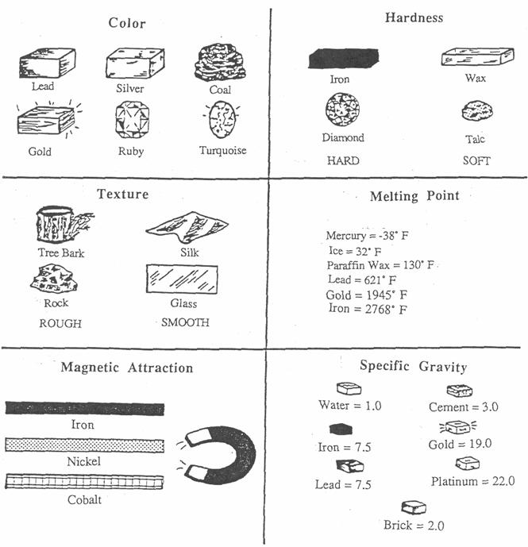
MATTER AND ITS CHANGES 1C1

MEASURING VOLUME

Materials: regularly shaped objects and assorted irregularly shaped objects
ruler
graduated cylinder

A. MEASURING VOLUME OF REGULARLY-SHAPED OBJECTS

1. Get an object and measure (in centimeters) its length, width and thickness. Record your measurements in the following table. Repeat with the rest of the objects that are “regularly-shaped.”

2. VOLUME = LENGTH X WIDTH X THICKNESS

Compute and record the volume of each object that you have measured. The units for volume are:
cm x cm x cm = cm³ (centimeters cubed or cubic centimeters)

Object | Length (cm) | Width (cm) | Thickness (cm) | Volume (cm3)

B. MEASURING VOLUME OF OBJECTS BY WATER DISPLACEMENT:

1. Get a graduated cylinder and one of the regular objects from above table, then irregularly-shaped objects.
2. Put some water in the graduated cylinder and record the level of the water. (Read it at eye level).
3. Tip the graduated cylinder and slide the object into the cylinder. If it does not sink, push the object under water.
4. The volume of the object is the difference between the starting and final volumes.

VOLUME = FINAL VOLUME - STARTING VOLUME

Find the volume by subtracting the starting volume from the final volume. The units measured by a graduated cylinder are milliliters (mL). 1 mL is the same volume as 1 cm³, (mL = cm³)

(objects from above)
Object | Starting Volume ( ) | Final Volume ( ) | Object Volume ( ) | Volume (cm3)

(irregular shaped objects)

Include proper units.

MATTER AND ITS CHANGES 1C1TN

MEASURING VOLUME

IDEA: PROCESS SKILLS:

The general properties of matter can usually Measure
be observed and measured. Record

LEVEL: L/U DURATION: 15 min.

STUDENT BACKGROUND: Participants must be able to estimate length using the correct number
of digits. Units used for liquid volume (mL) and for regular solid
volume (cm3) should be reviewed.

ADVANCE PREPARATION: Collect objects which are easy to handle and measure. The same objects might be used in the activity “Measuring Mass.” Suggested objects include: wooden blocks, books, dire, metal cubes, rocks and marbles. Objects measured by water displacement should sink and should fit into the available cylinders.

POINTS TO EMPHASIZE IN
THE SUMMARY DISCUSSION: Properties other than those revealed by the senses are necessary to fully describe substances. Volume, a property that measured, not simply observe, is a measure of the space an object occupies. While not a fundamental characteristic of property of matter, its measurement is necessary to find DENSITY, which IS a fundamental, characteristic property.

POSSIBLE EXTENSIONS: Find the volumes of more complicated shapes, along with the rectangular solids.
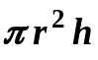
Cylinder or disk: Volume = base x height =

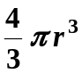
Sphere: Volume =

MATTER AND ITS CHANGES 1C2

MEASURING MASS

Materials: balance (and masses, if needed)
assorted objects
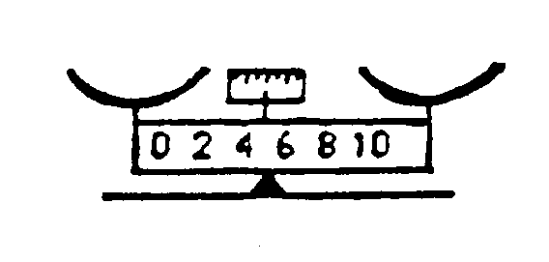

1. Obtain a balance and “zero” it.

2. Choose an object from those available (or one of your own) and find its mass.

3. Practice measuring mass by finding the masses of several objects. Record the masses below.

Object | Mass of Object ( )

Include proper units.

MATTER AND ITS CHANGES 1C3

YOU CAN'T JUDGE A PACKAGE BY ITS COVER
(Discussion)

1. In what ways are Mary's package and Julio's package the same?
_______________________________________________________________________________________
_______________________________________________________________________________________
2. How might the two packages differ?
_______________________________________________________________________________________
_______________________________________________________________________________________
3. How could you find out?
_______________________________________________________________________________________
_______________________________________________________________________________________
4. How is each package measured?
_______________________________________________________________________________________
_______________________________________________________________________________________
5. When you mail a package, how does the postman know how much to charge you? (Dimensions, as well as weight may affect shipping charges).
_______________________________________________________________________________________
_______________________________________________________________________________________
It might help to find out what Mary and Julio filled their packages with because you can't always “judge a package by its cover” or size. Nor can you judge by its weight alone.

The best way to compare two different things is to measure equal volumes of each, and find the mass of the equal volumes.

The mass of a certain volume of matter is called its density . The mass in grams of one cubic centimeter of matter is density.

MATTER AND ITS CHANGES 1C3

YOU CANT JUDGE A PACKAGE BY ITS COVER

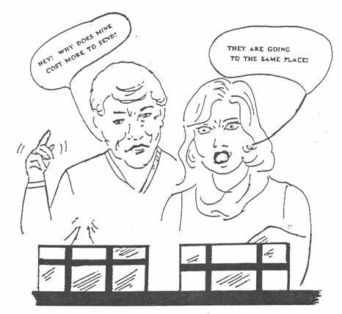

Julio and Mary each brought a package to the post office to be mailed, both packages going to the same city. Julio's cost more to send than Mary's. Why?

MATTER AND ITS CHANGES 1C4D

WHAT IS DENSITY?
(Demonstration/Discussion)

Have available, the materials that will, be used for the density activity (See density activity).

Discuss: 1. Transparency: “You Can't Judge a Package by its Cover.” (1C3).
2. Density is the mass of an object divided by its volume.

DENSITY = MASS/VOLUME

The unit of density is: __________________

Grams/Cubic Centimeter = g/cm3

Use “A” as “instructions” and also for discussion of the density of water and salt water
Water Salt Water

A. 1. Find the mass of an empty graduated cylinder. Record here ____________ ____________

2. Add some liquid to the cylinder and find the total mass ____________ ____________

3. What is the mass of the liquid? ____________ ____________

4. What is volume of the liquid? ____________ ____________

5. What is the density of the liquid? (mass/volume). ____________ ____________

6. Hypothesize which of the objects that you used previously will float in the liquid and which will sink.

7. How can you tell if an object will float in water?
_________________________________________________________________________________

MATTER AND ITS CHANGES 1C5

HOW CAN THE DENSITIES OF VARIOUS OBJECTS BE DETERMINED?

Materials: various objects (metal cubes, cork, steel, glass, marbles, rocks, wooden blocks, etc.)
graduated cylinder
triple-beam balance
metric ruler
water

A. Density of Regularly-Shaped Objects:

1. Determine the mass of each “regularly” shaped object. RECORD the mass on the data sheet.

2. Find each object's length (L) width (W) and height (H). RECORD these measurements on the data sheet. From these measurements, calculate volume:

V = L x W x H

3. a. Density is “mass-per-unit volume.” Determine the density of each of the objects. RECORD these densities on the data sheet.

b. Sequence your regularly-shaped objects by density - least dense to most dense.

c. CLASSIFY the objects into sever al groups based on the type of material (metal, wooden, plastic, etc.)

COMPARE this classification to a classification of the objects that might be made by density.

B. Density of Irregularly-shaped Objects:

1. Use a balance to determine the mass of the rock and any irregularly-shaped objects.
_________________________________________________________________________________
2. Partially fill a graduated cylinder with water. RECORD the volume or level of the water.

3. Place a rock into the graduated cylinder. RECORD the new volume.
_________________________________________________________________________________
4. How does the volume of the water displaced COMPARE with the volume of the solid?
_____________________________________________________________________________________
_____________________________________________________________________________________
5. Determine and RECORD the density of each object by dividing its mass by its volume (D = M/V). Include proper units.

6. Use the water displacement method to find the volume and then CALCULATE the density for the regular objects. RECORD this information on the data sheet.

You have now found the densities of regularly shaped objects using two methods of determining the volume. COMPARE the volumes and densities. do the pairs agree?
_____________________________________________________________________________________

MATTER AND ITS CHANGES 1C5

HOW CAN THE DENSITIES OF VARIOUS OBJECTS BE DETERMINED? 2

7. How could you use the water displacement method to find the density of sand?
_____________________________________________________________________________________
_____________________________________________________________________________________

8. Could you use water displacement to find the density of salt? EXPLAIN
_____________________________________________________________________________________
_____________________________________________________________________________________
9. Which of the objects will float in water, and which will sink?

Data Table
 | Mass | Length | Width | Height | Volume | Density
Material | (g) | (cm) | (cm) | (cm) | (cm)3 | g/(cm)3

MATTER AND ITS CHANGES IC5TN

HOW CAN THE DENSITY OF VARIOUS OBJECTS BE DETERMINED?

IDEA: PROCESS SKILLS:
Density is a general, physical Observing Predicting
property of matter. Describing Measuring
Recording Data Experimenting

LEVEL: U DURATION: 45 min.

STUDENT BACKGROUND: Knowledge of measuring mass, measuring volume, and use of metric
rulers and graduated cylinders.

ADVANCE PREPARATION: Assemble the objects. Objects should include some rectangular solids
such as wooden blocks, dice, metal cubes, rocks, marbles, corks, etc.

MANAGEMENT TIPS: Breakage of glass graduated cylinders can be minimized by sliding the
objects down the side of the cylinder instead of dropping them in.
Using plastic cylinders is a useful option.
The smaller the object measured by displacement, the greater the
percentage of error.

RESPONSES TO
SOME QUESTIONS: 4. Volume of the solid is equal to the volume of water displaced.
9. Greater density than water - sink, and less dense than water - float.
Most “floaters” sink to some extent in water. See “buoyancy” in
Forces in Fluid .
POINTS TO EMPHASIZE IN
THE SUMMARY DISCUSSION: Density is a general characteristic property of matter. Since all matter
has mass and volume, all materials have a certain density. Density is a
“derived” property. That is, its value is calculated from two measurable
properties of matter - mass and volume.
Density is the amount of mass in a given volume. Materials with very
high densities have a great deal of matter packed into a relatively small
volume. Hence, the mass-per-unit volume (densities) for such materials
is great. Lead, a solid at room temperature, is such a material. When
held in the hand, it feels “heavy.” Actually, its density is what is
perceived; a great deal of mass for its volume.
Substances can be identified by density because the mass-per-unit
volume varies from material to material. Density does not depend on
size alone. Two objects of different sizes have the same density if they
re, composed of the same matter.

MATTER AND ITS CHANGES IC5TN

HOW CAN THE DENSITY OF VARIOUS OBJECTS BE DETERMINED? 2

Density, while a characteristic property, CAN vary. An increase in temperature usually decreases the densities of materials. Although the mass does not vary, the volume increase that occurs when materials are heated causes the mass-per-unit volume to decrease.

Salt water is denser than fresh water. A sample of equal volumes of each reveals that salt water has a greater mass-per-unit volume than fresh water. This is because the salt, which is dissolved in the water, occupies intermolecular space in the water, spaces that are empty in fresh water. Therefore, one cubic centimeter of salt water has more matter, or more mass, than one cubic centimeter of fresh water.

POSSIBLE EXTENSIONS: Make a density column by carefully pouring the following liquids into
a tall glass column, starting with the most dense, liquid. Typical liquids
are glycerin, 1.26; colored water, 1.00; mineral oil, 0.88; colored
isopropyl alcohol, 0.785 (densities in grams per cubic centimeter).
Try dropping objects into the column to find their approximate
densities. Examples are Styrofoam, cork, different types of wood,
samples of plastic, and metal. The deeper the objects sink, the higher
the density. Suggested contains are an olive jar, plastic peanut butter
jar and a 2 liter cylinder.

MATTER AND ITS CHANGES 1C6

WHAT IS THE RELATIONSHIP BETWEEN THE DENSITY OF A
LIQUID AND THE DENSITY OF A SOLID FLOATING IN A LIQUID?

Materials: alcohol graduated cylinder (10mL) milk
balance ire cubes oil
beaker (50 or 1000mL) labeling or masking tape salt solution
corn syrup marking pencil water
6 drinking cups (paper or plastic) metric ruler
wood block (coated with a thin layer of wax)

Part A. Densities of Liquids

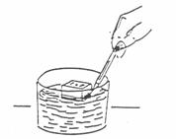
1. Label one face of the wood block with the word “top.” Measure the height of the block to the nearest 0.1 cm and record it in Data Table 1.

2. Label each cup as follows: water, alcohol, oil, corn syrup, milk or salt water. Pour 100 mL of each liquid into the corresponding cup.

3. Float the block in the water. The labeled side should be above the water (see the diagram above). Use a pencil to mark the line where the surface of the water meets the block. Be careful not to push the block deeper into the water while marking it.
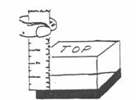
4. Remove the block from the water. Keep the labeled side up and measure the height of the block above the water's surface to the nearest 0.1 cm. Record this information in Data Table 1.

5. Repeat steps 3 and 4 for each of the other liquids.

6. For each liquid, calculate the ratio of the block's height above the liquid compared to the total height of the block. Record this information in Data Table 1.

Ratio equals height above liquid
height of block

 |  | Height of Block | Ratio
 | Height of Block | Above Liquid | Height Above Liquid
Liquid | (cm) | (cm) | Height of Block
Water
Alcohol
Salt Water
Milk
Corn Syrup
Salad Oil

MATTER AND ITS CHANGES 1C6

WHAT IS THE RELATIONSHIP BETWEEN THE DENSITY OF A
LIQUID AND THE DENSITY OF A SOLID FLOATING IN A LIQUID? 2

1. In what liquid did the block float highest? Why?
_____________________________________________________________________________________
_____________________________________________________________________________________
2. Which liquid has the greatest density? Which one has the lowest density? EXPLAIN how you reached your conclusion.
_____________________________________________________________________________________
_____________________________________________________________________________________
3. Suppose you poured equal amounts of oil and water into a cup. Which liquid would float to the top? Why does this happen?
_____________________________________________________________________________________
_____________________________________________________________________________________
4. Use the results of this experiment to make a generalization about the depth an object floats in a liquid.
_____________________________________________________________________________________
_____________________________________________________________________________________
Part B. Density of an Ice Cube
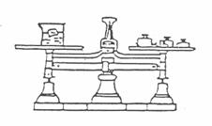
1. Use a balance to determine the mass of a small beaker.

2. Remove an ice cube from the freezer and quickly measure its length, width, and height to the nearest 0.1 cm. Record these dimensions in Data Table 2.

3. Place the ice cube in the small beaker. Determine the mass of the beaker plus the ice cube. Record this information in Data Table 2.

4. Calculate the volume of the cube.

5. Determine the mass of the ice cube.

6. Calculate the density of the ice.

7. Allow the ice cube to melt completely. Find the volume of the melted ice cube using the 10 mL graduated cylinder. Record this value in Data Table 2.

8. Calculate the density of the water in the beaker.

MATTER AND ITS CHANGES 1C6

WHAT IS THE RELATIONSHIP BETWEEN THE DENSITY OF A
LIQUID AND THE DENSITY OF A SOLID FLOATING IN A LIQUID? 3

Data Table 2

 | Length (cm) | Width (cm) | Height (cm) | Volume (cm3) 3)
Dimensions of
the ice cube

Mass of beaker and ice cube (g) ________________ Mass of beaker alone ________________
Mass of an ice cube alone ________________ Mass of water ________________
Volume of water (mL) ________________ Density of an ice cube ________________
Density of water (g/mL) ________________ D=m/v (g/cm³) ________________

1. Compare the density of liquid water to that of solid water (ice).
_____________________________________________________________________________________
2. Why does the ice float on water?
_____________________________________________________________________________________
_____________________________________________________________________________________
3. An ice cube placed in an unknown liquid sinks. What do you know about the density of the liquid?
_____________________________________________________________________________________
_____________________________________________________________________________________
4. Why is it easier to float in the ocean (salt water) than in a lake (fresh water)?
_____________________________________________________________________________________
_____________________________________________________________________________________
5. Discuss how you can predict whether an object will float or sink in a liquid knowing the densities of both.
_____________________________________________________________________________________
_____________________________________________________________________________________
6. Discuss how you can estimate how high a block of wood will float in different liquids knowing the densities of the liquids.
_____________________________________________________________________________________
_____________________________________________________________________________________

MATTER AND ITS CHANGES IC6TN

WHAT IS THE RELATIONSHIP BETWEEN THE DENSITY OF A
LIQUID AND THE DENSITY OF A SOLID FLOATING IN A LIQUID?

IDEA: PROCESS SKILLS:

Density is a general physical property of matter Observing
Inferring
Experimenting
Hypothesizing

LEVEL: U DURATION: 50 min.

STUDENT BACKGROUND: Students should be familiar with measurements of length, mass,
volume and calculation of density.

ADVANCE PREPARATION: 1. Scales may be permanently marked on the blocks.
2. Practice these activities so that you can help with the procedures.

MANAGEMENT TIPS: Measurements with the ice must be done quickly. (Varying densities of salt water and milk will change results).

RESPONSES TO
SOME QUESTIONS: 1. The corn syrup because it has the greatest density.
2. The corn syrup has the greatest density. The alcohol has the lowest density. The block floated highest in corn syrup and lowest in alcohol.
3. Oil would float to the top because the density of oil is less than water's.
4. The greater the density of the liquid, the higher the object will float.

POINTS TO EMPHASIZE IN
THE SUMMARY DISCUSSION: A solid will float or sink when placed in a liquid. The relationship between the density of the solid and the density of the liquid determines how high the solid will float or if it will sink. An ice cube consists of water molecules “trapped” into an open-structured crystalline pattern.
Because of this structure, the molecules occupy more space in the solid form (ice) than in the liquid form. The difference in densities between liquid water and ice causes the ice cube to float in water.

POSSIBLE EXTENSIONS: Show a glass containing ice floating in water. Then, using a liquid whose solid phase. is denser than the liquid, such as tertiary butyl alcohol, drop an “ice” cube of the material into its parent liquid the cube will sink to the bottom of the glass
MATTER AND ITS CHANGES 1D1F

FOCUS ON PHYSICS
PROPERTIES OF MATTER

Everything in the universe is either matter or energy. Matter and energy can neither be created nor destroyed; although one can be changed into the other.

Matter is anything that has mass (inertia) and takes up space (volume). Mass is a measure of the inertia of an object, or the reluctance of an object to change its state of motion. Simply, mass is the amount of material that an object contains. Weight, on the other hand, is the pull of gravity on that mass and depends upon its location. On earth, mass and weight are often used as if they had the same meaning. However, in outer space where there is little or no gravity, mass is the same, but weight changes. The amount of space that an object occupies is its volume. In the metric system, volume is expressed in cubic centimeters (cm³) in liters (L), or in milliliters (mL).

General properties identify something as matter, while other properties identify what kind of matter it is. Along with many others, these properties include state, color, taste, odor, freezing/melting point, and boiling point. These may be observed without changing the chemical composition of the matter. Properties of matter distinguish types of matter.

Scientists are always searching for new ways to use the special properties of matter. Many materials owe their usefulness to their physical properties, while other materials are useful because they do not have a particular property. Physical properties of certain kinds of matter make them suitable for specific uses: melting point - low melting metals are useful as solder to hold matter together, electrical conductivity - ability of copper to carry current and be drawn into thin wire (ductility) makes it useful in electrical wiring; physical state - mercury remains a liquid over a broad range of temperatures making it useful in thermometers; luster - reflective quality of silver makes it useful as a backing for mirrors; thermal conductivity - aluminum is an excellent conductor of heat making it useful for pots and pans; color - useful in making dyes; odor - scent of a rose makes it useful as a base for perfumes; density - a hot air balloon rises as the density of air changes. Some materials are useful because they do not carry electricity, because they are not transparent, or because they do not stretch. Overall, properties of matter determine its utility.

MATTER AND ITS CHANGES 2WL

WORKSHOP LEADER’S PLANNING GUIDE
STATES OF MATTER

Ordinary matter exists as solid, liquid or gas. (These states are sometimes referred to as “forms of matter” or “phases of matter”). This section begins with a recap of the properties of each state, proceeds through several activities involving change of state and accompanying processes, and concludes with several more activities whose purpose is to model the particulate description of each state. Leaders are strongly urged to combine the modeling activities (microscopic) with the change of state activities (macroscopic). Furthermore, all activities are sequenced from solid-to-liquid-to-gas state, accompanied by energy changes. More activities relating to change of state are found in the ENERGY and in the HEAT modules. Activities relating to liquids and gases are found in Forces in Fluids. Workshop leaders are encouraged to use any of these in conjunction with the activities in Matter and Its Changes.

Naive Ideas:

1. Expansion of matter is due to expansion of particles, rather than to increased particle spacing.
2. Particles of solids have no motion.
3. Relative particle spacing among solids, liquids and gases (1:1:10) is incorrectly perceived and not generally related to the densities of the states. (Microscopic model does not represent macroscopic properties).
4. Materials can only exhibit proper-Lies of one state of matter.
5. Particles possess the same properties as the materials they compose. For example, atoms of copper are “orange and shiny,” gas molecules are “transparent,” and solid molecules are “hard.”
6. Melting/freezing and boiling/condensation are often understood only in terms of water.

A. ORDINARY MATTER EXISTS IN THREE STATES: SOLID. LIQUID AND GAS (VAPOR). THE CHANCE FROM ONE STATE TO ANOTHER INVOLVES ENERGY,

1. Overhead: States of Matter.
This overhead reviews the properties of shape and volume with respect to the three states.

2. Demonstration/Discussion: It is Solid, Liquid or “Soliquid?”
This demonstration/discussion illustrates that some materials exhibit properties of both solids and liquids.

3. Demonstration/Discussion: What Happens to Molecules of Solid When They are Heated?
This demonstration/discussion relates particle behavior in solids to expansion, showing increased particle spacing as causing the observed phenomenon.

4. Activity: What Changes Occur When Ice Melts?
This activity uses the solid-to-liquid change of states as an example of an endothermic process.

5. Activity: What Changes Occur When Water Freezes?
This activity uses the liquid-to-solid change of state as an example of an exothermic process, as well as showing the relative volumes occupied by solid and liquid states.

6. Demonstration/Discussion: Are Water Molecules Stationary or in Motion?
This demonstration/discussion shows that molecular motion exists in apparently still matter.

7. Activity: Is Evaporation the Same as Boiling?
This activity compares and contrasts the processes involved in the liquid-to-gas change of state.
8. Activity: Are all Frozen Solids “Cold,” and all Boiling Liquids “Hot?”
This activity reinforces freezing/melting point and boiling point as temperatures where changes of state occur. Cold liquid nitrogen boils, while a “warm” room temperature liquid freezes.

9. Overhead: The Physical State of Three Substances.
This overhead compares the freezing and boiling temperatures of the two substances used in the previous
activity to those of water.

B. THE STATES OF MATTER DIFFER DUE TO BEHAVIOR OF THEIR PARTICLES. CHANGES IN STATE ARE DUE TO CHANGING MOTION OF THE PARTICLES.

1. Demonstration/Discussio : Are Molecules of Solid at Rest?
This demonstration/discussion shows the vibration-in-place of solid particles modeling definite volume and
size, while also showing energy of motion.

2. Demonstration/Discussion: How Does a Liquid Become a Solid?
This demonstration/discussion models the melting and freezing processes.

3. Demonstration/Discussion What Happens to the Molecules as Additional Energy is Supplied to a Solid? This demonstration/discussion models inter-molecular bond breaking in the melting process.

4. Demonstration/Discussion: What Happens to the Molecules as Additional Energy is Supplied to the Melting Phase? This demonstration/discussion models increased particle motion arising from energy absorption by a liquid with increased fluid behavior, but no significant volume change.

5. Demonstration/Discussion: What Happens to the Molecules as Additional Energy is Supplied to a Liquid? This demonstration/discussion models both evaporation, a surface phenomenon, and boiling, an internal phenomenon.

6. Demonstration/Discussion: What Happens to the Molecules After They Break Free?
This demonstration/discussion models the random motion of molecules, resulting in indefinite shape and volume observed in gases.

7. Demonstration/Discussion: Diffusion of Gases.
This demonstration/discussion illustrates the random motion of gas molecules, as well as the indefinite volume occupied by them.

8. Demonstration/Discussion: Molecular Motion in a Gas.
This demonstration/discussion further models the random motion of gas molecules.

9. Overhead: Molecules in Three States of Matter.
This overhead shows relative intermolecular spacings, molecular motion and “density.”

10. Overhead: Movement of Molecules. This overhead shows the hindered motion in molecules of a solid (ice) compared to the fluid motion of a liquid (water).

11. Activity: Molecular Motion and Change of State. This activity summarizes four processes involved in change of state and relate those processes to molecular motion.

C.

1. Discussion - Focus On Physics: State of Matter.

MATTER AND ITS CHANGES 2A1

STATES OF MATTER

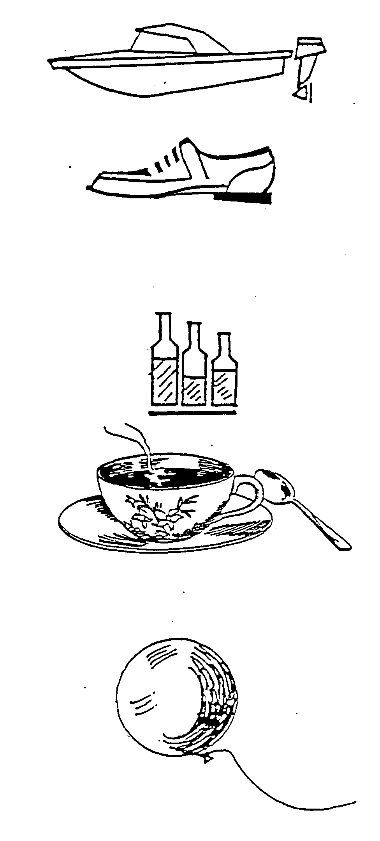

SOLIDS have a definite volume and shape

LIQUIDS take the shape of the container in which they are placed, but have a definite volume.

GASES spread out in all directions and take the shape of a container if it is closed. They have neither definite shape nor definite volume.

MATTER AND ITS CHANGES`` 2A2D

IS IT SOLID, LIQUID OR “SOLIQUID?”
(Demonstration/Discussion)

Materials: Silly putty recipe for “Glurch”
1 plastic cup 65 ml of white glue
125 mL laundry starch table salt, variable amount, less than 1/2 tsp.
1 plastic zip-loc bag stirrer

Mix the ingredients, then beat the mixture until a soft, smooth dough forms. Knead the dough and store it in the plastic bag. Freeze for later use.

Recipe for “Oobleck”: (named from Bartholomew and the Oobleck, Dr. Seuss, 1949, 1977).

1 lb. box of cornstarch
water
1 plastic zip-loc bag (preferably heavy duty)
food coloring (optional)

Note: For a small amount, use 3/4 cup cornstarch and 4 fluid ounces of water.

Mix he ingredients to make a stiff paste. (Adjust ingredients, as necessary, to obtain the proper consistency). The mixture resists rapid movement (exhibiting solid properties), but it does not resist slow movement (exhibiting fluid properties). Freeze the mixture for re-use and to inhibit mold formation.

1. Review the basic properties of solids, liquids and gases with respect to shape and volume.

2. Use one or more of the materials described above to illustrate that some materials exhibit properties of both solids and liquids.

a. Silly Putty - Roll some into a ball, bounce the ball, showing lack of shape retention. Form another ball and allow it to sit for 15-20 minutes, again illustrating change of shape. While the putty appears to flow after some time, it does not pour like a liquid.

b. “Gluch” or “Oobleck” - Both flow like liquids when their plastic bag containers are slowly tilted back and forth. When the bags are hit sharply with the side of a closed fist (bag closed!!), the contents resist motion and feel quite solid!

MATTER AND ITS CHANGES 2A3

WHAT HAPPENS TO MOLECULES OF
SOLID WHEN THEY ARE HEATED?
(Demonstration/Discussion)

Materials: candle metal pan
matches nail
forceps or tongs pair of pliers
screw eye (the eye of this should be just slightly larger than the nail. If it is not, tighten it with the
pair of pliers)

Optional: ball and ring set for thermal expansion of solids, Bunsen burner

1. Fix the candle so that it stands in the center of the. pan. To do this, light the candle wick and permit enough wax to drip onto the center of the pan. Then blow out the candle and place it, wick end up, in the puddle of wax. Hold the candle steadily in the puddle until the wax hardens.

2. Try to fit the nail into the hold of the screw eye.

3. Light the candle.

4. With the forceps or tongs, pick up the nail. Hold the head of the nail over the hottest part of the flame.

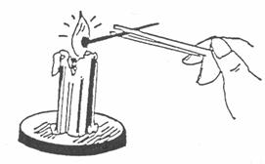
5. Pick up the screw eye and try to put the nail head through it.

Post- Demonstration Activity:

6. Ask participants to draw a molecular diagram showing the nail before and after heating. The purpose of this is to clarify the cause of expansion ON THE MOLECULAR LEVEL. Expansion of matter is often attributed to the expansion of the particles themselves, rather than to their movement away from each other. 'Me nail will not enter the screw eye because heat has caused increased molecular movement, resulting in the molecules being slightly farther apart. The effect is a very small one, as the nail is not visibly larger.

MATTER AND ITS CHANGES 2A4

WHAT CHANGES OCCUR WHEN ICE MELTS?

Materials: ice cube freezer or cooler

1. Take an ice cube directly from a freezer or cooler and observe it for a few minutes.

2. What changes do you observe?
_____________________________________________________________________________________
_____________________________________________________________________________________
3. Where, on the ice cube, do you see these changes?
_____________________________________________________________________________________
Why?
_____________________________________________________________________________________
_____________________________________________________________________________________
4. Is there any energy involved in the process?
_____________________________________________________________________________________
What is the source of energy?
_____________________________________________________________________________________
5. Could you reverse the process you have observed?
_____________________________________________________________________________________
How?
_____________________________________________________________________________________
_____________________________________________________________________________________
6. Would energy be involved in any reverse process?
_____________________________________________________________________________________
How?
_____________________________________________________________________________________
_____________________________________________________________________________________
MATTER AND ITS CHANGES 2A4TN

WHAT CHANGES OCCUR WHEN ICE MELTS?

IDEA: PROCESS SKILLS:
The phase change from solid to Observe
liquid involves absorption of energy. Explain

LEVEL: L/U DURATION: 15 min.

ADVANCE PREPARATION: To ensure that the ice cubes are below the freezing temperature, remove
them IMNIEDIATELY before use so that no liquid water appears on their surfaces at the beginning of observation.

RESPONSES TO
SOME QUESTIONS: 3. The ice is melting on all surfaces; liquid appears.

4. Energy is involved in melting. The, energy absorbed by the ice is the heat (thermal) energy of the air molecules in the room (ENDOTHERMIC PROCESS).

5. Yes, the process could be reversed by placing the remaining cube and liquid in the freezer again.

6. Energy is involved in this reverse process also, The cube/water 11 gives up” its energy to the freezer (EXOTHERMIC PROCESS). This energy appears as part of the thermal energy released back into the room (can be felt from behind the refrigerator unit).

MATTER AND ITS CHANGES 2A5

WHAT CHANGES OCCUR WHEN WATER FREEZES?

Materials: a small jar with a screw-on lid
a paper or plastic bag large enough to hold the jar

1. Fill a jar with water to the very top and screw the lid on very tightly. (Or cut top off a pop can.)

2. Place the jar of water inside the paper or plastic bag. (If use pop can without top, not need to put in bag.)

3. Place the jar and the bag in a freezer.

4. The next day, remove the jar.

5. What changes do you OBSERVE?
_______________________________________________________________________________________
_______________________________________________________________________________________

6. How does the volume of ice COMPARE to the volume of the liquid water originally in the jar?
_______________________________________________________________________________________
_______________________________________________________________________________________

7. Was energy involved in the change?
_______________________________________________________________________________________
_______________________________________________________________________________________

How?
_______________________________________________________________________________________
_______________________________________________________________________________________
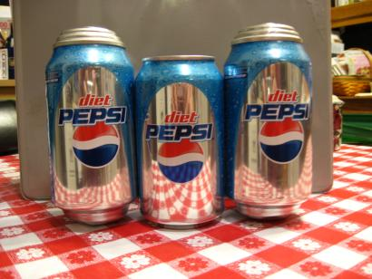
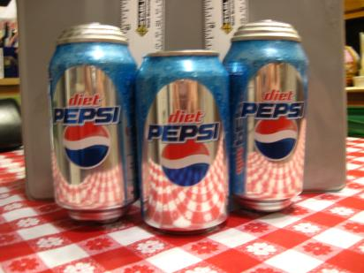
MATTER AND ITS CHANGES 2A5TN

WHAT CHANGES OCCUR WHEN WATER FREEZES?

IDEA: PROCESS SKILLS:
The phase change from liquid to solid Observe
involves release of energy to the Compare
surroundings. Explain

LEVEL: L/U DURATION: 60 Min.

ADVANCE PREPARATION: Collect jars and bags.

RESPONSES TO
SOME QUESTIONS: 5. The ice fills the jar and is outside the jar, around the lid, as well.

6. The ice volume is greater than the original liquid volume, but the volume difference is not a large percent of the original volume.

7. Energy was involved in the change. The liquid water lost energy in forming the solid. The molecules slowed down and eventually “locked into place.” The energy of movement they once had was lost to the surroundings as heat (EXOTHERMIC).

POINTS TO EMPHASIZE IN
THE SUMMARY DISCUSSION: Water is unusual in that it expands when it freezes. Almost all other substances contract.

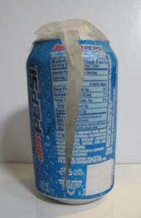
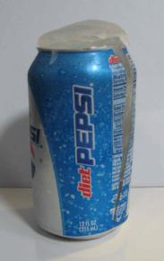
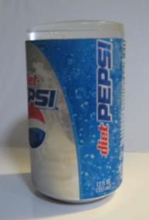
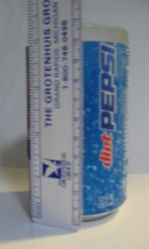
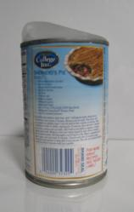
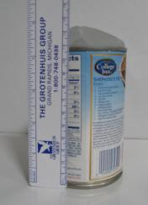
MATTER AND ITS CHANGES 2A6D

ARE WATER MOLECULES STATIONARY OR IN MOTION?
(Demonstration/Discussion)

Materials: (2) 1 quart jars
index card, or thin cardboard, poster board
food coloring
hot and cold tap water

Note: You may want to practice the demonstration beforehand.

Carry out the demonstration as described. That is, with the hot water on top of the cold water.

1. Fill one jar to the top with hot water. (It must be filled to the very top). Fill the other jar with cold water and add several drops of food coloring to it.

2. Put the index card on top of the hot water jar, hold the card in place, and turn the jar upside down, placing it on top of the cold water jar.

3. Slide the card out slowly and watch what happens. The colored water diffuses because the faster-moving hot water molecules mix with the slower-moving cold water molecules. Even though the water in the jars appeared to be still, molecules are always in motion.

Motion will not be immediately apparent. It may take 15-20 minutes, depending on the amount and initial temperatures of the water. Eventually, both jars will contain water of uniform color. Although molecular motion will continue, it will no longer be apparent.

If the jars' positions are reversed, the colored hot water will IMMEDIATELY rise into the colorless, cold water due to convection currents. (For further reference, see HEAT).

MATTER AND ITS CHANGES 2A7

IS EVAPORATION THE SAME AS BOILING?

Materials: fan
beakers, 250 ml,
alcohol, or available volatile liquid
hot plate
water

1. Place a 250 mL beaker filled with about 200 mL of alcohol in front of a fan which is set on “high.” Mark the initial level of the alcohol. Continue “fanning” the alcohol for 15-20 minutes, while setting up the water beaker.

2. Place a 250 mL beaker filled with about 200 mL of water on top of a hot plate which is set on “high.” Continue heating the water and observe any changes which occur over a period of 15-20 minutes.

3. At the end of the 20 minute period, turn off the fan and hot plate.

4. Has the alcohol level changed?
_______________________________________________________________________________________________
What occurred that accounts for this change?
_______________________________________________________________________________________________
Did any bubbles appear during this process?
_______________________________________________________________________________________________
Was energy involved in this change?
_______________________________________________________________________________________________
If so, how?
_______________________________________________________________________________________________
5. Has the water level changed?
_______________________________________________________________________________________________
What occurred that accounts for this change?
_______________________________________________________________________________________________
Did any bubbles appear during this process?
_______________________________________________________________________________________________
Was energy involved in this change?
_______________________________________________________________________________________________
If so, how?
_______________________________________________________________________________________________
_______________________________________________________________________________________________
6. Was the same process responsible for both the alcohol and the water levels changing?
_______________________________________________________________________________________________
How do you know?
_______________________________________________________________________________________________
_______________________________________________________________________________________________
7. What is necessary to continue both processes without liquid alcohol or liquid water remaining?
_______________________________________________________________________________________________
8. How were both processes similar?
_______________________________________________________________________________________________

MATTER AND ITS CHANGES 2A7TN

IS EVAPORATION THE SAME AS BOILING?

IDEA: PROCESS SKILLS:

Evaporation and boiling, while both involve a change Observe
of liquid to gas, are not the same process. Compare

LEVEL: L/U DURATION: 45 min
.
ADVANCE PREPARATION: Be sure to carry out the alcohol evaporation in a well-ventilated area.

DO NOT substitute a Bunsen burner for the hot plate alcohol vapors in proximity to an open flame will cause a violent combustion reaction!!

MANAGEMENT TIPS: Due to safety considerations, alcohol should not be, used to illustrate both processes.

RESPONSES TO
SOME QUESTIONS: 4. The alcohol level will be less due to accelerated evaporation. No bubbles will appear because no boiling occurs. Energy IS involved. The mechanical motion of the fan blades imparts energy to air molecules above and surrounding the alcohol, continually moving them away from the alcohol surface. Alcohol molecules at the liquid surface also receive this energy, which is sufficient to cause them to “break away” as invisible gas molecules. Although EVAPORATION occurs continually at the liquid interface, the increased energy hastens the process.

5. The water level changed due to both EVAPORATION and BOILING. The bubbles that appeared indicate that boiling occurs from within the body of the liquid, not just at the surface where evaporation occurs. Energy is involved. The thermal energy transmitted through the glass to the water is sufficient to raise the temperature of the water until it begins changing to gas throughout.

6. The alcohol level changed due to evaporation. The water level changed primarily due to boiling. In evaporation, there was no visible change within the body of the liquid, while in boiling large bubbles indicated the change from liquid to gas. Evaporation occurred without heating; boiling required heat.

7. Energy addition, either mechanical or thermal, is necessary to continue these processes.

8. Both processes resulted in formation of gas (vapor) from liquids.

MATTER AND ITS CHANGES 2A8

ARE ALL FROZEN SOLIDS “COLD”- AND
ALL BOILING LIQUIDS “HOT?”

Materials: tertiary butyl alcohol (Abutanol) tanol)
liquid nitrogen
Dewar flask
250 mL beakers
thermometer
refrigerator, or ice cooler with ice
Periodic Table of Elements (with physical data)
Part A:

1. Obtain some tertiary butyl alcohol and refrigerate it for a few minutes. (5 minutes is sufficient for 50 mL; up to 200 mL will solidify within 15-20 minutes in a refrigerator). Leave the alcohol refrigerated along enough to JUST solidify it.

2. Remove the container from the refrigerator and wipe any condensed moisture from it.

3. Place a thermometer into the container and GENTLY insert it into the solid. (Wait a minute if you cannot insert the thermometer easily). Record the temperature.
_____________________________________________________________________________________
4. Continue to monitor the temperature until the alcohol returns to its liquid state.

5. Was the solid “cold” in any everyday sense?
_____________________________________________________________________________________
6. How is tertiary butyl alcohol “ice” different from water “ice?”
_____________________________________________________________________________________
_____________________________________________________________________________________

Part B

I. Carefully pour some liquid nitrogen into a beaker. Observe what happens to the liquid.

2. Is the liquid “disappearing?”
_____________________________________________________________________________________
Is it evaporating?
_____________________________________________________________________________________
MATTER AND ITS CHANGES 2A8

ARE ALL FROZEN SOLIDS “COLD”- AND
ALL BOILING LIQUIDS “HOT?” 2

Is it boiling?
_____________________________________________________________________________________
How can you tell?
_____________________________________________________________________________________
_____________________________________________________________________________________
3. What is happening to the outside of the beaker?
_____________________________________________________________________________________
_____________________________________________________________________________________
How does it feel?
_____________________________________________________________________________________
4. How can cold liquids boil?
_____________________________________________________________________________________
_____________________________________________________________________________________
5. How can warm liquids freeze?
_____________________________________________________________________________________
_____________________________________________________________________________________
MATTER AND ITS CHANGES 2A8TN

ARE ALL FROZEN SOLIDS “COLD” AND
ALL BOILING LIQUIDS “HOT?”

IDEA: PROCESS SKILLS:
Freezing point refers to the specific temperature at which a Observe
particular liquid changes to solid. Boiling point refers to the Measure
specific temperature at which a liquid changes to a gas. Describe
Neither necessarily indicates “cold” or “hot.” Explain

LEVEL: U DURATION: 45 min.

STUDENT BACKGROUND: Participants should understand the meanings of melting/freezing point
and boiling/condensation point.

MANAGEMENT TIPS: 1 . This activity should be done in a well ventilated room. Advise
participants not to inhale any vapors from the alcohol, nor to spill
any liquid nitrogen on their skin. (Safety glasses should be worn).
2. The alcohol may be re-frozen and melted again for confirmation of
data. Tertiary butyl alcohol freezes at 25.0ºC or nearly room
temperature. NOTE: Depending on room temperature, the alcohol
might already be solid! Part A may be done as a demonstration.
RESPONSES TO
SOME QUESTIONS: Part A:
3. The temperature will be about 23-25ºC.

5. The alcohol is not “cold.”

6. The alcohol ice differs from water ice both in appearance (needle-like crystals) and in its temperature.

Part B:
1. & 2. The nitrogen is a turbulently bubbling liquid which is both evaporating and boiling. Bubbles forming within the body of the liquid indicate boiling. A “haze” which appears above the liquid surface (not in and climates!) results from water in the air freezing as it loses heat to the boiling nitrogen.

3. The outside of the beaker feels extremely cold and it may develop a layer of frost, as explained above.

4. Liquids boil at their characteristic boiling points. Liquids with very weak attraction among its particles will boil at very low temperatures. Such liquids are normally gases at room temperature.

5. Liquids freeze at their characteristic freezing points. Intermolecular attractions cause some liquids to freeze with relatively little energy removal. Others require more energy loss before their solid state will form.

MATTER AND ITS CHANGES 2A9D

THE PHYSICAL STATES OF THREE SUBSTANCES

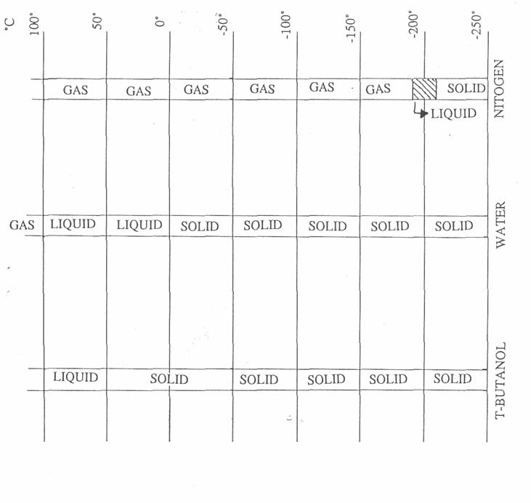

MATTER AND ITS CHANGES 2B1D

ARE MOLECULES OF SOLID AT REST”?
(Demonstration/Discussion)

All matter is composed of tiny particles, either atoms or molecules. These particles are in constant motion. Since the particles are so small and not ordinarily revealed to us except by scanning tunneling microscopes (STMs), it is necessary to model their behavior to better understand the changes which occur in matter.

Arrange the participants as in the drawing: right hand on your sideman's shoulder, and left hand on your foreman's shoulder. (Front has left hands free, and right wing has right hands free).

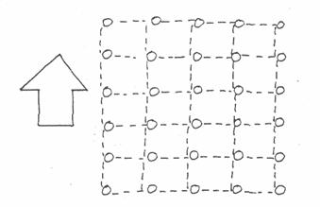

Like this, the particles are arranged in a solid. Remember, the particles are not at rest, they vibrate. (The whole, class must shiver). The vibrations get more violent, the temperature rises.

MATTER AND ITS CHANGES 2B2D

HOW DOES A LIQUID BECOME A SOLID?
(Demonstration/Discussion)

1. Arrange the participants as they were in a solid.

2. Have. “solid” participants stretch out their free arms, ready to catch some molecule going by.
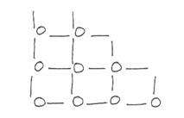

3. Ask all participants whose last names begin with the letters “B,” “M,” and “S” to break the bonds and begin moving as a liquid.

4. Some of the liquid particles are caught (by the “solid” participants).

5. The solid particles get extra vibrations when a liquid particle is caught and thus keep the temperature the same.

6. Solid particles whose last names begin with “D,” “M,” and “S” are solidifying.

7. The process that occurs fastest determines solidification or melting.

8. All motion should be “slow motion,” so the effect can be more easily visualized.

9. All interactions should take place within the bounds of the original solid configuration.

MATTER AND ITS CHANGES 2B3D

WHAT HAPPENS TO THE MOLECULES AS
ADDITIONAL ENERGY IS SUPPLIED TO A SOLID?
(Demonstration/Discussion)

1. Arrange the participants as they were in the solid phase.

2. Encourage considerable vibration on their part (temperature increases).

3. Have only those participants whose last name begins with the letter “S” drop their arms. Their bonds have been broken. They have melted.

4. The space occupied by the participants should remain constant.

5. Maintain the same vibrations while more participants “melt” from the solid. (Temperature remains constant during melting. All energy is used to break the bonds, NOT to increase the molecular motion).

MATTER AND ITS CHANGES 2B4D

WHAT HAPPENS TO THE MOLECULES AS ADDITIONAL
ENERGY IS SUPPLIED TO THE MELTING PHASE?
(Demonstration/Discussion)

1. Start with the participants arranged in the “solid” configuration. Imagine that he-at is applied to the solid.

2. Some of the bonds are broken so that participants are in groups of approximately six.

3. These groups can wander around moving relative to each other; the “liquid” can change shape.

4. Participants continue to vibrate more violently than when a solid because of the higher temperature achieved as heat is applied.

5. Try this in slow motion; it is a difficult procedure and participants will need encouragement and instruction.

6. The groupings change. Bonds are broken and new bonds are made. The groups get smaller as temperature rises, which makes the liquid more free-flowing.

7. All of this takes place within the same space as you started in the “solid” configuration.

MATTER AND ITS CHANGES 2B5D

WHAT HAPPENS TO THE MOLECULES AS ADDITIONAL
ENERGY IS SUPPLIED TO A LIQUID?
(Demonstration/Discussion)

1. Arrange the participants as they were in a liquid; that is, groups of approximately three participants. Let these groups wander around in the same space. This space continues to be the same as was represented in the “solid” configuration.

2. High vibrations, because of the additional energy, breaks many bonds. The process of evaporation is modeled.

3. Some of these participants (molecules) are allowed to move out of the controlled area and occupy approximately 10 times more space (out into the room).

4. All action again should be in “slow motion.”

5. To model boiling, bonds should break within the “liquid,” not just at the edges or surfaces.

MATTER AND ITS CHANGES 2B6D

WHAT HAPPENS TO THE MOLECULES
AFTER THEY BREAK FREE?
(Demonstration/Discussion)

1. Arrange the participants as they were in a liquid, that is, groups of three wandering around in a “controlled” space (with no definite “boundaries”).

2. After bonds are broken in the group of three, encourage the participants to occupy approximately 10 times as much space as they did previously. (They are modeling the gaseous state).

3. Have the participants move in straight lines.

4. When they collide with a wall or another participant, have them rebound off as a ball in -a game of billards. See diagram below.

MATTER AND ITS CHANGES 2B7D

DIFFUSION OF GASES
(Demonstration/Discussion)

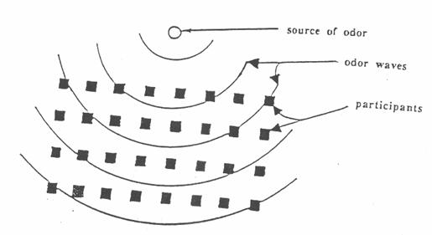

This demonstration helps to explain molecular theory and transportation of gases or diffusion. An evaporating dish or watch glass is filled with a liquid which evaporates easily and has a distinct odor. With all doors and windows closed to prevent drafts, the liquid is allowed to evaporate in the room.

Participants are instructed to signal when they detect an odor, and observe the pattern of the hand raising throughout the room. The last person to raise his hand is asked to define the odor.

The pattern of hand raising will be similar to waves in water. Those students who are close to the source of odor will raise their hands first; those students farther away will raise their hands later.

The pattern of hand raising will help to explain that the molecules of an evaporating substance must be transported by the movement of air molecules, that is, by the bouncing of air molecules against the molecules of the evaporating substance. The odor is caused by the millions of molecules of the substance being carried out in almost a wave motion to the olfactory nerves of the observers.

MATTER AND ITS CHANGES 2B8D

MOLECULAR MOTION IN A GAS
(Demonstration/Discussion)

If a two-speed electric fan, some coarse screening, and ping-pong balls are obtainable, a model can be made to demonstrate the random motion and collisions of molecules in a gas. Make a hollow cylinder with the screening and tape circles of screening over each end. Place at least a dozen ping-pong balls inside. Support this over the fan so that air is forced upward through the cylinder.

Some trial and error experimentation may be necessary to make this model work properly. The fan should be powerful enough to set the ping-pong balls in motion at low speed The effect of heat can then be shown by switching the fan to high speed. If one of the balls is colored, its movements can be readily traced. If the fan won't move the ball, try using styrofoarn packing “peanuts.” A hair dryer may be used.
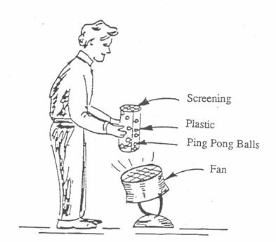

MATTER AND ITS CHANGES 2B9D

MOLECULES IN THREE STATES OF MATTER

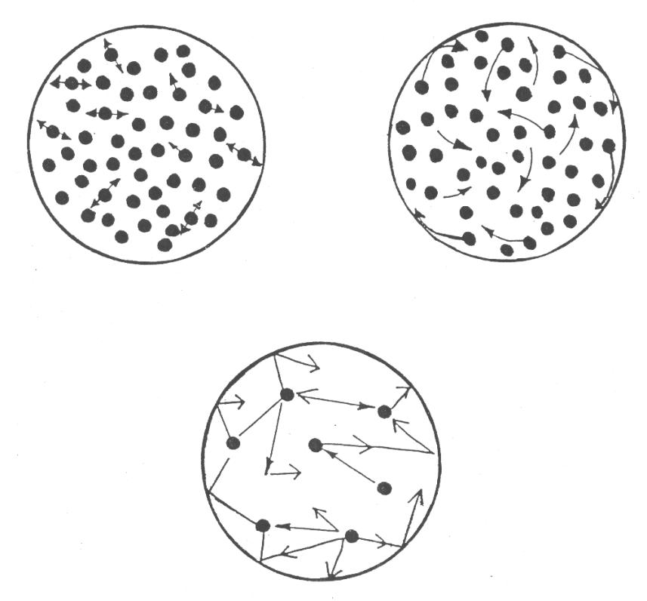
MATTER AND ITS CHANGES 2B10

MOVEMENT OF MOLECULES

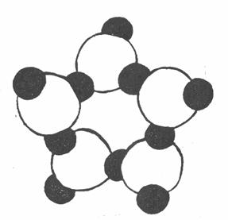

Molecules of ice have
a definite and orderly pattern

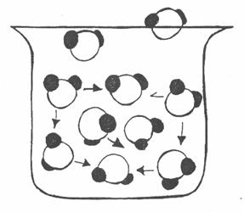

Molecules of water are attracted
to each other, but still move
about freely

MATTER AND ITS CHANGES 2B11

MOLECULAR MOTION AND CHANGE OF STATE

Materials: None

Describe how molecules move during each process.

NAME OF PROCESS MOLECULES

Evaporation ___________________________________________________________________

Condensation ___________________________________________________________________

Melting ___________________________________________________________________

Freezing ___________________________________________________________________

move quickly move slowly move closer together move farther apart

MATTER AND ITS CHANGES 2C1F

FOCUS ON PHYSICS
STATES OF MATTER
(Discussion)

Matter exists in four states: solid, liquid, gas and plasma. The particles in each state are in constant motion. In SOLIDS, they vibrate in fixed positions, giving a solid definite shape and volume. If energy is added to a solid, some of the particles “break free” and begin to wander throughout it: MELTING occurs. All the energy is used in dislodging particles from their fixed positions; hence, no change in temperature occurs (MELTING POINT). When all of the particles have moved from the fixed positions, the material is a LIQUID. Particles move within the same general space they occupied as solids. Therefore, liquid volume is fixed, and liquids do not differ greatly from solids in their densities. However, because the particles are quite mobile, liquid shape is variable. Further addition of energy causes particles to speed up and eventually overcome mutual (electrical) attraction. Temperature remains constant while the liquid turns to GAS (BOILING POINT). A gas has neither fixed volume nor shape because its particles are in constant, random motion. If sufficient energy is added, the particles themselves can rip apart, spewing out subatomic bits ---nuclei, electrons --- this is PLASMA. While plasma comprises most of the stars and interstellar space, it is not common in our daily experience.

Matter can be changed from one state to another by the addition or removal of ENERGY, allowing particles to speed up or slow down. FREEZING and CONDENSATION are processes which am the reverse of what has been already described. Freezing or melting, and boiling or condensing are PHYSICAL changes. Particles may separate or come together, but the composition of the material remains the same. (Liquefied air is still 21% oxygen, 78% nitrogen, 1% argon and other gases). DURING a change of state, constant temperature reflects an average constant speed of particles while the change occurs.

Matter can also be changed from one state to another by an increase or decrease in PRESSURE, either forcing particles closer together or allowing them to “break free.” For every material there exists a temperature (CRITICAL TEMPERATURE) above which no amount of pressure can force its particles together. The particles have so much energy, that they are no longer attracted to one another.

MATTER AND ITS CHANGES 3WL

WORKSHOP LEADER’S PLANNING GUIDE THE PARTICULATE NATURE OF MATTER

In everyday life, familiar substances are viewed mainly in terms of their uses, such as detergents for cleaning, wax for polishing, and insecticides for exterminating. However, the NAME of a substance implies much more than its use. To the scientist, “water” conjures up not only a state of matter, a useful solvent, but also a chemical formula, H20, which represents tiny particles called molecules. KINETIC THEORY provides a convenient way of explaining many observable properties and changes in matter - the MACROSCOPIC world - in terms of particle arrangement and behavior - the MICROSCOPIC world.

The ability to describe matter at the particulate level is necessary for explaining physical or chemical changes, fluid behavior, and some properties of mixtures. It is fundamental to an understanding of MATTER, yet the particulate model is not intuitive. Misconceptions about states of matter on the microscopic level abound. When describing physical and chemical changes, particle structure, motion, distribution, and conservation are often ignored or incorrectly represented.

Previous subtopics, PROPERTIES OF MATTER and STATES OF MATTER included many activities involving the macroscopic level. From this experiential base, the microscopic level can be addressed in this subtopic, THE PARTICULATE NATURE OF MATTER.

Naive Ideas:

1. Particles viewed as mini-versions of the substances they comprise: oxygen molecules are invisible, water molecules are tiny droplets, and diamond molecules are hard. (2LA4).

2. Particles misrepresented in sketches: no differentiation is made between atoms and molecules. (3A6)

3. Particles misrepresented and undifferentiated in concepts involving elements, compounds, mixtures, solutions, and substances. (3A7, 3A8, 3A9, 3A11). 1).

4. Frequent disregard for particle conservation and orderliness when describing changes. (3A6)

A. MICROSCOPIC MODELS OF PARTICLE BEHAVIOR ARE DEVELOPED TO ACCOUNT FOR THE MICROSCOPIC BEHAVIOR OF MATTER.

1. Discussion - Focus On Physics: What Are Molecules?
This discussion explains that models, while useful, are limited in explaining matter, and is an adjunct to the
activity “Developing a Model.”

2. Activity: Developing a Model.
This activity is a variation of a “black box” experiment to show how models of matter are developed from
indirect observation.

3. Demonstration/Discussion: Probing Matter.
This demonstration/discussion further reinforces MODEL-BUILDING from indirect observation.

MATTER AND ITS CHANGES 3WL

WORKSHOP LEADER’S PLANNING GUIDE THE PARTICULATE NATURE OF MATTER - 2

THE REMAINING ACTIVITIES ARE NOT INCLUDED IN THIS UNIT.

4. Activity: What Color are Copper Atoms?
This demonstration/discussion attempts to refute the notion that particles of a substance possess all the
properties of that substance.

5. Discussion : What Do Atoms and Molecules Look Like?
This discussion employs textbook diagrams, as well as recent photographs of atoms and molecules to
illustrate how we “see” particles of matter.

6. Demonstration/Discussion/Overhead: What Happens to Air Molecules in a Flask When Some are Removed? This demonstration/discussion uses an “invisible” event to initiate discussion and develop models about changes occurring on the particle level.

7. Activity: Modeling Matter Elements, Compounds and Mixtures. THIS activity involves observations of samples of each category of matter followed by modeling their particulate structure to account for homogeneity.

8. Overhead: Elements, Compounds and Mixtures. This overhead can be used in conjunction with the previous activity or independently to summarize the categories of matter and their properties.

9. Activity: Constructing a Concept Map. This activity utilizes the concept mapping technique to relate ideas about matter and its particles.

10. Overhead: Mauer.
This overhead is a sample concept map for participant use during the preceding activity.

11. Overhead: Matter and Particles.
This overhead can be used alone, or in conjunction with other activities such as “Constructing a Concept
Map.

B

1. Discussion - Focus On Physics: Some Basic Particles of Matter.
Atoms, molecules and ions are summarized and illustrated.
MATTER AND ITS CHANGES 3A1F

FOCUS ON PHYSICS
WHAT ARE MODELS?
(Discussion)

Although many properties of matter are observable, materials are often too large, too small or too distant to be directly examined. To find reasonable explanations for various phenomena, scientists develop MODELS, Numerous models exist to explain our physical world, from galactic to subatomic. Even after astronomers scan the sky with the largest telescopes, obtaining direct information from photographs, they must still develop a model to explain the outward movement of galaxies. While scientists today probe material surfaces with the Scanning Tunneling Microscope, resulting in photographs of atoms, they too resort to models to explain bonding and surface chemical reactions. MODELS are powerful tools for imagining worlds that are, for the most part, incomprehensible to us.

However, while models are useful, they re not “real.” A plastic scale model of the Space Shuttle only vaguely resembles it. And certainly, predicting Shuttle behavior based on flying the plastic model is foolish! While models resemble their real-life materials in many ways, they are limited in the utility.

In the last 2,500 years, the model of that fundamental particle of matter, the atom, has evolved. From Aristotle, who believed in the continuity of matter, to Leucippus and Democritus, who supported the particulate (atomic) nature of matter, scientists have continually sought models that would explain the behavior of matter. Models were modified or abandoned as new observations were obtained. Today, our spherical, charge-cloud atomic model is both vastly different from its precursors, while strikingly similar!

MATTER AND ITS CHANGES 3A2

DEVELOPING A MODEL

Materials: “black boxes”

1. Each “black box” contains an object that is analogous to the atom. While we don't usually see particles of matter, we can develop a model that describes them based on indirect observations. Your purpose is NOT to guess the identity of the object inside. Rather, it is to build a mental model of it without opening the box or directly viewing it in any way.

2. Manipulate the box to detect subtle sounds and feelings from the object inside. Record your detections.

3. Continue. to turn, tilt or jostle the box to gather and record more information.

4. Are there any properties you might detect by use of equipment?

What equipment would you need?

5. Are there properties which cannot be revealed without direct viewing? If so, which ones?

6. Briefly describe the object by using the properties you have detected.

7. Optional: Hypothesize about the identity of the object. Sketch a picture of the object.

MATTER AND ITS CHANGES 3A2TN

DEVELOPING A MODEL

IDEA: PROCESS SKILLS:
Models provide a way of “looking” at matter Observe
that cannot be. directly perceived. Record
Hypothesize

LEVEL: L/U DURATION: 15 min.

ADVANCE PREPARATION: 1. Place a different object in each shoe box. Choose a wide enough
variety to exhibit different properties.
2. Secure the boxes with tape. (Optional: to make a permanent set
of “black boxes,” construct wooden plywood boxes that can be
nailed shut. Make a coded list of the contents for reference).
3. Suggested objects: sponge, cassette case, paperback book,
face cloth, shampoo bottle, butter knife, jumbo marker pen, small
tape dispenser roll, several pencils secured by a rubber band, and a
heavy-duty zip-loc bag half-filled with water.
4. Note: Junior high schools may still have commercial black boxes
from IPS (Introductory Physical Science) which you may use.
5. Optional: Insert knitting needles or sharpened pencils into the shoe
boxes to serve as probes.

MANAGEMENT TIPS: 1. Encourage participants to focus their observations. For a
description such as “long,” ask “How long?” For a description
such as “light,” ask “Compared to what?”

2. Keep participants focused on the main purpose of the activity, modeling without seeing, rather than on “guessing the object.”

3. Workshop Leaders may prefer leaving the boxes closed and not revealing the objects' identities, although be prepared for objections. This approach more appropriately represents model development.
RESPONSES TO
SOME QUESTIONS: 4. Yes, properties such as magnetism (magnet), mass (balance),
volume (ruler or graduated cylinder), or transparency (x-ray) could
be determined.
5. Properties such as color and luster cannot be perceived directly.
Properties such as flammability, absorbency, and elasticity are
revealed only by further manipulation of the objects.
6. Participants can estimate mass, shape, size (with dimensions),
material (metal, non-metal), and density.
POINTS TO EMPHASIZE IN
THE SUMMARY DISCUSSION: 1. Point out the “large” amount of information obtainable by indirect
observation.
2. Mention that some scientists are unable to directly view the objects
of their study, but are still successful at predicting properties and
behavior by developing models.

MATTER AND ITS CHANGES 3A3D

PROBING MATTER
(Demonstration/Discussion)

Materials: cardboard mailing tube (for posters)
cardboard tube (from roll of paper towels)
wooden dowel, small diameter
blindfold
object to be “probed” (preferably a large, unbreakable, irregularly
shaped object, such as a hair dryer, food processor or coffeepot).

1. Request a volunteer to be blindfolded. Supply the volunteer with the first probe, a cardboard mailing tube.

2. The volunteer probes the object carefully, while describing it to the group. (Little information can be revealed by using the mailing tube).

3. Use the second tube, (from a roll of paper towels). This tube can provide greater detail than the first.

4. After no more information can be found, give the dowel to the volunteer. Even more details should be revealed by probing with the dowel; the object might be identifiable at this point.

5. Compare, this probing demonstration to the manner in which instruments such as the microscope, electron microscope and scanning tunneling microscope have increasingly refined our “picture” of the atom.

The purpose of this demonstration/discussion is to develop a MODEL of the object, not necessarily to identify it. It is also important to note that models are continually refined as instrumentation advances to reveal more about matter.”

MATTER AND ITS CHANGES 3A4

WHAT COLOR ARE COPPER ATOMS?

Materials: samples of elements: powder ed sulfur or carbon, aluminum or tin, or copper foil (or turnings)
scissors or spatula
magnifiers

1. Obtain an element sample and describe its properties. (You may consult the list “Properties of Matter”).

2. Using an appropriate tool, subdivide the sample into several smaller samples. Examine any one of your smaller samples. What are its properties?
_______________________________________________________________________________________________
_______________________________________________________________________________________________

3. Take one small sample and continue subdividing it into smaller and smaller samples until it is inconvenient to proceed any farther. Examine one of the final subdivisions with a magnifier. What are the properties of this sample?
_______________________________________________________________________________________________
_______________________________________________________________________________________________

4. If you could continue the subdivision until just one atom of your element remained, what properties would it have?
_______________________________________________________________________________________________

Would it have all the same properties as the sample with which you began? Why?
_______________________________________________________________________________________________

How do you know?
_______________________________________________________________________________________________
_______________________________________________________________________________________________
MATTER AND ITS CHANGES 3A4TN

WHAT COLOR ARE COPPER ATOMS?

IDEA: PROCESS SKILLS:

individual particles possess SOME, but not all, of the Observe
macroscopic properties of the substances they comprise. Infer

LEVEL: L/U DURATION: 20 min.

STUDENTBACKGROUND: Knowledge of the atom as a basic particle of matter.

ADVANCE PREPARATION: Collect all materials. Choose readily available samples of elements that are easy to subdivide and safe to handle. (Metal turnings may be substituted fro foil). Project the overhead “Properties of Mauer” (1B5) or distribute copies for reference.

MANAGEMENT TIPS: Allow sufficient time for participants to collaborate and brainstorm ideas, especially when discussing question 4.

RESPONSES TO
SOME QUESTIONS: 1-3. The properties of the samples do not change with subdivision. The
smallest sample of sulfur, for example, remains solid, pale yellow,
malodorous, crystalline, and brittle. The smallest sample of aluminum, for example, remains lustrous, metallic, grey, flexible, malleable and solid.

4. At the microscopic level, atoms do not retain all of the properties of the elements they comprise. While an individual copper atom has mass and volume, it does not possess lustre nor malleability, conductivity, and ductiliy. These properties are the result of aggregate behavior of atoms. Neither does an individual atom possess color, per se. The yellow color of sulfur or the “orange” color of copper is due to transitions of electrons which manifests itself through aggregate behavior.

POINTS TO EMPHASIZE IN
THE SUMMARY DISCUSSION: 1. The particulate model views matter as discrete, rather than
continuous. That is, subdivision of matter is not infinite.
Individual atoms of matter have finite mass and volume. While this
discrete model is simple and offers some explanations, it doe not explain all properties of matter.

2. The naive idea that individual atoms possess all the properties of its parent substance may have arisen from frequent textbook reference to the subdivision process. Often, an atom or molecule is described as the end result of a series of divisions. One can “logically” conclude from this that a molecule of water then, is transparent, has a boiling point, a freezing point, a refractive index, and can dissolve sugar!

Explanations based on aggregate behavior and interaction of particles is disregarded when this simplistic view is accepted.

MATTER AND ITS CHANGES 3A5D

WHAT DO ATOMS AND MOLECULES LOOK LIKE?
(Discussion)

Materials: recent photographs from magazines and textbooks
diagrams of atoms and molecules from textbooks

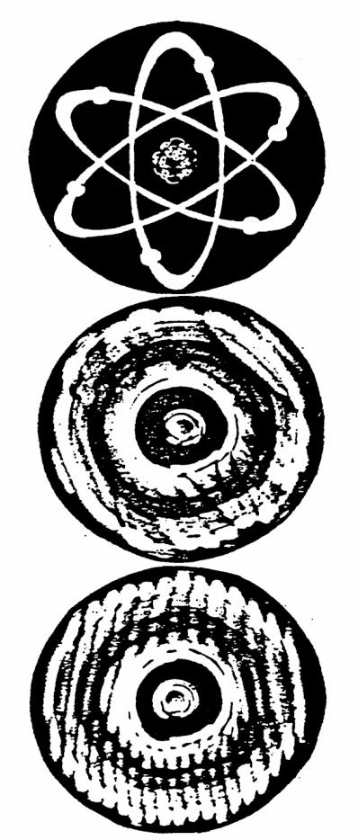
Sources: Scientific American, Discover, Science (February 24, 1989). Scientific American Library. Molecules (1987), Powers of Ten (1982), as well as current textbooks of physics or chemistry

1. Examine diagrams of atoms or molecules that appear in textbooks. Notice that they all show atoms as spherical. Protons and neutrons are shown centered in the atom with electrons “whirling about” them.

2. Examine recent photographs of atoms or molecules. Photographs reinforce the spherical, fuzzy models that serve to explain particles.

3. The “Dazer” (c 1983, the DZ Company, available in most science museum shops) is a disc which statically illustrates an atomic model. When spun, it shows a different atom, and a cloudy model with concentric rings of electron density. While dynamic, this still only MODELS certain aspects of the atom.

MATTER AND ITS CHANGES 3A6D

WHAT HAPPENS TO AIR MOLECULES IN A
FLASK WITH SOME ARE REMOVED?
(Demonstrtion/Discussion/Overhead)

Materials: one liter flask

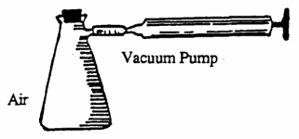 hand evacuating pump (Note: If only a motorized pump is available, be sure to tape the outside of the flask in the event of an explosion)

The purpose of this demonstration/discussion is to show that when some gas is removed from its container, the remaining gas molecules uniformly occupy the space available.

To perform this demonstration, the overhead of the flask sets can be projected, or copies can be provided for participants.

1. Explain the function of the pump.

2. Connect the flask to the pump and operate the pump to remove some of the air from the flask.

3. Have participants complete the “before” and “after” sketches of the flask by showing the molecules before and after partial evacuation. While sketching, collaborate and brainstorm ideas. Leading questions such as “Did the flask expand? Cave in?” or “Is the flask empty?” may be helpful.

4. Optional: Have participants share their sketches with others.

5. Discuss the overhead which shows several “before” and “after” sketches.

The “before” flasks in A through D show particle distribution too great for gases.

The “before” flasks in E through H show more appropriate particle distribution. However, only H shows the correct “after” situation with random distribution of particles that accounts for uniform gas pressure.

The “ after” sketches of A through G show particles either clustered or arranged next to totally empty space. Perhaps these erroneous views arise from the idea of pulling a vacuum on the air.

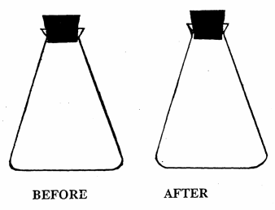

MATTER AND ITS CHANGES 3A6D

Sketches of “Before” and “After”

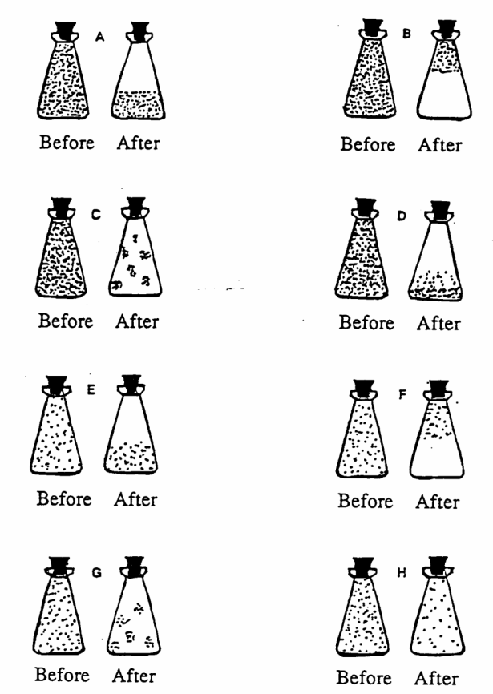

MATTER AND ITS CHANGES 3A7

MODELING MATTER: ELEMENTS, COMPOUNDS AND MIXTURES

Materials: beakers or clear plastic cups magnifiers
compounds: water, sodium chloride, sugar. alcohol metal file
mixtures: sand, vinegar, soda. pennies (post-1981) scissors or metal snips
elements: aluminum, sulfur, carbon, copper
Part I

1. Choose an element, a compound and a mixture from those provided. Place each in a cup or beaker.

2. Examine each, using a magnifier, if you choose. Record the properties of each. (Note: If your mixture sample is a penny, you must notch the penny with a metal file to reveal is interior).

PROPERTIES OBSERVED:

Element: _____________________ ___________________________________________________________

Compound: ___________________ ___________________________________________________________

Mixture: _____________________ ___________________________________________________________

3. Which of the substances is homogeneous (same properties throughout?)
_______________________________________________________________________________________________
4. Which of the substances is heterogeneous (different properties throughout?)
_______________________________________________________________________________________________
5. For any mixture whose container is available, read its label, and list the substances that comprise it.
_______________________________________________________________________________________________
6. a. If your mixture appeared homogeneous, explain why it exhibited uniform properties.
_______________________________________________________________________________________________
_______________________________________________________________________________________________
b. If your mixture appeared heterogenous, explain how it could be separated.
_______________________________________________________________________________________________
_______________________________________________________________________________________________
7. Compare answers with other members of the group. Summarize what you have learned about elements, compounds and mixtures.
_______________________________________________________________________________________________
_______________________________________________________________________________________________
_______________________________________________________________________________________________
MATTER AND ITS CHANGES 3A7

MODELING MATTER: ELEMENTS, COMPOUNDS AND MIXTURES - 2

Part 1

Materials: molecule model kits (with color key)
optional: gum drops, jelly beans and toothpicks
clear plastic cups

1. Obtain a model kit for constructing molecules. The wood or plastic balls represent individual atoms. Each type of atom has a distinct color. Use the color key to determine the identity of your “atoms.”

2. Obtain three plastic cups. Using the balls from the kit (or candy pieces), fill each cup to correctly represent an element, a compound and a mixture.

Helpful Hints:

a. Have you used all the same kind of particles for elements? Most elements exist as individual atoms; some exist as molecules, such as H₂, Cl₂, 0₂, N₂, and S₈

b. Have you connected the atoms when forming molecules? Many compounds, such as water, are made of molecules. Choose a simple compound to model, such as water, carbon monoxide (CO), carbon dioxide (CO₂) or ozone (0₃).

c. The mixture can include any combination of atoms, molecules or both.

3. Examine the cups. Which contain the same particle repeated throughout it?
_______________________________________________________________________________________________
Which contain different particles?
_______________________________________________________________________________________________
4. Does the particle model agree with what you observed about the homogeneity of elements, compounds and mixtures in Part I? Why or why not?
_______________________________________________________________________________________________
_______________________________________________________________________________________________
MATTER AND ITS CHANGES 3A7TN

MODELING MATTER: ELEMENTS, COMPOUNDS AND MIXTURES

IDEA: PROCESS SKILLS:
Elements and compounds are homogeneous bemuse Compare
they am each composed of identical repeating units. Explain
Mixtures are heterogeneous (some APPEAR homo- Observe
geneous) because they contain different kinds of particles. Classify

LEVEL: L/U DURATION: 30 min.

ADVANCE PREPARATION: Be sure that model kits contain color keys and are in good order. If necessary, substitute model kits with candy pieces connected with toothpicks. Have soda and vinegar bottles available for inspection.

MANAGEMENT TIPS: 1. Most elements can be correctly modeled using individual atoms. Carbon is an ideal element to model. For hydrogen, oxygen, nitrogen and chlorine, the particles are diatomic molecules, two atoms joined by a bond. However, this is not crucial because the main idea is to show that elements consist of the same particle throughout

2. Compounds should consist of molecules shown correctly bonded by connector sticks, springs or toothpicks.
RESPONSES TO
SOME QUESTIONS: Part 1

3. Substances which appear homogeneous are water, sodium chloride,
sugar, alcohol, aluminum, sulfur, carbon, copper, vinegar and soda.

4. Substances which appear heterogeneous are sand and pennies.

5. Soda contains water and several other ingredients. Vinegar contains
primarily water and acetic acid.

6. a. Soda and vinegar appear homogeneous because they are
SOLUTIONS. Solutions contain dissolved substances;
individual particles am invisible.

b. Sand can be separated mechanically, or with a magnet. The
penny can be separated into copper and zinc by submerging it
in hydrochloric acid (3 Molar); the zinc will dissolve from the
interior and the copper shell will remain. The penny must be
notched to expose the zinc interior.

7. Elements and compounds are homogeneous substances. Mixtures
am heterogeneous, even though some APPEAR homogeneous.

MATTER AND ITS CHANGES 3A8

ELEMENTS, COMPOUNDS AND MIXTURES

Category and Definition Particles Examples

Element:
all 109 on the
substance made of one Periodic Table:
kind of atom or molecule atoms, molecules
gold, silver, tin

Compound:

substance made of two sulfur dioxide
or more elements bonded ozone
to one another in definite water
proportions molecules, ions calcium oxide

Mixture:
tonic water
substance made of sodas
elements, compounds, rocks
or both physically minerals
combined in no air
definite proportions any of the above sterling silver

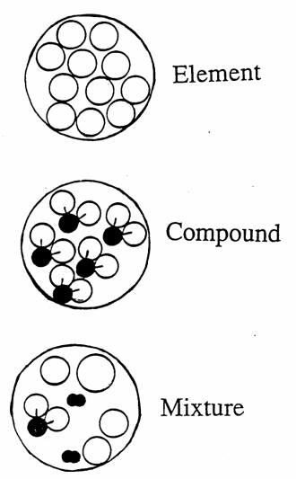

MATTER AND ITS CHANGES 3A9

CONSTRUC71NG A CONCEPT MAP

Materials: paper
pen or pencil
transparencies
transparency projection pens

1. Concept mapping is a way of organizing ideas about a subject, in this case, “THE PARTICULATE NATURE OF MATTER.” Concept maps summarize what you have learned and help clarify misconceptions. Collaborate with other participants in developing the concept map.

2. Individually, brainstorm a list of any words you can think of that relate to “THE PARTICULATE NATURE OF MATTER.” LIST words, non-stop, for three minutes. Do not be concerned over whether or not a word is “correct.”

_______________ _______________ _______________
_______________ _______________ _______________
_______________ _______________ _______________
_______________ _______________ _______________
_______________ _______________ _______________

3. Share lists among group members, adding words to your list and deleting those that seem less appropriate.

4. Link words that are related by drawing arrows or lines from one to another.

5. Select at least 10 words, but no more than 15, from which to construct a concept map on paper and on a transparency.

6. Display your concept map for group discussion.

MATTER AND In CHANGES 3A9TN

CONSTRUCTING A CONCEPT MAP

IDEA: PROCESS SKILLS:
Concept maps link ideas and help Classify
clarify misconceptions. Identify
Interpret
LEVEL: L/U DURATION: 30 min.

STUDENT BACKGROUND: Participants should have completed several activities from Matter and
Its Changes, from any of the first three subtopics, such that they can
generate lists of words and begin to connect ideas.

MANAGEMENT TIPS: 1. Because some participants may be uneasy with concept mapping, the Workshop Leader might also construct a concept map. The leader might even provide a “seed list” of words, such as “atom,” .molecule,” “ion,” and “indivisible.”

2. Encourage participants to use words from other topics related to
matter, including properties and states of matter.

3. Final versions of maps should be displayed both for content and for clarification of inter-related ideas.
POINTS TO EMPHASIZE IN
THE SUMMARY DISCUSSION: Concept maps can link seemingly unrelated terms and help lead to a
better understanding of how matter at the particulate level is related to
matter at the macroscopic level.

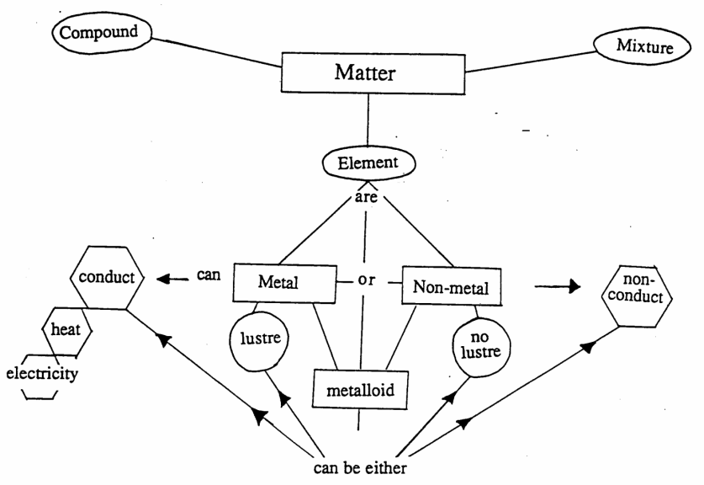
MATTER AND ITS CHANGES 3A11

MATTER AND PARTICLES

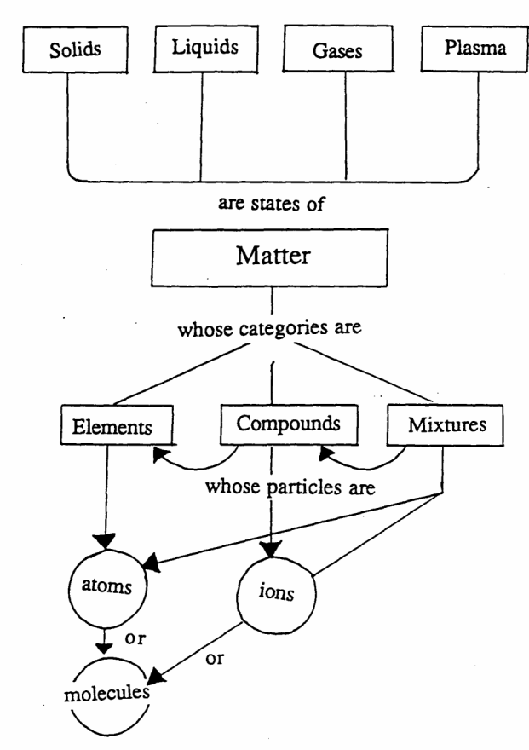

MATTER AND ITS CHANGES 3B1F

FOCUS ON PHYSICS
SOME BASIC PARTICLES OF MATTER

ATOM: the smallest, whole, independent particle of matter. While the basic sub-atomic particles (proton, neutron, electron) are known and numerous others have been discovered (quarks, mesons, gluons, to name a few), the atom remains the fundamental particle from which to study matter.

Atoms are small, spherical structures, so small that there are about 10²³ atoms in one drop of water! That’s 100,000,000,000,000,000,000,000 or one-hundred sextillion atoms!

Most-elements are composed of individual, identical atoms. For this reason, they are not ordinarily broken down and are
homogeneous. Elements differ from one another in their “proton counts.” The numbers of these sub-atomic particles
defines the properties of its atoms. Neutrons add mass and are central to nuclear properties, but they barely affect the
surrounding electron cloud.

SOLIDS, including all common metals, are composed of atoms. LIQUIDS such as mercury, gallium, cesium and francium consist of atoms, as do the GASES helium, neon, argon, krypton, xenon and radon.
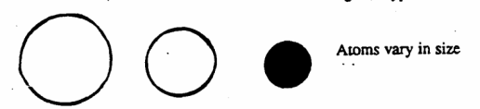

MOLECULE: two or more atoms bonded together in a new, whole particle of matter. Molecules have various shapes, depending on the way in which their atoms are bonded. They are small, with a wider range of sizes than atoms. Molecules contain from two atoms to hundreds of atoms. Some molecules are smaller than atoms, while others are much larger. Nevertheless, the atomic or molecular world is still small compared to our macroscopic world of matter.

Many ELEMENTS are composed of simple molecules. Hydrogen, nitrogen, oxygen, fluoride, chlorine, bromine, iodine, and astatine are made of two-atom (diatomic) molecules. Most COMPOUNDS are made of molecules. Like elements, they possess uniform properties because of the repeating molecular units. Unlike elements, compounds can be broken down by chemical means.

SOLIDS such as plastics and waxes are made of molecules. Water and other LIQUIDS, such as oil and solvents, are also made of molecules. Many GASES, such as carbon dioxide, sulfur dioxide, ozone and methane consist of molecules.
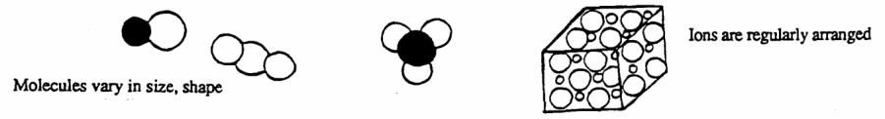
ION: charged atom. A positive ion results from losing one or more electrons to a partner atom-ion; a negative ion results from a gain of electron(s). Ions are similar to atoms in their sizes.

Many COMPOUNDS are made of ions. “Salts,” minerals, and 0 crystalline solids are composed of ions. LIQUID solutions containing dissolved salts, such as sea water, contain ions. PLASMA, the fourth state of matter, consists of ions.

MATTER AND ITS CHANGES 4WL

WORKSHOP LEADER’S PLANNING GUIDE
CHANGES IN MATTER

Matter undergoes physical and chemical changes. Physical changes do not alter the type of matter present. Chemical changes, however, result in the formation of new substances with new properties. Whereas physical changes involve only the spacing and order of particles, chemical changes involve a rearrangement of particles into new combinations. AD changes in matter am accompanied by energy changes, however subtle. All changes illustrate conservation of matter and energy. The total mass and energy remains constant after either physical or chemical changes.

Ibis subtopic includes activities which distinguish between physical and chemical changes, confirm that energy is involved in all changes, and verify conservation of matter. An attempt has been made to combine the macroscopic and microscopic views of matter described in previous subtopics by observing changes and then attempting to explain some on a particulate level.

Naive Ideas:

1. Absence of conservation of particles during a chemical change. (4A4).

2. Chemical changes perceived as additive, rather than interactive. After chemical change, the original substances are perceived as remaining, even though they are altered. (4A3).

3. Failure to perceive that individual substances and properties correspond to a certain type of particle formation of a new substance with new properties is seen as simply happening, rather than as a result of particle rearrangement. (4A3), (4A4).

A. IN A CHEMICAL CHANGE. A NEW SUBSTANCE WITH NEW PROPERTIES IS FORMED, IN A PHYSICAL CHANGE, ALTHOUGH CERTAIN PROPERTIES MAY CHANCE. NO NEW SUBSTANCE FORMS.

1. Overhead: Some Physical Changes.
This overhead shows some examples of changes in matter where no new substance forms.

2. Overhead: Some Chemical Changes.
This overhead shows some examples of changes resulting in the formation of a new substance or substances.

3. Activity: Physical or Chemical?
This multi-part activity is aimed at distinguishing between physical and chemical changes in matter. Parts may
be selected, or the activity may be done in its entirety.

4. Overhead/Discussion/Demonstration: Particle View of a Chemical Reaction.
This overhead models the particle interaction in a chemical change that produces a new substance.

5. Overhead/Discussion: Which is Correct?
This overhead illustrates two views regarding changes in matter, only one of which is correct. It may be used in
conjunction with activity 3, “Physical or Chemical?” either as an introductory provocative question, or as a
conclusion to the activity.

B. IN BOTH PHYSICAL AND CHEMICAL CHANGES. MASS US CONSERVED AND ENERGY IS INVOLVED.

1. Activity: Changes in Matter- Does Mass Change?
This activity uses a physical and a chemical change to illustrate that mass remains constant in both types.

2. Activity: Changes in Matter What Energy Is Involved?
This activity examines various forms of energy used or observed in activity 4A3, “Physical or Chemical?”

3. Actively: Heat Transfer in Physical Changes.
This activity illustrates endothermic and exothermic solution processes.

4. Activity: Is There an Energy Change in Chemical Reactions?
This activity employs four chemical changes that have accompanying energy changes.
C 1. Discussion - Focus On Physics: Changes in Matter.

MATTER AND ITS CHANGES 4A1

SOME PHYSICAL CHANGES

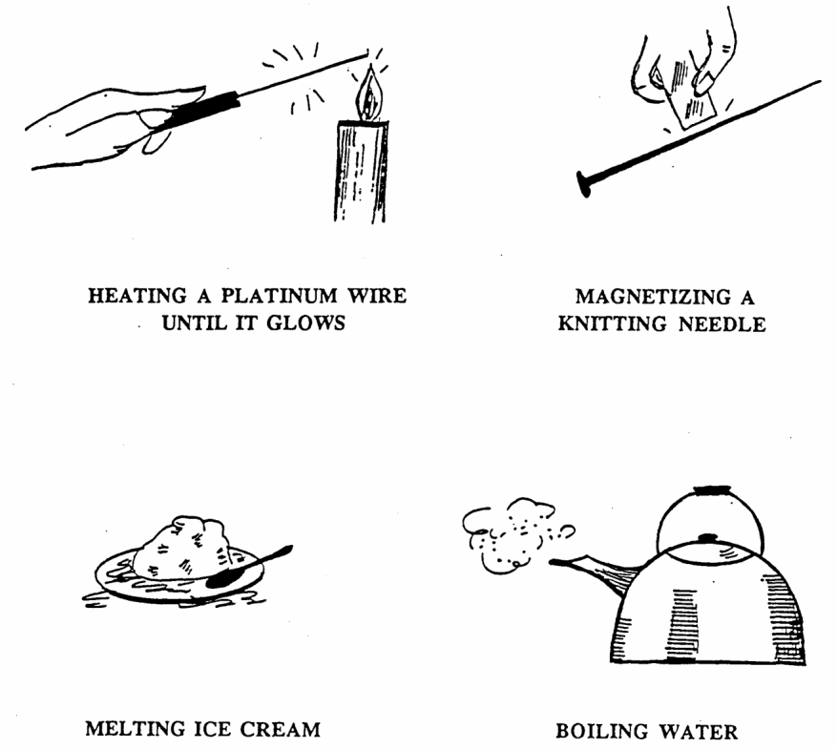

MATTER AND ITS CHANGES 4A2

SOME CHEMICAL CHANGES

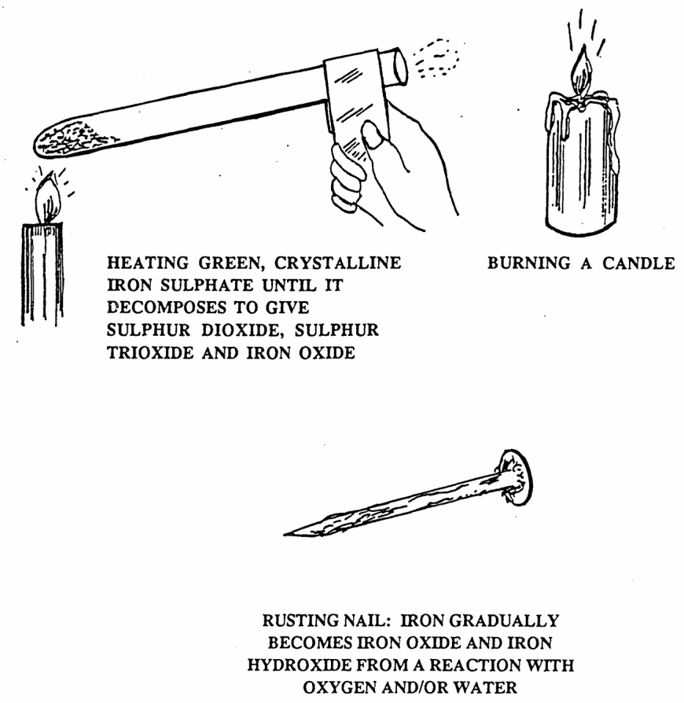

MATTER AND ITS CHANGES 4A3

PHYSICAL OR CHEMICAL?

Different materials and directions apply for each part of this activity. There is no correct sequence for the activity. Parts may be done in any order. In each case, after making observations, determine whether a PHYSICAL change ONLY has occurred or whether a CHEMICAL change has occurred. (If you think a truly NEW substance or substances have formed, then a chemical change (reaction) has occurred. The change is PHYSICAL if NO NEW substance has formed, even though some properties of the original substance have changed).

NOTE: WEAR SAFETY GLASSES DURING ALL PARTS OF TIES ACTIVITY!
__________________________________________________________________________________________________

Use the chart, which is provided, to record observations.

1. Materials: food color water plastic cup or beaker
Add a drop of food color to some water in a cup.

2. Materials: ice cubes plastic cup or beaker
Allow the ice cubes to remain in the cup for 15-20 minutes.

3. Materials: Petri dish, water, potassium iodide (solid, crushed fine), lead nitrate (solid, crushed fine), 2 spoons
Place water in the Petri dish to JUST cover the bottom. Make sure the dish is on a horizontal surface. Add a few crystals of lead nitratae to the dish, at the very edge.

Observe. After 20 seconds, add a few crystals of potassium iodide to the opposite side of the. dish, at the edge. Observe. Continue to observe for several minutes.

4. Materials: white chalk brightly colored chalk mortar and pestle magnifier
Grind a small piece of white chalk and a small piece of brightly colored chalk in a mortar. Remove the solids to a piece of paper and observe through a magnifier.

5. Materials: hydrated iron (Ell) chloride (yellow solid) sodium acetate (colorless solid) 2 clean mortars and pestles
Grind some iron chloride in a clean mortar and grind some sodium acetate in another clean mortar. Be sure to use a different pestle. Then add one solid to the other and grind them together. Observe.

6. Materials: sugar table salt (sodium chloride) Petri dish water’ spoons or spatulas
Follow the same directions as in part 3, using only salt and sugar. Observe.

7. Materials: liquid nitrogen in a Dewer flask small beaker Optional: use a few small chunks of dry ice
Pour some liquid nitrogen from its container into a small beaker. Observe.

8. Materials: alcohol evaporating dish or Pyrex watch glass matches
Place a small amount of alcohol in the bottom of an evaporating dish. Ignite the alcohol. (WARNING: Be sure that the stock bottle of alcohol has been stored away before lighting the match. Do not touch the dish because it gets very hot’)

9. Materials: baking soda (sodium bicarbonate) vinegar (5% acetic acid solution) plastic cup or beaker dropper
Add a few drops of vinegar to some baking soda in a cup. Observe.

10. Materials: steel wool copper sulfate solution test tube plastic or glass stirrer
Push a loose ball of steel wool into a Lest tube, near, but not touching the bottom. Add about 5 mL of copper sulfate solution to cover the steel wool. Observe.

MATTER AND US CHANGES 4A3

PHYSICAL OR CHEMICAL? - 2

11. Optional: (to replace, #3)

Materials: iron (III) chloride (solid)
potassium hexacyanoferrate (11) (solid)
Water
Petri dish
2 spoons or spatulas

Follow the procedure described in #3. Observe.

 | OBSERVATIONS | PHYSICAL OR CHEMICAL?
food color, water
ice
lead nitrate-potassium iodide
white and colored chalk
iron chloride-sodium/acetate
sugar-salt
liquid nitrogen
alcohol
baking soda-vinegar
steel wool-copper sulfate

MATTER AND ITS CHANGES 4A3TN

PHYSICAL OR CHEMICAL?

IDEA: PROCESS SKILLS:

A chemical change produces a new substance with Observe
completely new properties, where as a physical change Control Variables
does not produce a new substance, even though some Compare
properties may change. Interpret

LEVEL: L/U DURATION: 45-60 min.

ADVANCE PREPARATION: Collect all chemicals. Crush solids fine, using a CLEAN, DRY mortar and pestle. Make sure to use separate mortars and pestles for each solid, or, if only one set is available, to thoroughly clean and dry the mortar and pestle between uses.

MANAGEMENT TIPS: It is not necessary to complete all eleven items in order to get a sampling of physical and chemical changes. For example, item #3 and # 11 are similar. However, #4 and #5 should be done because both use the same mixing technique, yet only one results in a chemical change.

Because potassium iodide migrates considerably faster than lead nitrate, the laatter must be placed in the water first. The visible product, lead iodide, should be removed to a waste container for heavy metal compounds, after filtration. It should NOT be discarded in the sink or trash basket.

Copper sulfate solution can be made by dissolving 12 grams of copper sulfate pentahydrate crystals in enough water to make 100 mL of solution. This is sufficient for 20 individual experiments. If any copper sulfate solution remains after the reactions (blue color, visible), add more steel Wool to it. When the solution is pale green or colorless, pour it down the sink after removing the solid, crude copper that was precipitated. The copper may be discarded with solid waste.

RESPONSES TO
SOME QUESTIONS: 1. FOOD COLOR, WATER:
Observation - color swirls appear, water becomes uniformly colored
Type of Change - Physical (mixing, solution forms)

2. ICE:
Observation - ice melts to liquid
Type of Change - Physical (change of state)

3. LEAD NITRATE/POTASSIUM IODINE:
Observation - small, shiny, yellow crystals appear in the middle of the
dish after each solid dissolves and migrates through the water
Type of Change - Chemical (new solid forms), and Physical (original
solids dissolve)

4. WHITE AND COLORED CHALK.
Observation - color appears a paler version of the colored chalk;
. .individual pieces are visible through a magnifier
Type of Change - Physical (mixing)

5. IRON CHLORIDE/SODIUM ACETATE:
Observation - a bright red paste forms from a yellow and a colorless
solid
Type of Change - Chemical (new state; new color)

MATTER AND ITS CHANGES 4A3TN

PHYSICAL OR CHEMICAL? - 2

5. IRON CHLORIDE/SODIUM ACETATE:
Observation - a bright red paste forms from a yellow and a colorless solid
Type of Change - Chemical (new state; new color)

6. SUGAR/SALT.
Observation - solids dissolve in water, water remains colorless
Type of Change - Physical (dissolving)

7. LIQUID NITROGEN:
Observation - nitrogen boils violently; beaker gets extremely cold; frost
appears on the outside of the beaker (ice from moisture in the air)
Type of Change - Physical (change of state)

8. ALCOHOL IGNITING:
Observation - alcohol bums with a pale blue flame which extinguishes when the alcohol is consumed
Type of Change - Chemical (combustion carbon dioxide and water form)

9. BAKING SODA/VINEGAR:
Observation - rapid effervescence; white paste with a vinegar odor remains
Type of Change - Chemical (gas from a solid and liquid)

10. STEEL WOOL/COPPER SULFATE:
Observation - blue copper sulfate solution pales; steel wool turns orange and settles
Type of Change - Chemical (crude copper forms in place of iron)

POINTS TO ENTHASIZE IN
THE SUMMARY DISCUSSION: Both types of changes involve changes in physical properties of matter.
However, chemical changes produce one or more new substances, formerly
not present. Physical changes produce no new substances, just an altered
form of the matter originally present. All changes of state such as melting,
freezing, boiling, condensing, evaporating, and subliming involve physical
changes only. Stearn is still water, as is ice.

Some evidence of true chemical change emerges from experience with
changes in matter. These involve formation of a solid from two liquids;
evolution of gas as evidenced by foaming, bubbling, or effervescing; a
change in temperature (although this may also indicate a physical change);
combustion, flames, sparks, luminescence or other visible energy emitted
from matter.

Often, ease of reversibility is given as a clue to physical change. However, this is a simplistic explanation and can serve to confuse the two types of changes. While melting-freezing are fairly easily reversed and are indeed physical changes, other physical changes are not easily reversed. Crushed chalk cannot easily be reformed to a stick; popped corn cannot be reencapsulated into a kernel, both situations result from physical changes. It is best to emphasize that no new substance results from physical changes rather than site relative caw of reversibility.

It is important to emphasize that not every physical combination results in a chemical reaction, even though interaction between substances occurs. The lack of a reaction between sugar and salt occurs because, although they physically contact each other, there is no combination of the substances.

MATTER AND ITS CHANGES 4A4

PARTICLE VIEW OF A CHEMICAL REACTION

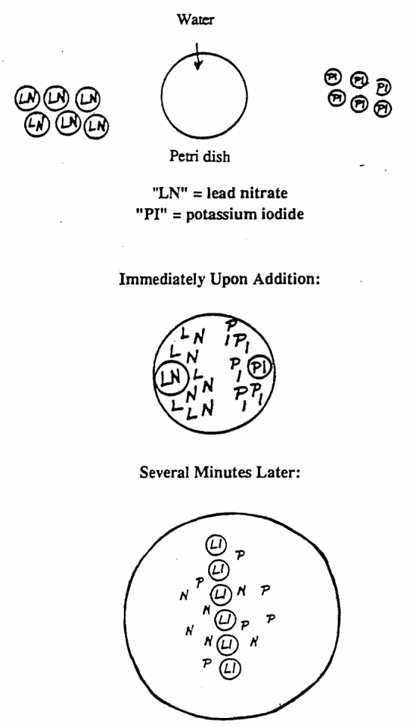

MATTER AND ITS CHANGES 4A4

PARTICLE VIEW OF A CHEMICAL REACTION - 2
DEMONSTRATION:

Do the reaction between lead nitrate and potassium iodide as a demonstration on the overhead projector (from activity 4A3 “Chemical or Physical?”) Invite participants to examine the substances before and immediately upon addition to the Petri dish. Upon addition, as the two solids dissolve. a swirling motion will be visible. Allow this system to stand undisturbed for several minutes while participants continue viewing. A thin yellow line will appear near the middle of the Petri dish and gradually, shiny crystals of lead iodide will be visible.

Discussion should reveal that a chemical reaction has occurred because a solid with different properties from either of the original solids has formed. Use of the accompanying overhead further describes the processes involved. “Before addition” shows solid particles of lead nitrate and potassium iodine, intact, outside the Petri dish. “Immediately upon addition” shows that the solid particles have “dissociated” into individual “L,” “N,” “P,” and “I” particles, with just one each of the “LN” and “Pl” particles not yet dissociated. This models what was observed because solution begins immediately, yet some solid crystals of the original substances are still visible. “Several minutes later” shows formation of a new substance, “LI,” which is the yellow crystalline solid,- lead iodide, that forms. The other “new product,” potassium nitrate, is not visible as it is soluble in water and does not come together as a solid under these conditions. Therefore, the particles of “P” and “N” remain migrating throughout the water. (Water particles are not shown for simplicity, but they are assumed to be present throughout).

MATTER AND ITS CHANGES 4A5

DISCUSSION

Participants should each view the overhead to. determine its intent first, without an explanation. The overhead shows two sets of circles. One implies that all physical changes include or are accompanied by chemical change. The other implies the reverse: that all chemical changes include or are accompanied by physical change. The latter is the correct view because physical changes such as gas formation, spontaneous temperature change, and precipitate formation provide physical evidence for chemical change. On the other hand, a physical change can occur without a chemical change; a change of state alone, while. a physical change does not produce a new substance.

WHICH IS CORRECT?
(Overhead)

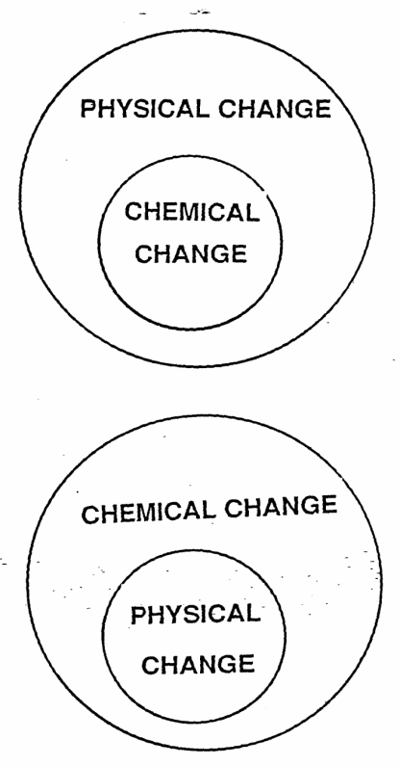

MATTER AND ITS CHANGES 4B1

CHANGES IN MATTER: DOES MASS CHANGE?

Materials: balance
white and colored chalk
mortar and pestle
steel wool
copper sulfate solution
test tube

1. Refer to activity 4A3 “Physical or Chemical?” for procedure and analysis of the two changes.

2. Find the mass of the individual substances before they are combined. That is, find the mass of the two pieces of chalk. Record your findings. Find the mass of the steel wool + copper sulfate solution + test tube. Record your finding.

3. After carrying out the procedures, find the mass of the combinations. (Carefully scrape out all chalk from the mortar and pestle before finding the mass).

 | Initial Mass | Final Mass | Mass Change
Chalk, white
Chalk, colored
Steel Wool/Copper Sulfate

4. What type of changes were involved?
______________________________________________________________________________________________
______________________________________________________________________________________________

Did the mass change as a result of these changes?
______________________________________________________________________________________________
MATTER AND ITS CHANGES 4B1TN

CHANGES IN MATTER: DOES MASS CHANGE?

IDEA: PROCESS SKILLS:
In both physical and chemical changes, Observe
mass does not change. (Law of Measure
Conservation of Mauer and Energy). Record
Infer

LEVEL: L/U DURATION: 20 min.

STUDENT BACKGROUND: Ideally, this activity should be done in conjunction with activity 4a3
“Physical or Chemical?” Participants will likely be familiar with the
Law of Conservation of Matter and Energy. This activity may serve as
a reminder or as a reinforcement of that law
.
ADVANCE PREPARATION: Refer to Activity 4A3
.
MANAGEMENT TIPS: Refer to Activity 4A3.

RESPONSES TO
SOME QUESTIONS: 4. Ground chalk results from a physical change; steel wool and copper sulfate produces a crude form of copper and an iron sulfate solution; a chemical change has occurred. Any change in mass is negligible and within limits of precision of a balance. Whether a physical or a chemical change occurs, mass does not change, providing nothing is lost or removed.

MATTER AND ITS CHANGES 4B2

CHANGES IN MATTER: WHAT ENERGY IS INVOLVED?

Materials: same as activity 4A3, “Physical or Chemical?”

1 . Follow the procedure for Activity 4A3 “Physical or Chemical?”

2. As you do each part of the activity, deciding on whether the change is physical or chemical, consider if any energy is involved. Some types of energy to consider are mechanical, thermal, electrical, light, sound, or “kinetic energy.”

3. In which changes were you able to detect or employ energy?
______________________________________________________________________________________________
______________________________________________________________________________________________
What types of energy were involved?
______________________________________________________________________________________________
______________________________________________________________________________________________
4. From your observations, what can you infer about energy and changes in matter?
______________________________________________________________________________________________
______________________________________________________________________________________________
MATTER AND ITS CHANGES 4B2TN

CHANGES IN MATTER: WHAT ENERGY IS INVOLVED?

IDEA: PROCESS SKILLS:
Energy is involved in both physical and Observe
chemical changes. (Sometimes the Classify
energy changes are not detectable by Compare
the senses). Record

LEVEL: U DURATION: 45 min.

STUDENTBACKGROUND: Participants may already be familiar -with the Law of Conservation of
matter and energy. This activity connects the law with physical and
chemical changes in matter.

ADVANCE PREPARATION: Refer to Activity 4A3.

MANAGEMENT TIPS: Refer to Activity 4A3.

RESPONSES TO
SOME QUESTIONS: 3. Some type of energy is detectable in most of the changes.
Mechanical energy or kinetic energy are evidenced in all changes
where either mixing, grinding or migration of substances occurs
(#1, #3, #4, #5, #6). Thermal energy is obvious in changes of
state or combustion (#2, #7, #8). Sound energy is evident in #9
and #7. #10 should produce heat, but the change is subtle due to
the quantities used. Light energy is visible in #8.

4. Changes in matter, whether physical or chemical, are accompanied
by energy transfer or production.

MATTER AND ITS CHANGES 4B3

HEAT TRANSFER IN PHYSICAL CHANGES

Materials: ammonium nitrate or sodium thiosulfate
calcium chloride
alcohol
2 test tubes and corks
matches
water, room temperature

When heat is given off to the environment in a physical or chemical change, that change is called exothermic. When heat is absorbed from the environment in a physical or chemical change, that change is called endothermic. in this activity, two physical changes are examined.

1 . Half-fill two test tubes with water that has been allowed to come to room temperature. Feel the tubes.

2. To the first tube, add enough ammonium nitrate (or sodium thiosulfate) to raise the water level about 3/4 of the way up the tube. Cork and shake the tube to dissolve the solid, Feel the tube during the dissolving process.

3. To the second tube, add enough calcium chloride to raise the water level about 3/4 of the way up the tube. Cork and shake the tube to dissolve the solid. Feel the tube during the dissolving process.

4. a. Which was an exothermic physical change (gave off energy?)
___________________________________________________________________________________________

b. Which was an endothermic physical change (absorbed energy?)
___________________________________________________________________________________________
5. a. Dab some alcohol on your arm and blow on it. Is heat energy given off to your arm or absorbed from your arm? EXPLAIN.
___________________________________________________________________________________________
___________________________________________________________________________________________
b. Is evaporation an exothermic or an endothermic physical process? EXPLAIN.
___________________________________________________________________________________________
___________________________________________________________________________________________
MATTER AND ITS CHANGES 4B3TN

HEAT TRANSFER IN PHYSICAL CHANGES

IDEA: PROCESS SKILLS:
Observe
Explain

LEVEL: LIU DURATION: 20 min.

ADVANCE PREPARATION: Assemble the materials (sodium thiosulfate can be bought as a photographic fixer - “hypo”).

MANAGEMENT TIPS: Do not spill ammonium nitrate solution o-n skin. Rinse solutions down the drain.

RESPONSES TO
SOME QUESTIONS: 4. a. Calcium chloride releases heat as it dissolves (exothermic). The test tube feels warm.

b. Ammonium nitrate (or sodium thiosulfate) absorbs heat from the surroundings as it dissolves (endothermic). The test tube feels cold.

5. b. Evaporation is an endothermic process. Heat energy (from the body, in this case) is absorbed by the liquid alcohol in order to convert to gas. Hence, the body (skin) feels cool.

POINTS TO EMPHASIZE IN
THE SUMMARY DISCUSSION: Most physical changes do not involve such apparent energy changes. These were chosen to emphasize that energy is involved in all physical changes.

POSSIBLE EXTENSIONS: Discuss the use of “cold packs” for minor athletic injuries. Most contain materials that, when mixed, absorb heat from the body part to which the pack is applied.

MATTER AND ITS CHANGES 4B4

IS THERE AN ENERGY CHANGE IN CHEMICAL REACTIONS?

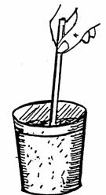Materials: 1 paper cup plaster of paris
I stirring rod vinegar (acetic acid)
2 beakers, 150 ml bromthymol blue
3 Styrofoam cups per team household ammonia
I balance and masses (ammonium hydroxide)
I dropper water/distilled water
I graduated cylinder, 100 mL epsom salts
1 pr. of safety glasses (magnesium sulfate)
I thermometer
(10ºC to 110ºC)
baking soda (sodium bicarbonate)
washing soda (sodium carbonate)
teaspoon

Part 1: (Wear safety glasses)

1. Fill a paper cup about half full with dry plaster of paris. Fill a beaker half full of room temperature water. Feel the outside of the cup and the outside of the beaker.

2. Add the water to the plaster of paris and stir. Feel the outside of the cup while you stir and while the plaster hardens. Describe.
_______________________________________________________________________________________________
_______________________________________________________________________________________________
3. Has a chemical change occurred?
_______________________________________________________________________________________________
4. What energy change occurred when the plaster and water were mixed?
_______________________________________________________________________________________________
Part 2:

1. Pour 50 ml of ammonia into a Styrofoam cup. Add 5 drops of bromthymol blue to the ammonia. Record the color in Table 1.

2. Pour 50 ml of vinegar into a beaker. Record its color.

3. Measure the temperature of the ammonia and Record it in Table 1. Clean and dry the thermometer.

4. Measure the temperature of the vinegar and record it in Table 1.

5. Add the vinegar to the ammonia and stir. Measure and record the temperature and color.

Table 1 | Substance | Temperature ºC | Color
 | Ammonia
 | Vinegar
 | Combination

What evidence is there that a chemical change took place?
_______________________________________________________________________________________________
_______________________________________________________________________________________________

MATTER AND ITS CHANGES 4B4

IS THERE AN ENERGY CHANGE IN CHEMICAL REACTIONS? - 2

Part 3:

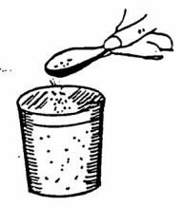
1. Put about 150 ml of distilled water into a styrofoam cup. Measure the temperature of the water. Record it in the Table.

2. Put a level teaspoon of baking soda into the water. Stir with a stirring rod. Measure and record any change in temperature.

3. Now, add 1 teaspoon of baking soda to the water. Record the temperature. Add another teaspoon of baking soda to the water and record the temperature. Add a third teaspoon of baking soda to the water and record the temperature.

Table 2 | Substance | Temperature, ºC
 | distilled water
 | distilled water + 1 teaspoon baking soda
 | + 2 teaspoons baking soda
 | + 3 teaspoons baking soda
 | + 4 teaspoons baking soda

What evidence is there that a chemical change took place?
_______________________________________________________________________________________________

Part 4:

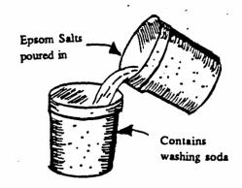1. Add 50 mL of water to each of 2 styrofoarm cups.

2. Add 10 g of washing soda to one. Add 10 g of epsom salts to the other. Stir the contents of each. Let both stand for 5 minutes.

3. Measure the temperature of each solution. Record the temperature.

4. Add the epsom salts to the washing-soda solution. Stir the mixture. Record the temperature of the combination.

Table 3 | Substance | Temperature, ºC
 | Washing-soda solution
 | Epson-salts solution
 | Combination

What evidence is there that a chemical change took place?
_______________________________________________________________________________________________
_______________________________________________________________________________________________
Was any energy involved in that change? Give evidence to support your answer.
_______________________________________________________________________________________________
_______________________________________________________________________________________________

MATTER AND ITS CHANGES 4B4TN

IS THERE AN ENERGY CHANGE IN CHEMICAL REACTIONS?

IDEA: PROCESS SKILLS:
Whether a change is chemical or physical, Observing
there is always some energy change Inferring
involved. Measuring

LEVEL: U DURATION: 50 Min.

STUDENT BACKGROUND: Students should be able to distinguish between chemical and
physical changes, and should be able to read a thermometer.

ADVANCE PREPARATION: Have a gallon of tap water set aside so that it will be at room
temperature.

MANAGEMENT TIPS: Breathing in ammonia fumes can be dangerous.

Have students remove stirring rods from the plaster before it hardens.
In the ammonia and vinegar activity, the temperature changes
are small.

Do not pour the plaster of paris down the drains. Discard with
solid wastes.
RESPONSES TO
SOME QUESTIONS: Part 1
2. After the water is added to the plaster of paris, the cup feels
warm. The cup becomes hot as the mixture is stirred.
3. Yes.
4. Yes, heat was generated

Part 2 Table I

Substance Temp.
Ammonia room temp. blue
Vinegar room temp. colorless
Combination temp. rise pale green

A chemical change took place because the temperature rose and the solution changed color.

Part 3 Table 2

Substance Temp.
distilled water room temp.
dis. water+1 tsp. baking soda variable temp.
dis. water+-2 tsp. baking soda should drop
dis. water+3 tsp. baking soda 1 or 2ºC with every addition
dis. water+4 tsp. baking soda same as above

A chemical change took place because the temperature changed.
MATTER AND ITS CHANGES 4B4TN

IS THERE AN ENERGY CHANGE IN CHEMICAL REACTIONS? - 2

Part 4 Table 3

Substance Temp.
washing-soda solution room temp.
epsom-salts solution slightly below room temp.
combination temp. should fall

A chemical change took place because the mixture got cooler. Yes, energy was involved in the change because the temperature dropped. Heat energy was absorbed.

POINTS TO EMPHASIZE IN
THE SUMMARY DISCUSSION: Energy is involved in all chemical changes, even if it is hard to detect.

POSSIBLE EXTENSIONS: Discuss the formation of a gas and the formation of a precipitate as additional evidences of chemical change.

MATTER AND ITS CHANGES 4C1F

FOCUS ON PHYSICS
CHANGES IN MATTER

Any change of matter that results in a change of physical properties, such as shape, size, form or appearance is called a physical change. A physical change in matter does not produce a new substance: that is, no change in the chemical makeup of the substance takes place. The most common physical changes are changes in state.

When matter undergoes a chemical change, a new substance having new properties results. Its chemical composition differs from the original substance. Chemical changes are always accompanied by physical changes, usually involving the release or absorption of heat, light, or electricity, and can sometimes be recognized by the presence of bubbles, a color change, or precipitate (solid) formation.

Energy is either added (transferred) or given off (transferred) in any physical or chemical change. When a change in matter results in the release of energy, causing an increase in temperature, it is called an exothermic change. Changes in which energy is absorbed (temperature decreases) and which require the continuous addition of energy in order to proceed are called endothermic changes.

Matter and energy can be changed from one form to another, but neither can be created or destroyed. This is the Law of Conservation or Matter and Energy: matter can be changed into energy, but the total amount of matter and energy always stays the same, in all changes.

OOBLECK, GLURCH, and SLIME

Activity adapted from OPERATION PHYSICS and OPERATION CHEMISTRY
by
Dr. Doris Simonis
Kent State University Kent OH 442420

Introduction:

Textbooks say that matter exists in three states: solid, liquid, and gas. However, there are many materials that do not fit neatly into these categories.

Colloids, for example, have one or more substances suspended in another. The suspended materials are so small that they do not sink or settle out of the mixture. And they affect the properties of the “host” material so that together, the materials display properties unlike those of the separate components. Some examples of colloids or materials which have one or more ingredients “floating” in another are:

mayonnaise smoke fog
homogenized milk Jello oobleck

Polymers are complex organic compounds made from different, less complicated substances. The word comes from the Greek language and means “many parts”. Polymers are usually:
easy to clean
strong
don’t rot or rust
re-usable: moulded and hardened over and over
colored
difficult to break down

Some examples of substances that can be called polymers are:
Plastics
nylon s
ynthetic rubber
fluorescent paint
glurch

TODAY you have had a chance to play with two interesting substances, oobleck and glurch. If you want to experiment more with them at home, try to answer some of these questions:

- What happens to glurch if it is left out (uncovered) overnight?

- What happens to oobleck if it is left out overnight?

- What happens if you change the-recipe for oobleck?

(Hints: use more water, or less; use Jello water instead of tap water; use flour instead of cornstarch; use spackling plaster (dry powder) instead of cornstarch; use baby powder and water.)

- What happens if you refrigerate glurch and oobleck overnight?

- What happens if you drop a ball of glurch and a ball of oobleck into a pan of boiling water to “cook” for five minutes?

- Can you make two glurches, one that tears and one that stretches when pulled apart? (Hint: this means you will probably change the recipe in some way.)

OOBLECK, GLURCH, and SLIME - 2

RECIPES:

Glurch: 4 T. liquid laundry starch
2 T. Elmer’s White Glue (Black Label)
1/4 t. salt

Pour starch into a cup. Add salt & stir until dissolved. Add white glue & stir about 30 strokes. Pick up resulting glob, leaving excess starch behind. Knead into a ball.

If glurch seems too runny, sprinkle in a little more salt. Chilling it overnight in a plastic bag makes it more pliable and resililent without stickiness.

If you want slime, use the same recipe WITHOUT ANY SALT.

Oobleck: 4 T. cornstarch
2 T. cold water
drop of food coloring (optional)

Pour water into a cup. Add cornstarch a little at a time while stirring. Remove from cup and knead.

Arbor Scientific

HAPPY AND UNHAPPY BALLS P6-1000

Happy and Unhappy balls are a pair of black spheres which appear to be almost identical: The “unhappy” ball is formed from a proprietary rubber compound developed and manufactured under the trade name “Norsorex”, while the “happy” ball is made of conventional neoprene rubber. Although the two balls appear to be quite similar, they exhibit marked differences in their physical properties:

Physical Properties

Low vs. High Hysteresis: Hysteresis is a measure of the retardation of the natural tendency of rubber to return to its original shape after deformation. This retardation is caused by intemal frictional forces resulting from the molecular structure of the rubber. The dead or “unhappy” ball exhibits the greatest hysteresis.

Rate of Restitution: The ball with low hysteresis (the “happy” ball) exhibits a more rapid return to its original shape, resulting in its greater bounce (it has a high coefficient of restitution). Paradoxically, as the balls are cooled below room temperature, the bounce of the “happy” ball is diminished somewhat while that of the dead ball increases. Figure I shows the changes in the energy absorption rate of Norsorex, with changes in temperature.

Coefficient of Friction: The molecular structure of the two types WE rubber is also responsible for discrepant qualities in the surface friction of the balls. The “happy” ball exhibits lower surface friction and rolls more rapidly’ than the dead ball.

Suggested Experiments

Challenge your students to perform the following experiments and come up with logical explanations for the observed events.

(1) A Rolling Ball Gathers Momentum

Set up an inclined plane at least one meter in length (a table tilted 15-20 degrees by books propped under the legs will suffice) and roll both balls simultaneously from the same starting point. Note which ball reaches the end of the incline first. Does it do so consistently? What clues does this provide about the friction of the balls relative to the surface and in comparison with each other? The “unhappy” ball, of course, because of its higher coefficient of friction, rolls more slowly. It is this friction which makes rubber of this type very desirable for racing tires where road adhesion is required at high speeds. Too much friction, however, will cause heat build-up and excessive tire wear, so this property must be balanced by blending high-friction rubber with a more firmly vulcanized rubber.

(2) Sphere of Flying

Drop both balls onto a hard surface from a fixed height and determine the height of their first bounce (if any). Place both balls in a container of ice or a freezer for about twenty minutes and repeat your measurements. What differences are observed? Why does the dead ball bounce? Would you think that the dead property of the rubber is temperature dependent? Why? Explain any observed differences in the behavior of the “happy” ball.

(3) The Chiller Instinct

Determine the rate at which each ball returns to shape after being compressed by a vise or heavy tongs. Chill the balls as before, then repeat. Am there differences in the rate at which the balls return to shape?

Restitution is the “desire” of a substance to return to its original shape, almost a molecular memory of its original form. The dead ball has a very low coefficient of restitution, the other ball a high coefficient; each property can have practical benefits. In running shoes, for example, the superior ability of a “dead” rubber to absorb shocks helps to alleviate the tremendous pounding to which the foot, leg, and ankle art subjected. A rubber with a high coefficient of restitution - that is, one with a lot of bounce - would be ideal for handballs or other applications. Ask your students to think of practical uses for both types of rubber. They might surprise you with their creative answers.

Arbor Scientific

HAPPY AND UNHAPPY BALLS - 2 P6-1000

Chemical Formulation:

Figure 2 outlines the primary steps in the formation of Norsorex. First, ethylene cyclopentadiene is converted to the monomer norbornene via the Diel’s-Alder’s reaction, then the monomer is polymerized by a process which opens the norbornene ring, creating alternating bonds between the five-member ring and the newly-exposed double bonds. This polymerization process means that vulcanization can be done utilizing the double bond.

Arbor Scientific P.O.Box 2750 Ann Arbor, MI 48106-2750
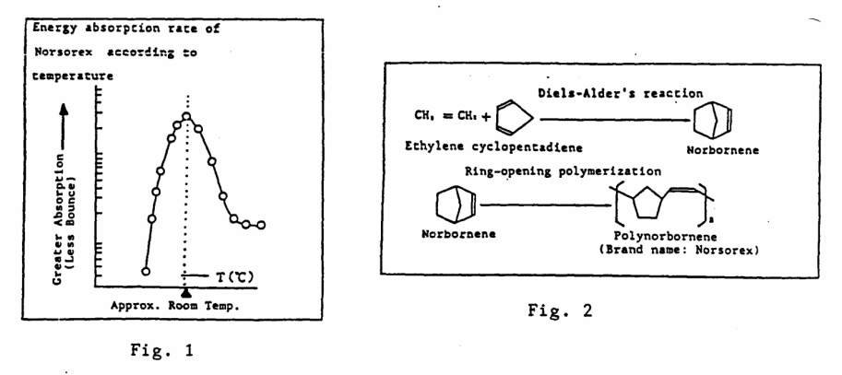

Questions? Call toll-free 1-80-367-6695 In Michigan: (313) 663-3733

BLACK BOXES

MYSTERY BOXES

MODELS FOR SCIENCE TEACHING

Dr. Doris G. Simonis, Kent State University

There are many kinds of “black boxes” f or sharpening children’s observational skills and to model the indirect methods by which we probe the Universe with technology and with our minds.

Two of the activities-suggested in this packet are from OPERATION PHYSICS, Developing a Model and Probing Matter. A third suggestion is from Alan McCormack who uses a siphon hidden inside a box to “generate water.: (See sketches.)

The fourth model is one I used with you, the one I do not like to open! I want it to model problems for which there is no assurance that we are mirroring reality. At a very basic level, it can be used as a vocabulary builder. Ask for observations but recognize and categorize inferences or assumptions and models as they are suggested by your students. No introduction is necessary for this kind of activity. Use the learning cycle approach: exploration of some unfamiliar activity concept building based on students’ own observations and data collection and application or extensions.

Note that I do not use a typical sponge. I use unflavored, uncolored gelatin in one internal funnel and some flavor of Jello in the other. The filter paper itself does not retard the flow of water, but it does prevent the gelatin and sugar from running down the tubes where it can gel/crystallize. and really plug up the works. (I’ve done that!)

Many variations are possible, as the models you developed suggest. Exactly how your box works and what is inside is not the important point. You use this as an analogy to the problem of explaining systems that are too big, too small, or too remote to examine directly.

Challenge your students to make their own “black boxes” from shoe boxes, cereal or rice cartons, or any small cardboard
boxes. Note suggestions on teacher’s notes for Developing a Model, p. 82. Kids will think of many more variations if
you give them the opportunity. Let them exchange boxes with classmates and try to develop a descriptive list/sketches of
the properties of the “unknown” contents to be explored.

BLACK BOXES

MYSTERY BOXES

MODELS FOR SCIENCE TEACHING - 2

MATERIALS:

2 pieces of plywood 8” x 24” x .75” (sides, including “legs”) ($4.00)
2 pieces of plywood 16” x 16” x .75” (back, one cut in half for doors) ($8.00)
2 pieces of plywood 7.5” x 15” x .75” (shelves) ($3.50)
1 piece of plywood 8” x 16” x .75” (top) ($2.00)
4 “surface mount” door hinges for doors ($8.00)
1 door clasp ($2.50)
1 padlock ($3.00)
3 funnels ($3.50)
6’ plastic tubing ($3.50)
“T” joint for plastic tubing ($1.00)
Finishing nails ($1.00)
2 round sponges ($2.00) (Costs rounded off) 1993 prices

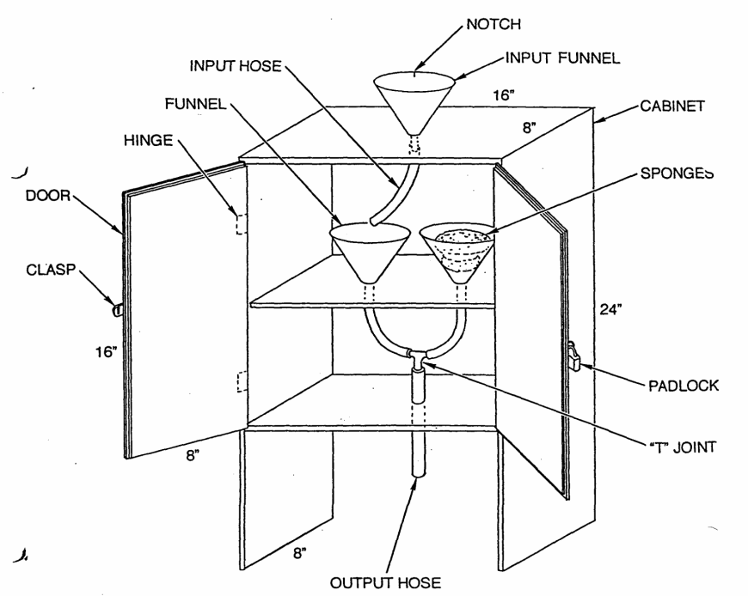

Imagineering

Imagineering is a model of teaching developed by Alan J. McCormack and is designed to encourage visual and* spatial thinking.⁴⁰ McCormack explains that imagineering is the result of fusing parts of the words “imagination” and “engineering.” Imagineering is designed to apply existing scientific knowledge to visualizing solutions to challenging problems. McCormack, who is well known for his presentations at local, state, and national science teacher meetings, advocates the use of teacher demonstrations to set the stage for imagineering. He has designed an array of imagineering activities that can be used in any science curriculum.⁴¹ Here is one example, called the water-expanding machine (Figure 7.26), and this is how McCormack explains the use of this device in an imagineering lesson:

This device is a cardboard box with an input funnel located on its top and an output tube that extends through one of its sides. The teacher states that this great new invention can expand by three times any volume of water that is poured into the funnel to be “processed’ by the device. An actual demonstration follows: 500 mL of water is poured into the machine and 1500 mL flows from the output tube. Teacher asks the key question that already puzzles everyone: “Has water actually been expanded?’ Few students believe that it has, so they are challenged to draw an ‘imagineering blueprint- of what might be inside the machine that could account for the apparent volume expansion of the water. Later ideas are presented, compared, and criticized. Invariably, a number of good, plausible explanations have been invented. Meanwhile, youngsters have honed both visualization and creative problem-solving skills.42

⁴⁰ AIan J. McCormack, Vbual/Spatial Thinking: An Essential Element of Elementary School Science (Washington, D.C.: Council for Elementary Science International, Monograph and Occasional Paper Series, 1988).

⁴¹ For further examples of imagineering, see Alan J. McCormack, Inventors Workshop (Belmont, Calif.: David Lake, 1981).

⁴² AIan J. McCormack, Visual/spatial Thinking: An Essential Element of Elementary School Science (Washington, D.C.: Council for Elementary Science International, Monograph and Occasional Paper Series, 1988). pp. 23-24.
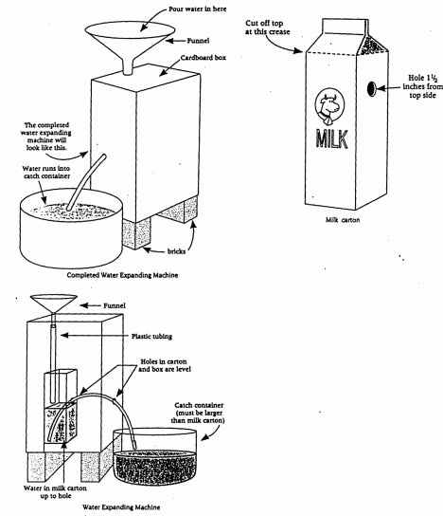

FIGURE7.26 The McCormack Water Expanding Machine. Man 1. McCormack. inventors Workshop. Eden Prairie, MN: Fearon Teacher Aids. 198 1. pp. 14-15. Used with permission of the publisher.

CIRCUIT ENERGY RACE
by
GLORIA D. SMITH - Operation Physics Teacher
Amherst Elementary School
Massillon, Oh

OBJECTIVE: To explain that a series circuit and a parallel circuit use the energy produced by a battery at a different rate

INTENDED AUDIENCE: This is suitable for upper elementary or middle school students.

PRESENTATION: This would be suitable as a class presentation.

MATERIALS: Posterboard cut outs of:
4 light bulbs (approx. 14” x 22”)
1 battery
A clothes line or ball of twine,
one box of graham crackers,
cinnamon crisp or any cracker divided into four sections.

This role play would be used after the students have had hands on experience making series and parallel circuits. They would also have created open and closed circuits by adding a switch to a series circuit.

TIM REQUIRED: 30 to 40 minutes.

PROCEDURE: Use one packet of the crackers to represent the power or energy in the battery. One student will play the-part of the battery. The poster board cut out of the batte ry can be held by the student or hung around
his neck. He will distribute the crackers to students who will be playing the part of electrons. Their role will be to move through the circuit by walking on the clothesline which will represent the wire. As the electron meets a student playing the role of a bulb he will drop off his load of energy and continue around the circuit to pick up another load of energy (cracker) at the battery. If only one bulb is in the circuit the electron will deliver one whole cracker to the bulb. If there are two or more bulbs in the circuit, the energy (crackers) will be used at a faster rate. Ask what the students noticed. They should become aware of the fact that energy is used faster by a parallel circuit than a series circuit.

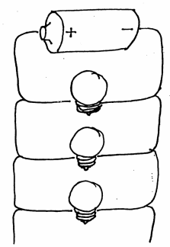I made my bulbs with white poster board on one side and yellow poster board on the other side. This way the students holding the bulbs could turn the bulb to the yellow side to show when the bulb was “on” and to the white side when it was off. I have also used this arrangement to review which parts of the circuit are the users (bulbs), the path (the wire or the twine), and the source of the power (the battery). I have poster board labels made for the student to place on the correct parts. If you use a yardstick attached to the twine or rope, you can also demonstrate an open and closed circuit by using the yardstick as a gate.

When the gate or switch is open, the students playing the game must remain stationary as the electrons can’t move through the circuit or wire (open circuit), When the gate or switch is closed, the students playing the electrons can move through the circuit or wire (closed circuit).

My students really enjoy this role playing of scientific concepts and are able to remember and apply their knowledge much better after participating in them. Hearing them discuss these concepts in such a knowledgable way as they leave the room really makes me feel good.

PETALS AROUND A ROSE

This is a game which illustrates some aspects of the process a scientist goes through when he develops a hypothesis to explain data. To begin the game, your leader will roll 5 dice and will tell you for each roll how many petals around the rose are showing. The procedure will be repeated as often as necessary for you to discover the rule which determines the number of petals showing on a roll. The same rule will work for any number of dice. Some examples of 4 dice are shown below.

Directions: 1. The name of the game tells you what the rule is.
2. No one is EVER told what the rule is; everyone must discover the rule for themselves.

During the play of the game, if you have a conjecture about what the rule is, let your leader know. Do NOT tell him what your conjecture is. The instructor will allow you to test your conjecture by letting you roll the dice and stating the number of petals around the rose. Once you have a conjecture that consistently gives the correct number of petals, then you have won the game. Remember Direction 2 above!!! Do NOT tell anyone else the rule. Let them win by themselves.

Questions: 1. How did your thinking change as you obtained more and more information and experience?
2. What errors persisted in spite of your best efforts?
3. When and what made order out of confusion?
4. What would have made the game easier? harder?

EXAMPLES

 | 0 |  | 0 0  0 0  0 0 |  | 0 0  0  0 0 |  | 0  0  0 |  | 0  0 |  | 0 0  0 0 |  | 0 0  0 0  0 0 |  | 0  0  0
6 petals are showing 2 petals are showing

 | 0 0  0  0 0 |  | 0 |  | 0  0  0 |  | 0 0  0  0 0 |  | 0 0  0 0 |  | 0  0  0 |  | 0  0 |  | 0  0
10 petals are showing 2 petals are showing

 | 0 0  0 0 |  | 0  0 |  | 0 0  0 0 |  | 0 0  0 0  0 0 |  | 0 0  0  0 0 |  | 0 |  | 0 0  0 0 |  | 0  0
0 petals are showing 4 petals are showing

 | 0  0 |  | 0  0 |  | 0  0  0 |  | 0  0  0 |  | 0 0  0  0 0 |  | 0 0  0 0  0 0 |  | 0 |  | 0 0  0  0 0
4 petals are showing 8 petals are showing

Baric Sense Set
By
Dick Heckathorn

Students for a part of their life are unable to comprehend density and are thus unable to properly associate mass with size. Thus given objects of the same size, they will say that they have the same mass. Further, if the objects are of different size, they will say that they have different masses. The following apparatus will offer evidence to begin to reshape their thinking and/or understanding.

Construction: Objects of the same size but with different mass.
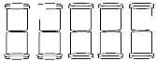
10 35 mm black film canisters with lids
5 ½ inch, #6 machine screws
5 #6 nuts
- #6 washers
roll of black friction tape
drill, 5/16 inch bit
265 pennies

- Drill holes in the center of the bottom of the 10 film canisters.
- Fasten the bottom of the two film canisters together using the machine screw, two washers and a nut.
- Add masses to the cans to make masses of 50, 100, 150, 200 and 250 grams. (Include the two lids and tape.) If using pennies, need approximately 13, 33, 53, 73 and 93.
- Close the end canisters with lids.
- Using friction tape, run two strands around the canisters from end to end to keep the lids on. (The tape adds approximately 2.5 grams to the mass of the film canisters.)

Construction: Objects of the same mass but different sizes.
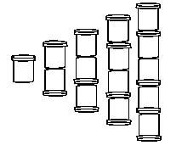
- 35 mm black film canisters with lids
10 ½ inch, #6 machine screws
10 #6 nuts
- #6 washers
pennies

- Drill holes in the center of 6 lids and 14 film canisters.
- Fasten the bottom of 2 film canisters using a bolt, nut and two washers. (Make 4 sets.)
- Fasten a lid to the bottom of a film canister using a bolt, nut and two washers. Make sure the lid is positioned so that another film canister will go into it. (Make 6 sets.)
- Puts the lids and film canisters together as shown to the right.
- Add mass until they all are the same mass. Suggestion 100 grams.
- Using friction tape, run two strands around the canisters from end to end to keep the lids on. (The tape adds various amounts of mass to the film canisters.)

Usage

- Place the objects with different sizes so that the students can see them. Ask, “Which has the greater mass?” Solicit explanation(s) as to why they gave the answer they did.
- Once discussion has ended, have a student lift the different combination of film canisters and place them in the order from…..
- Repeat using objects of same size.
Chapter 1: About Science Inquiry Method

Activity 1: Making Hypotheses

Purpose

To practice using observations to make hypotheses.

Required Equipment/Supplies

(2) 1-gallon metal cans, (2) 2-hole #5 stoppers, glass funnel or thistle tube, glass tubing, rubber tubing, 500-mL beaker

Discussion
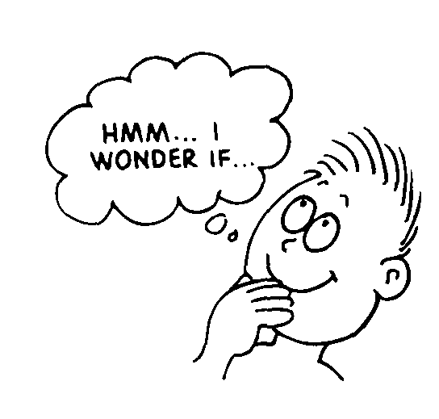
Science involves asking questions, probing for answers, and inventing simple sets of rules to relate a wide range of observations. Intuition and inspiration come into science, but they are, in the end, part of a systematic process. Science rests on observations. These lead to educated guesses, or hypotheses. A hypothesis leads to predictions, which can then be tested. The final step is the formulation of a theory that ties together hypotheses, predictions, and test results. The theory, if it is a good one, will suggest new questions. Then the cycle begins again. Sometimes this process is brief, and a successful theory that explains existing data and makes useful predictions is developed quickly. More often, success takes months or years to achieve. Scientists must be patient people!

Procedure

Step 1: Observe the operation of the mystery apparatus (shown in Figure A) set up by your teacher.

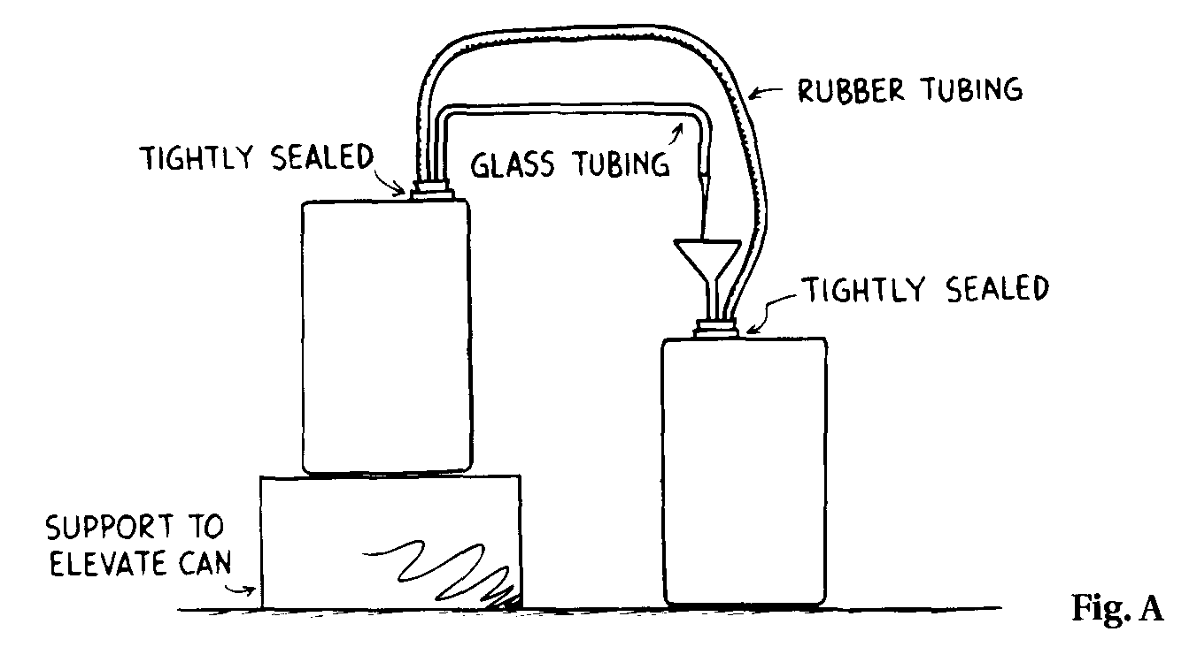

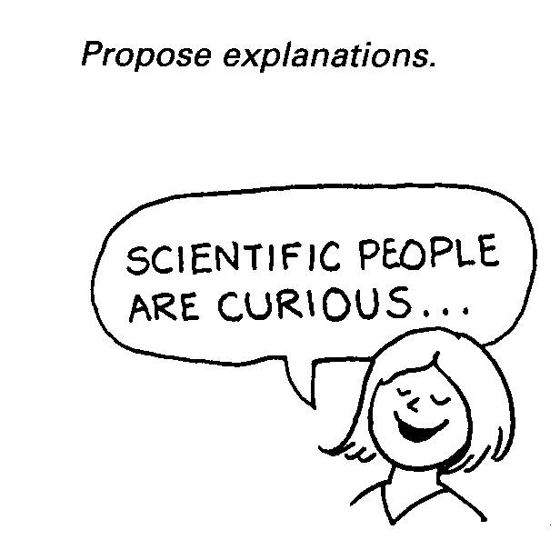

Step 2: Attempt to explain what is happening in the mystery apparatus and how it works. Write a description of how you think it works.
__________________________________________________________________________________________________
__________________________________________________________________________________________________
__________________________________________________________________________________________________

Step 3: Report your findings to the rest of the class. The class should reach a consensus about how it works. Record the consensus here.
__________________________________________________________________________________________________
__________________________________________________________________________________________________
__________________________________________________________________________________________________
From Lab Manual of Conceptual Physics Addison Wesley Publishing Company, Inc.

Chapter 1: About Science Inquiry Method

Activity 1: Making Hypotheses - 2

1. Since atoms cannot be observed directly, physicists base their model of atomic structure on data collected through experimentation. Inferences are made that best describe the atom in terms of available data. The model of the atom has been changed and refined over the years as more information is collected. This lab encourages students to make inferences that allow them to construct a model of a system that they cannot view internally.

2. Fill the elevated can nearly to the top with water. Can B should have about 2 cm of water in it. Pour water from the beaker into the funnel (or thistle tube). The water level in Can B will rise, creating unequal air pressure in the two cans. Air flowing from Can B to Can A in the rubber tubing increases the air pressure on the surface of the water in Can A. Water is forced through the tubing and fountain, creating a siphon effect.

3. Have the apparatus set up before students come to class. When class starts, pour the water into the funnel to start the siphoning action.

4. Encourage students to ask questions about the setup, such as "Is the liquid water?" or "is there an electric pump?" but don't disclose the operation of the system. After a few minutes, encourage the students to sketch what they think the insides of the cans look like. Encourage creativity in the explanations they offer. When the students finally agree on an explanation that is feasible, put the apparatus away. Don't let them look at it. Explain that this is how physicists infer models that explain things they can't actually investigate further.



