Simple Machines, Work and Power

For Students of Baldwin Wallace College

Spring Semester 2008

Monday – Wednesday
10:00 – 11:15 am
Room 6
Wilker Hall

Faculty

Richard Heckathorn

This manual was the result of scanning, formatting and editing
by
Richard D. Heckathorn

14665 Pawnee Trail
Middleburg Hts, OH 44130-6635

440-826-0834

from

OPERATION PHYSICS, a program to improve physics teaching' and learning, in upper elementary and middle schools, Is funded by the National Science Foundation, Grant #TEI-8751216.
SIMPLE MACHINES, WORK AND POWER INTRODUCTION

WORKSHOP LEADER TOPIC INFORMATION
SIMPLE MACHINES, WORK AND POWER

This unit focuses on the topics Simple Machines, Work and Power. The topic of energy could be incorporated into each of these topics. Instead, the authors of this unit have focused on the visible, manipulatable elements of these topics. Only in the last section of the unit are energy changes in a system discussed.

The materials in the unit vary in the degree of quantification required. The materials developers felt that relative quantities would be appropriate for the lower grades, while more formal quantitative measurements should be used in the upper grades. All levels should learn that it is possible to describe observations through the use of measurements. The unit does not include extensive discussion of which measurement units should be used. Some textbooks use English units (e.g., ft., lb.) while other use metric (eg.- Newton, joule). The choice of units may be best be governed by the nature of the materials used and the scope of the local curriculum.

The language used in textbooks on the topics of work and simple machines is not consistent. Books may use either the terms input and output or the terms effort and resistance to distinguish forces in describing work. Books may categorize simple machines by different names. Books may introduce language to classify type or classes of machines. The consequence is often an extensive (and irrelevant?) introduction of new language in the science curriculum. We have tried to limit the number of terms used in these materials. Workshop leaders may need to assist teachers in linking our language to that used in the local curriculum (or, maybe the workshop leader can help to reduce and simplify the unnecessary language in the local curriculum.)

The unit is organized into the subtopics of simple machines, force x distance, input/output, power and work/energy. The general scheme is to provide acquaintance with a wide variety of simple machines, and then to define work (Force x Distance). This unit does not include exercises regarding the measurement of force or distance. However, these concepts should be covered by use of activities from other units if the participants are unfamiliar with the topics.

The potential misconceptions likely to be encountered in this unit are of two types. One type of misconception arises when commonly used words have specific, often operationally defined, scientific meaning (eg. work). The other type of misconception occurs when there is a conflict between an intuitive notion gained through experience and the formal structure of scientific knowledge.

Confusing words: work force harder/easier advantage power simple machine
Confusing ideas

1. Failing to be able to identify the direction in which a force is acting.

2. Believing that any force times any distance is work.

3. Believing that machines put out more work than we put in.

4. Not realizing that machines simply change the form of the work we do, i.e., "trade off" force for distance or distance for force.

WORKSHOP LEADER'S PLANNING GUIDE
SIMPLE MACHINES Section 1

Some simple machines are introduced to provide an overview of mechanical devices, with the stress on the ability of machines to change the amount, distance and direction of a force needed to do work. The introductory section simple machines is not meant to include details of work done, mechanical advantage or discussions of energy. This section provides lots of examples of the use of different types of simple machines. While the activities focus on the uses of machines, participants may need a definition of what is a simple machine and names and examples of different types of simple machines. The order of activities in this section is not critical.

Confusing words: force and simple machine
Confusing Idea: Failing to be able to identify the direction in which a force is acting.

ALL OF THE ACTIVITIES IN THIS SECTION HELP TO DEFINE THE CONFUSING WORD “SIMPLE MACHINE”.
SIMPLE MACHINES, WORK AND POWER INTRODUCTION

WORKSHOP LEADER TOPIC INFORMATION
SIMPLE MACHINES, WORK AND POWER - 2

FORCE x DISTANCE
Section 2

This section provides examples of measuring work and focuses on identifying the appropriate force, distance and direction variables in each situation. The activities at this level are critical to this sub-topic. Most have been designed to use at both the lower and upper levels.

COMMON MISCONCEPTIONS:

Confusing Words: work, force

Confusing Ideas:

1. Failing to be able to identify the direction in which a force is acting, and

2. Believing that any force times any distance is work.

ALL OF THESE COMMON MISCONCEPTIONS ARE ADDRESSED IN EACH OF THE ACTIVITIES IN THIS SECTION.

INPUT/OUTPUT
Section 3

The section Input/Output defines input work versus output work and introduces the related topics of loss due to resistive forces, mechanical advantage and efficiency. The idea of "trade-offs" is introduced. This section has many activities which are references to other activities. A lab using pulleys or levers illustrates most of the concepts studied in this section, however, it is strongly recommended that the key ideas be studied in the sequence presented in this section.

Confusing Words: harder/easier, advantage

Naive Ideas

1. Believing that machines, put out more work than put in

2. Not realizing that machines simply change the form of the work we do (trade-off force for distance or distance for force).

POWER Section 4

The section Power presents a major new concept. As with other "rate" problems, this concept is potentially difficult for students in the 4-8 grade range. Most of the activities in this section are designed for the upper grade ranges.

COMMON MISCONCEPTIONS:

Confusing words: work, power

ALL ACTIVITIES IN THIS SECTION HELP TO DEFINE THESE CONFUSING WORDS.

WORK/ENERGY Section 5

The understanding of Work/Energy relationships can be a potentially difficult topic for some students. The activities presented are recommended for use only at the upper grade levels.

SIMPLE MACHINES, WORK AND POWER INTRODUCTION

REFERENCES AND RESOURCES

The following is a list of reference materials related to this unit. Additional suggestions to this list are welcomed.

BOOKS
Addison Wesley Level 6.
A science text covering these topics.

Darby, Gene. Finding Out About Simple Machines. Benefic Press, Chicago, Illinois. 1980.
A low level student reader with chapters entitled lever, wheel and axle, pulley, incline plane, wedge and screw. Low level reading ability. Might stimulate some, students to try an -activity.

Heath Science, Level 4. D.C. Heath and Co.
A science text covering the topics of this unit.

Invention Convention. Silver Burdett. A competitive program sponsored by Silver Burdett to encourage students to make "inventions." Many of these inventions relate to applications of simple machines. Contact Silver Burdett for details.

Liem, Tik L. Invitations to Science Inquiry. Ginn and Co., Lexington Mass. 1981
A source book of science teaching ideas. This book stresses the use of readily available materials in demonstrations to promote student inquiry.

Machines and Work Millikea Publishing Co., St. Louis, Missouri.
A book of trans pare nci e s/duplicati ng masters on this topic.

Mandell, Murell. Physics Experiments for Children. Dover Publications. New York.

Marson, Ron. TOPS Learning Systems Machines. TOPS Learning Systems, Canby, OR 97103
A series of 16 task cards and teacher manual with simple, easy to build teaching ideas.

Pine, Tillie, and Lavine, Joseph. Simple Machines and How to Use Them. McGraw Hill, 1965. pp.48.
A story book about machines. Focuses on machines to lift things, turn things and cut things.

Society for Visual Education Introducing Simple Machines. Chicago, Illinois. 1986.

COMPUTER SOFTWARE

Gears. Sunburst Communications, Pleasantville, New York.
A simulation of rotating gears in which participants can be challenged to design gear arrangements.

Semantic Calculator . Sunburst Communications, Pleasantville, New York.
A computer program which uses a "units" approach to solving math problems. Could be useful in designing lessons involving calculations.
FILM STRIPS

Six film strip/tapes each about 50 frames. Teachers Manual has sample work sheets.
Recommended for the intermediate level.

"Simple Machines at Work" "How Levers Work"
"How the Incline Plane, Screw and Wedge Work" "How the Wheel and Axle Work"
"How Pulleys Work" "Combining Simple Machines"

ARTICLE
Hunt, Robert G., "Bicycles in the physics lab," The Physics TeacheR , Vol. 27, pp. 160- 165. (1989).
SIMPLE MACHINES, WORK AND POWER INTRODUCTION

MATERIALS LIST

Levers
Pulleys
String (about 30 lb. fishing line - braided - works)
Weights
Scales
Hammers
Nails
Screw drivers
Screws
Wood & styrofoam blocks
Paint can and lid
10-20 Meter rope, and 2 short ropes (approximately 2 meters)
Rubber bands
Tacks
Rulers (meter sticks)
5 kg mass
1 kg mass
Single pulleys
Paper cups
Paper clips
Stop watch
Straws (flexible)
Boards
2 Pairs of work gloves
2 Large pulleys (one with a strap so that a rope can be attached to either end)
Bicycle

SIMPLE MACHINES, WORK AND POWER 1WL

WORKSHOP LEADER’S PLANNING GUIDE
SIMPLE MACHINES

Some simple machines are introduced to provide an overview of mechanical devices, with the stress on the ability of machines to change the amount, distance and direction of a force needed to do work. The introductory section simple machines is not meant to include details of work done, mechanical advantage or discussions of energy. This section provides lots of examples of the use of different types of simple machines. While the activities focus on the uses of machines, participants may need a definition of what is a simple machine and names and examples of different types of simple machines. The order of activities in this section is not critical.

Common Misconceptions:

Confusing words: force and simple machine

Confusing Ideas: Failing to be able to identify the direction in which a force is acting.

ALL OF THE ACTIVITIES IN THIS SECTION HELP TO DEFINE THE CONFUSING WORD “SIMPLE MACHINE.”

A. THE INCLINE PLANE, LEVER, PULLEY AND THE WHEEL AND AXLE ARE EXAMPLES OF SIMPLE MACHINES.

1. Activity: “Why Use Simple Machines?”

A short lab which uses simple tools to insert/remove nails and screws from soft wood or styrofoam boards.

2. Overhead/Discussion: “Wedges at Work”

An overhead which illustrates the use of several different kinds of wedges (e.g. door stop, knife) used in everyday activities.

3. Demonstration: “How Do You Pop the Top?”

An introductory demonstration activity which contrasts the futility of attempting to pull the top off of a paint can, and the use of a tool (screwdriver - lever) to do the same task.

B. MACHINES CAN CHANGE THE AMOUNT OF FORCE NEEDED TO DO WORK. (All of the activities in Section B address the confusing word “force”).

1. Activity: “How Strong A Force Do You Need?”

This is an activity in which students analyze various pulley systems by using them in “tugs-of-war.” This activity explores how machines can change the direction of a force, the amount of force, and the distance moved.

2. Overhead/Discussion: “Strength Of Forces.”

This overhead shows several simple machines used to change the amount of force used to do a task.

3. Activity: “How Can Changing The Angle Affect Force?”

A lab exploring the use of an incline plane. Books are used to give the board a height and rubber bands are used to measure force.

SIMPLE MACHINES, WORK AND POWER 1WL

WORKSHOP LEADER’S PLANNING GUIDE
SIMPLE MACHINES - 2

C. MACHINES CAN CHANGE THE DIRECTION OF A FORCE NEEDED TO DO WORK

1. Demonstration/Discussion: “Gravity and the Simple Pulley.”

A demonstration using the Atwood machine single pulley with two weights in balance. This demonstration encourages prediction and discussion because many teachers believe the system will change position.

2. Overhead/Discussion: “Which Way?”

This is an overhead which illustrates several ways simple machines can be used to change the direction of a force.

3. Activity: “Which Way Should You Pull?”

A short lab in which teachers predict and measure the amount of force required to pull !a rope wrapped over a single pulley. The direction of the pulling force is varied.

D. MACHINES CAN CHANGE THE DISTANCE THROUGH WHICH A FORCE ACTS TO DO WORK.

1. Overhead/Discussion: “Why Take the Longer Road?”

This is an overhead showing a truck driving straight up a mountain and a truck driving an incline road up a mountain.

E. SIMPLE MACHINES CAN BE COMBINED TO DO WORK

1. Overhead: “Wake-Me-Up Machine.”

This is a drawing of several machines connected in an unnecessary complex manner to wake up someone. The drawing can serve as a worksheet. or overhead for discussion-.

F.

1. Discussion - Focus On Physics: “Simple Machines.

SIMPLE MACHINES, WORK AND POWER 2WL

WORKSHOP LEADER’S PLANNING GUIDE
FORCE x DISTANCE

This section provides examples of measuring work and focuses on identifying the appropriate force, distance and direction variables in each situation. The activities at this level are critical to this sub-topic. Most have been designed to use at both the lower and upper levels.

COMMON MISCONCEPTIONS:

Confusing Words: work, force

Confusing Ideas:
1. Failing to be able to identify the direction in which a force is acting, and
2. Believing that any force times any distance is work.

ALL OF THESE COMMON MISCONCEPTIONS ARE ADDRESSED IN EACH OF THE ACTIVITIES IN THIS SECTION.

A. FORCE x DISTANCE (WORK) IS A WAY TO DESCRIBE WHAT A MACHINE CAN DO.

1. Activity: “How can Changing the Angle Affect the Work?

It is suggested that the lab used for 3A1 through Section 10 would be appropriate here.

B. IN MACHINES. WORK DONE BY AN OBJECT IS DEFINED BY THE PRODUCT- OF A FORCE x DISTANCE WHERE FORCE ACTS IN THE DIRECTION OF MOTION

1. Overhead/Discussion: “What Are the Components Of Work?”

This is a series of four transparencies designed to show that work is not done if there is no change in position and that work done is calculated from using the force applied and the direction of movement.
2. Dgmonstration/Discussion: “is The Hand Doing Work?”

A demonstration/discussion of a swinging weight supported by a string over a simple pulley.* The string is hand held and in part of the demonstration the hand “reels in” the string. Ask participants to determine when work is being done as the demonstration is performed.

3. Demonstration/Discussion: “What Work Was Done?”

This is a demonstration/discussion that qualitatively compares the amount of work done in raising one, two or three identical objects to various heights.

4. Overhead/Discussions “Work! Work! Workl”

This is a summary overhead that compared, by the use of graphic symbols, the amount of work done in different settings.

C.

1. Discussion - Focus On Physics: “Force x Distance.”

SIMPLE MACHINES, WORK AND POWER 3WL

WORKSHOP LEADER’S PLANNING GUIDE
INPUT/OUTPUT

The section Input/Output defines input work versus output work and introduces the related topics of loss due to resistive forces, mechanical advantage and efficiency. The idea of “trade-offs” is introduced. This section has many activities which are references to other activities. A lab using pulleys or levers illustrates most of the concepts studied in this section, however, it is strongly recommended that the key ideas be studied in the sequence presented in this section.

Confusing Words: harder/easier, advantage

Naive Ideas:

1. Believing that machines, put out more work than put in

2. Not realizing that machines simply change the form of the work we do (trade-off force for distance or distance for force).

A. A USEFUL WAY TO ANALYZE A MACHINE IS TO COMPARE THE WORK PUT INTO THE MACHINE (INPUT[) AND THE WORK DONE BY THE MACHINE (OUTPUT).

1. Activity: “Is Work Always the Same?”

This lab requires pulling an object up an incline plane to a given height. The slope of the incline plane is varied and the object is directly lifted. The work done is compared in each case.

B. IN AN IDEAL SYSTEM. INPUT WORK EQUALS OUTPUT WORK, E.G.. F*D = F*D.

1. Activity: “What Is the Trade-off For a Smaller Force (Pulleys)?”

The output work of a pulley used to lift an object to a constant height is measured. The lab contains extension activities that can be used with III C, D, E.

2. Activity: “What Is the Trade-off For a Smaller Force (Levers)?”

This lab begins by measuring the output work of a lever system used to lift an object to a constant height. The lab contains extension activities that can be .used with I I I C, D, E.

3. Overhead/Discussion: “Can You Compare Work Done?”

A transparency which graphically illustrates a large force’ moving a small distance may be the work equivalent of a small force moving a large distance.

4. Discussion: “Which Is Easier?”

A discussion session to explore the notion of trade-off when considering which is easier. Uses an example of carrying grocery bags up stairs.

5. Discussion: “Who Does More Work?”

A transparency and question set which examines who does more work when using levers under different conditions.

SIMPLE MACHINES, WORK AND POWER 3WL

WORKSHOP LEADER’S PLANNING GUIDE
INPUT/OUTPUT - 2

C. IN -REAL MACHINES- INPUT WORK IS GREATER THAN OUTPUT WORK BECAUSE OF RESISTIVE FORCES.

1. See extension on activities 3B1, 3B2, and 3E1.

D. MECHANICAL ADVANTAGE IS FORC OUT DIVIDED -By FORCE IN,

1. See activities 3B1 and 3B2.

2. Home Project: “Investigate the Bicycle.”

A take home investigation which teachers can give to their students examines the parts of the bicycle to determine which simple machines are at work.

3. Activity: “Straw Machine.”

A working model of a wheel and axle is constructed to examine ideal mechanical advantage. (This lab can be extended to measure other aspects of simple machines).

E. THE EFFICIENCY OF A MACHINE IS CALCULATED BY DIVIDING OUTPUT WORK BY THE INPUT WORK.

1. Activity: “Does The Pulley Give a Work Advantage?”

A simple pulley exercise using a paper cup and a paper clip as a pulley. Students quantify force and distance measurements to calculate mechanical advantage.

2. See “Possible Extensions” in activities 3B1 and 3B2.

F.

1. Discussion - Focus On Physics: “Input/Output.”

2. Discussion - Focus On Physics: “Input/Output Distances with the Lever and the Wheel and Axle.

SIMPLE MACHINES, WORK AND POWER 4WL

WORKSHOP LEADER’S PLANNING GUIDE
POWER

The section Power presents a major new concept. As with other “rate” problems, this concept is potentially difficult for students in the 4-8 grade range. Most of the activities in this section are designed for the upper grade ranges.

COMMON MISCONCEPTIONS:

Confusing words: work, power

ALL ACTIVITIES IN THIS SECTION HELP TO DEFINE THESE CONFUSING WORDS.

A. POWER IS THE RATE OF DOING WORK: POWER WORK/TIME.

1. Activity: “How Much Horsepower Can You Produce?”

This activity calculates the horsepower generated by climbing a flight of stairs.

2. Overhead/Discussion: “Wafts Used.”

This is an overhead which users compare the watts of energy used by different devices.

3. Discussion: “How Do I Build a Power Lab?”

An exercise to assist teachers in the design of a lab to measure power used. A focus of this activity is the identification and control of variables in the design of the lab.

B.

1. Discussion - Focus On Physics: “Power.”

SIMPLE MACHINES, WORK AND POWER 5WL

WORKSHOP LEADER’S PLANNING GUIDE
WORK/ENERGY

The understanding of Work/Energy relationships can be a potentially difficult topic for some students. The activities presented are recommended for use only at the upper grade levels.

A. WHENEVER WORK IS DONE. ENERGY CHANGES OCCUR.

1. Demonstration/Discussion: “Why Work?”

In this demonstration/discussion an object is lifted to a table and then a consideration is given to its energy state. Examples showing how the lifted object could do work from the higher position are presented:* Several extension situations examine the energy changes that occur when work is done.

2. Discussion: “What happened?”

This exercise asks for reflection on any of the activities done in the workshop to consider what energy changes occurred. This is a qualitative approach to consideration of energy changes when work is done.

B.

1. Discussion - Focus On Physics: “Work and Energy.”

SIMPLE MACHINES, WORK AND POWER 1A0

EGGS-ACTLY

Teaching suggestion from Doris G. Simonis, Kent State University

Objective:

To demonstrate the advantage of using a simple machine.
To see and feel the difference machines make on an everyday task.

Materials:

3 clear glass bowls
3 fresh eggs, raw
1 fork and 1 mechanical egg beater
3 (1 cup size) glass measuring pitchers or 3 small (100 ml. size) graduate cylinders
1 timer, stopwatch, or clock with second hand

Procedure:

Ask for 3 student volunteers.
Provide each with a glass bowl on front desk or stand visible to rest of class.
Give each an egg.
Give one a fork; another, the egg beater.
The third will have only her hands to use.
Ask each to break an egg carefully into the bowl.
Assign a fourth student to use a timer, stopwatch or clock with a second hand to START and STOP the three contestants after 30 seconds. On the START signal, each student is to beat her egg vigorously, with one hand, with the fork, or with the egg beater. On the STOP signal, all three stop their actions. Measure the volume of each beaten egg. Provide a sticker or other small prize to the winner! Discuss the advantage of using a tool (or simple machine; these words are interchangeable) to accomplish specific tasks.

NOTES TO THE TEACHER:

Tools (simple machines) are extensions of human hands and muscles. They extend our abilities to hit, pry, twist, cut, and hold. In other words, they increase capability to do work as physicists and engineers define it: force times distance. You can accomplish the same amount of work by moving a lesser force through a larger distance as you do by moving a greater force through a smaller distance.

SIMPLE MACHINES, WORK AND POWER 1A1

WHY USE SIMPLE MACHINES?

Materials: hammer
2 nails, #8 or #10
screwdriver
2 sheet metal #12 x 2 inch screws
scrap lumber (at least 5 cm thick, soft wood)

1. Pound 2 large nails into scrap lumber. Be sure at least 3 cm of the top of the nail sticks up above the board. Which moves farther the head of the hammer or your hand?
_____________________________________________________________________________________________

2. Try to remove the first nail with your fingers. Were you able to remove the nail?
_____________________________________________________________________________________________

3. Use the claw of the hammer to remove the second nail. Was it easier to remove the nail with the hammer? Why?
_____________________________________________________________________________________________
_____________________________________________________________________________________________

4. Turn two wood screws in the piece of scrap lumber.

5. Try to turn out the first screw with your fingers. Try to remove the second one with the screwdriver. Why do we use a screwdriver to turn the screw?
_____________________________________________________________________________________________
_____________________________________________________________________________________________
SIMPLE MACHINES, WORK AND POWER 1A1TN

WHY USE SIMPLE MACHINES?

IDEA: PROCESS SKILLS:
Machines change the amount of force, the Observe
direction of the force and/or the distance Explain
through which the force acts.

LEVEL: L DURATION: 20 Min.

STUDENT BACKGROUND: None.

ADVANCE PREPARATION: Gather materials. Use lumber that is soft wood.
Styrofoam may be used instead, especially with
younger children.

MANAGEMENT TIPS: For students who are too "overactive" to use the
tools as described, the lab may be done by the
class as a whole.

RESPONSES TO
SOME QUESTIONS: 1. The head of the hammer.

3. The hammer acts as a simple machine to increase the force. Note that the handle of the hammer is pushed down a greater distance than the nail moves. Force is traded for distance.

5. A screwdriver is a wheel and axle. The handle has a larger circumference than the blade, making the hand turn a larger distance. The force on the handle, however, is less than the force transmitted to the screw.

POINTS TO EMPHASIZE IN
THE SUMMARY DISCUSSION: We use machines because they help us to do work.
Machines can change force, change direction in
which the force acts, or change the distance
through which the force acts.

The way in which they help us is different in each situation. People design machines to do a specific job -- the machine fits the job.

POSSIBLE EXTENSIONS: None.

SIMPLE MACHINES, WORK AND POWER 2B1

WHAT ARE THE COMPONENTS OF WORK?
(Transparency Discussions)

TRANSPARENCY 1:

The person pulls upward on the rock. The rock is very heavy and it doesn't move at all.

Force ↑ d = O

Scientists define work as force times the distance through which that force acts.

work = force x distance

Force without distance means NO work is done.

If the force exerted is 250 Newtons and the distance moved is 0 meters, we can do the following calculation:

work = force x distance
(250 Newtons) x (0 meters)
0 (any number multiplied by zero is zero).

Force without distance means NO work is done.

TRANSPARENCY 2:

The person pulls upward on the rock. The rock is very heavy but the rock moves upward.

Force ↑ d ↑

Is work done? YES. A force moves an object through a distance.

How can we find the amount of work done in lifting the rock?

Measure the upward force.
Measure the distance the rock is moved upward.
Work = force x distance.

If the force exerted is 250 Newtons and the distance moved is 1 meter, we can do the following calculation:

Work = force x distance
= (250 Newtons) x (1 meter)
= (250 Newton-meters)
= (250 joules - 1 joule of work is applying a force of one Newton for a distance of 1 meter)
= 250 joules
SIMPLE MACHINES, WORK AND POWER 2B1

WHAT ARE THE COMPONENTS OF WORK? 2
(Transparency Discussions)

TRANSPARENCY 3:

Key Misconception: Any force times any distance gives work.

The person pulls sideways on the rock. The rock moves sideways -

force ---- > distance ---- >

Is work done? (Yes, work is done when a force moves an object through a distance. The force pulls in the same direction the object moves.)

How can we find the work done? (Use a spring scale to measure the pulling force and measure the distance the object moved.)

If the force needed to pull the rock is 50 newtons and the distance the objects moves is 2 meters, we can find the work done to move the rock?

Work = force x distance
= (50 Newtons) x (2 meters)
= 100 joules

We can calculate the work done if we know the amount of force exerted and the distance the object moves in that direction.

TRANSPARENCY 4:

We measure the amount of force needed to lift the rock upward. We measure the distance the rock moves sideways.

Can we find the amount of work done in moving the rock sideways? (No).

Force ↑ distance ---- >

The force must be measured in the same direction as the distance is measured.

If not, what information do we need to find in order to be able to find the work done? (The force exerted to move the rock sideways must be measured.)

POSSIBLE EXTENSIONS: 1 For systems 2 and 3, it is interesting to see how many participants it would take to hold off participant 1. (It should be two because this machine has a mechanical advantage of two).

2. If double pulleys are available, participants can design their own systems. Care should be used as more participants are pulling on the rope.

TRANSPARENCY 1

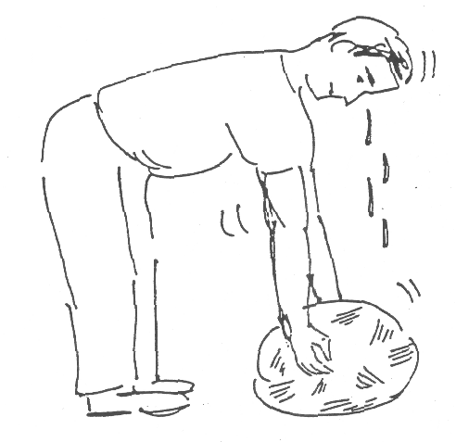

PERSON PULLS UPWARD ON ROCK.

ROCK DOES NOT MOVE.

IS WORK DONE?

WHY/WHY NOT?

F x d = 0

2B1

TRANSPARENCY 2

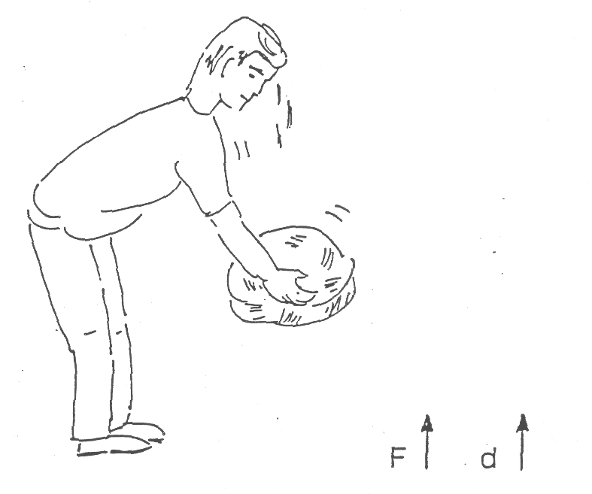

PERSON PULLS UPWARD ON ROCK

ROCK MOVES UP

IS WORK DONE?

WHY/WHY NOT?

HOW CAN WE FIND THE AMOUNT OF WORK DONE?

TRANSPARENCY 3

F → d →
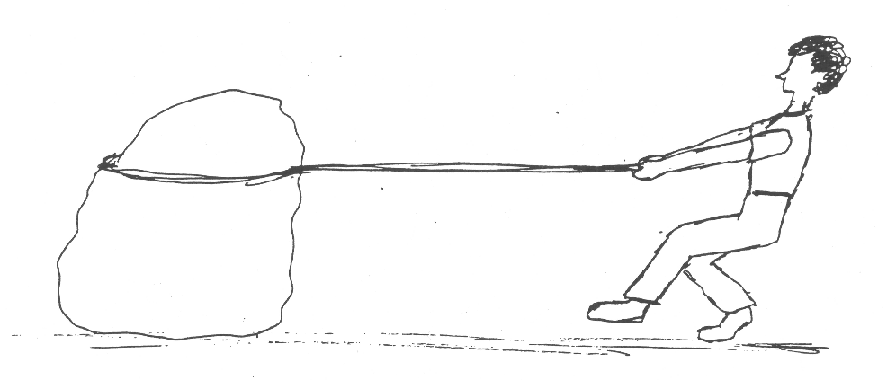

PERSON PULLS - SIDEWAYS ON ROCK

ROCK MOVES 51DEWAYS.

IS WORK DONE?

WHY/WHY NOT?

HOW CAN WE FIND THE AMOUNT OF WORK DONE?

TRANSPARENCY 4

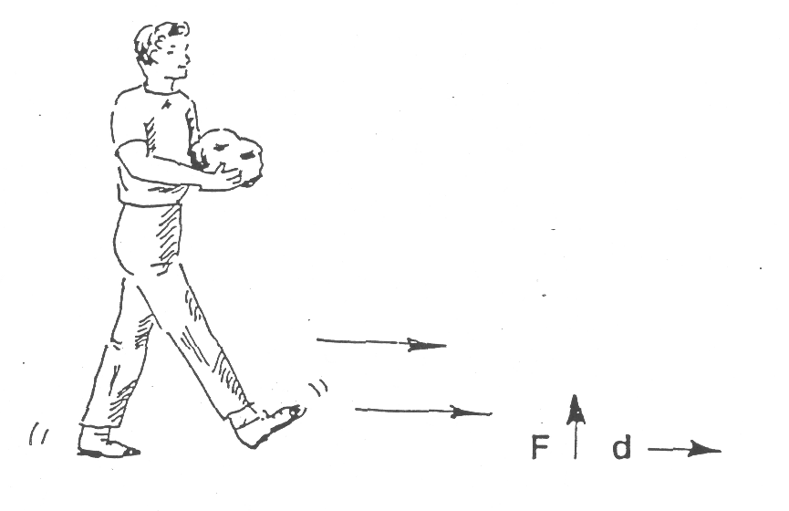

PERSON HOLDS ROCK WHILE WALKING FORWARD.

IS WORK DONE?

WHY/WHY NOT?

SIMPLE MACHINES, WORK AND POWER 2B3D

WHAT WORK WAS DONE?
(Demonstration/Discussion)

This is designed to be a demonstration with student participation. A metric ruler, and seven objects with a similar weight, such as books or bricks, are needed.

Set-up:

Place seven of the uniform objects (books, bricks) at the base of a bookcase. The objects should all rest on the floor, not on top of each other.

Procedure:

Introduce the activity by saying that we are going to examine the amount of work done in some similar situations.

Select a volunteer and have him/her pick up one of the objects and place it on a shelf about 1 meter (or two) from the ground. Record on the board the number of objects and the distance listed. Ask how to calculate the work done. Do the calculations on the board and discuss with students. (Use of arbitrary units, such as book-meter is OK; you may want to weigh the book and use newton-meter as the unit.)

Select another volunteer. Ask this volunteer to move two objects to a shelf half the height of the first case (e.g. 1/2 meters). Record the data on the board. Discuss the amount of work done in each case.

Ask what work would be done if four objects were moved to 1/4 of the original height. Have someone complete this task. Compare the work done in all four cases.

Ask students what it means to know the amount of work that was done? Could you do the same amount of work by lifting a light object very high and a heavy object just a little? (Yes). Ask if work is how far we move something (it isn't). Ask if work is how great a force we use (it isn't). Ask if we can do the same amount of work in different ways, and solicit examples.

SIMPLE MACHINES, WORK AND POWER 2B4

WORK! WORK! WORK!
(Discussion)

See accompanying transparency master, next page.

This transparency illustrates that the WORK done on an object depends on both the distance that the object moves and the force that acts on the object in the direction of this motion. (Work = Force x Distance)

It is important to remember that the forces acting to move the wagon do not represent the weight of the wagon. (It typically requires much less force to pull the wagon over a horizontal surface than to lift it!) Stress that the force that accomplishes the work must be directed in the same way as the motion of the object.

Notice that the work done in situation 1 could be similar to the amount of work done in situation 4.

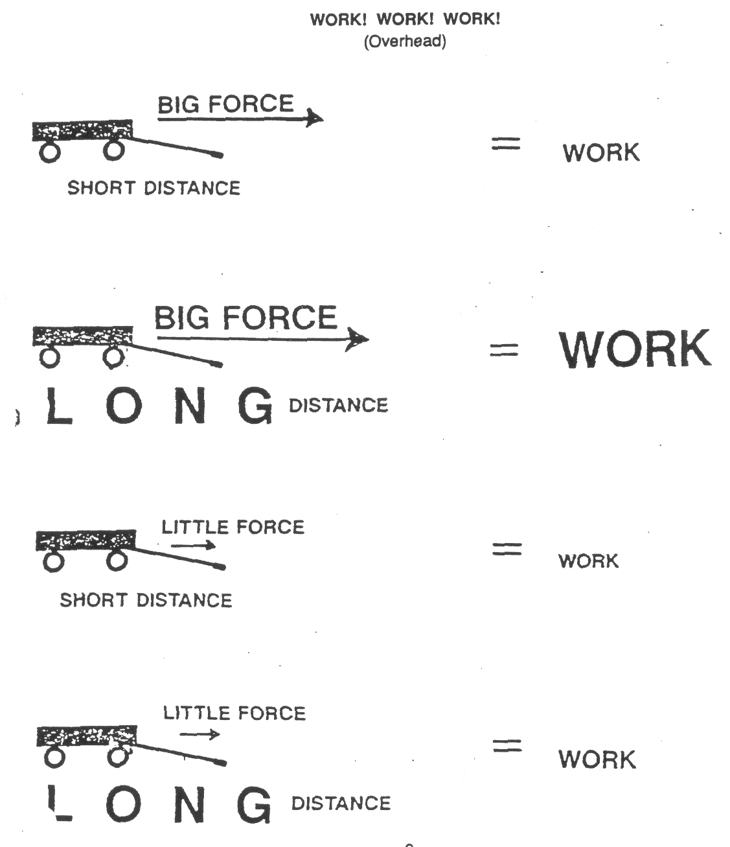

SIMPLE MACHINES, WORK AND POWER 2C1F

FOCUS ON PHYSICS
FORCE x DISTANCE
(Discussion)

In everyday language, the word "work" has many meanings. What one person calls work, another might call pleasure. In physics, the term "work" has a very specific meaning. Work is the product of the force on an object and the distance the object moves in the direction of the force, or, W = F x d.

If a force is put on something without moving it, work is not being done on that object. A good example of this is the wall in a room. It might put a great force on the ceiling, holding it up, but the ceiling does not move; therefore, no work is done. Likewise, a person standing still holding a stack of books in the air is not doing work on the books. Admittedly, inside the person, work is being done to move blood, air, etc., but the person is still not doing work on the books.

If an object moves without a force acting on it, work is not being done on that object. Newton stated that anything in motion will stay in motion in a straight line and at a uniform speed as long as there isn't a force acting on it. In this case, no work is being done on the object.

If a force, or a component of the force, on the object is not in the same direction as the distance it moves, then work is not being done by that force. This however is not true for all cases. An example of this would be a hockey puck sliding across smooth ice (assuming the ice is frictionless): Gravity would be putting a downward force on the puck, but it is not moving in a downward direction because the ice is pushing up. It is moving sideways, but there isn't a sideways force. No work is being done on the hockey puck. Note that in this case, the direction of the force is at right angles to the direction of the motion If the angle between the direction of the force and the direction that the object moves, then there is work being done.

Consider the following diagram. A child is putting a force on a wagon at an angle and the wagon is moving sideways. The force on the wagon is really doing two things. Part of the force (the vertical component) is trying to pick it up, but the force of gravity is keeping it from going up. Another part of the force (the horizontal component) is moving it sideways. Since it only moves sideways, it is only the horizontal component of the force that does work. To calculate the work done, we would have to find out how much of the force was pulling sideways and multiply this component of the force by the distance.

From a mathematics point of view, the following equation works for all situations.

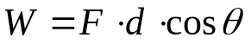

θ is the angle between the direction of the force ‘F’ and the direction the object moves, ‘d’.

The units of work are force units times distance units. In the SI system, it would be the Newton of force times the meter of distance. A Newton-meter of work is called a Joule.
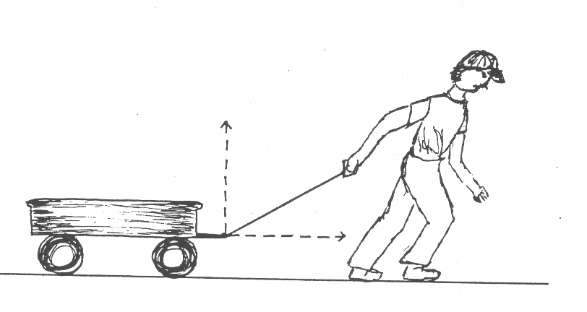

SIMPLE MACHINES, WORK AND POWER 5D1

WHY WORK?

(Demonstration/Discussion)

Before conducting this demonstration, make sure students are familiar with the idea that (Force x distance = work) and that the direction of this force must be parallel to distance.

Set up the equipment as shown below. If equipment is not available, you may simply show the figures below on a transparency.

Discuss the following as each of the figures are demonstrated or shown on a transparency.

Figure 1 - Introduce to students the idea that whatever machine we use, we could raise the weight from the floor to the table top. Work would be done.

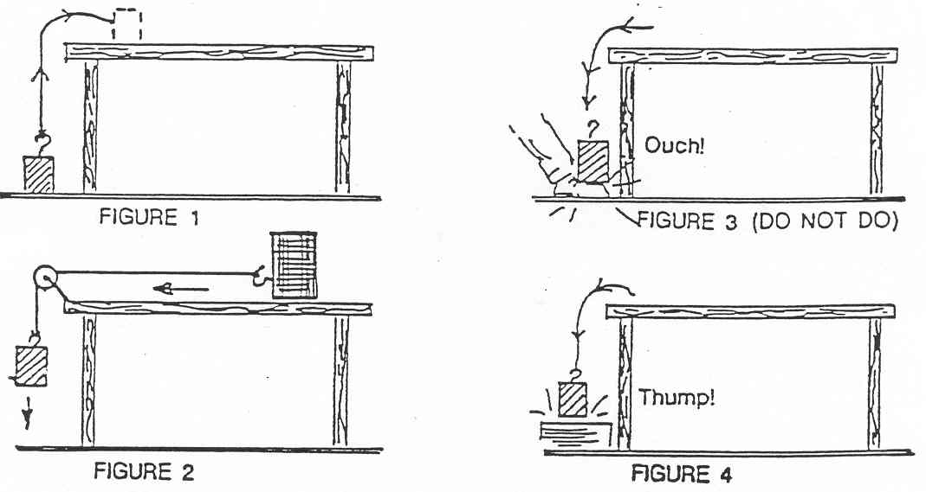

Figure 2 Do we have anything now that we didn't have before? (It may be a rhetorical question at this point.) We could hook it up to a pulley system and let it do some work for us, when we drop it back to the floor.

Figure 3 We could let it go off the edge and it could fall on our toe and do damage, or it could fall on a nail ...

Figure 4 And pound the nail into wood.
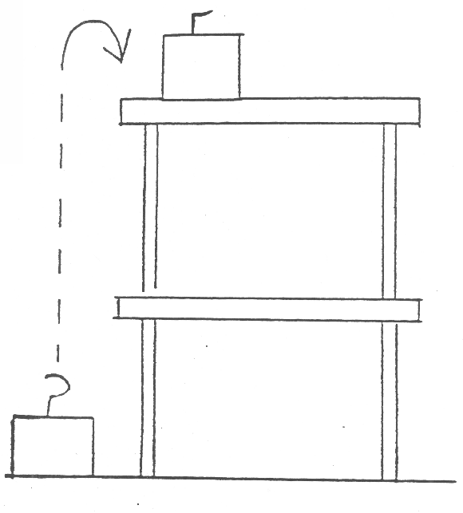
At this point we can see that:

1. The raised weight has energy.
2. We can use the energy to do work for us.
3. We can leave the weight on the table until we are ready to use this energy, so this is stored energy or potential energy. It has the “potential” to be used at some future time.

Figure 5 What happens to the amount of potential energy if the weight is lifted to the top of a second table? (Potential energy increases.)

SIMPLE MACHINES, WORK AND POWER 5A1D
WHY WORK? - 2

Q: How does the work I had to do to lift this compare with the work to lift it to the top of one table?
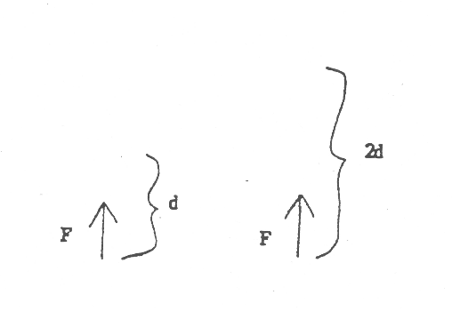
(It's more here, twice as much)

Q: Did I need to exert more force?

(No, the force is still the same as the weight of the object.)

Q: Then, how do you figure that more work was done?

(You had to lift the same weight through a greater distance.)

Q: How does the potential energy that the weight has now compare with what we have stored before?

(Twice as much).

Q: If I exert a fairly big force on this cart in a direction parallel to the floor for some distance what do I get for all my work?

(Motion, i.e. energy of motion.)

Speed = 0 Big Speed
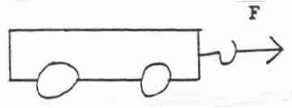

d

Q: If I exert a force on the block in a direction parallel to the floor for some distance and then stop, what do I get for all my work? This one is a bit tougher. (pause)

Q: What if you take one hand and push it back and forth across your other hand?

(Heat, the hands warm up. You do the “work and you get heat energy.)

T: So in every case where work is done you get a change in the amount of some kind of energy in return.

SIMPLE MACHINES, WORK AND POWER 5A1D
WHY WORK? - 3

Figure 9 Extension - (Requires higher level reasoning capabilities.)
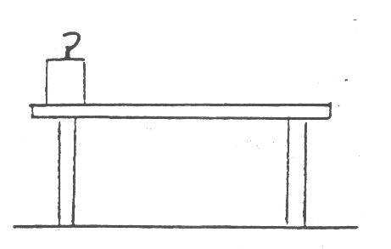

Q: What if I just slightly pick up the weight and slowly bring it to the other end of the table with no rubbing. Do I have anything now that I didn't have before? More heat? More motion? More potential energy? Can I do more work with the weight now than I could before?

(Probably a rhetorical question. No. / don't see any. No heat, no motion now. No more potential energy.)

In this case, the force was upward to lift the weight only slightly, but the -motion was across the table. We end up with no change in energy. (This activity ties back to 2B2 “is the Hand Doing Work?”).

Note for teacher: Technically, no mechanical work is done and we can tell because there has been no change in energy. But biologically, to move the parts of our body and in our cells to make nerves and muscles operate a small amount of work was done.

SIMPLE MACHINES, WORK AND POWER 4A2

WATTS USED
(Discussion)

You may recall that a watt can be defined as the work done per unit of time. More specifically, the watt is the number of newton - meters of work done per second of time. The watt is commonly used to describe the energy required by a machine each second and can be helpful as a means of comparing machines.

The overhead includes examples of living organisms, mechanical machines and electrical machines. Several interesting comparisons can be made. A few are listed below:

1. The dolphin and the running dog differ in their “wattage”. While this is in part due to differences in size, the dolphin must constantly move through a more resistive environment and therefore does more work.
____________________________________________________________________________________________
____________________________________________________________________________________________
2. Mechanical and electrical machines often require more energy than other ways listed to do the task. The clothes dryer uses a lot of watts compared to air drying. Discuss the type of mechanical work (moving clothes, moving air) done by the dryer in addition to heating the air.
____________________________________________________________________________________________
____________________________________________________________________________________________
____________________________________________________________________________________________
3. Consider the type of mechanical work done in each of the cases listed.
____________________________________________________________________________________________
____________________________________________________________________________________________
4. Students may want to see if they can find out the “wattage” of other items to add to this list.

SIMPLE MACHINES, WORK AND POWER 4A2

WATTS USED 2

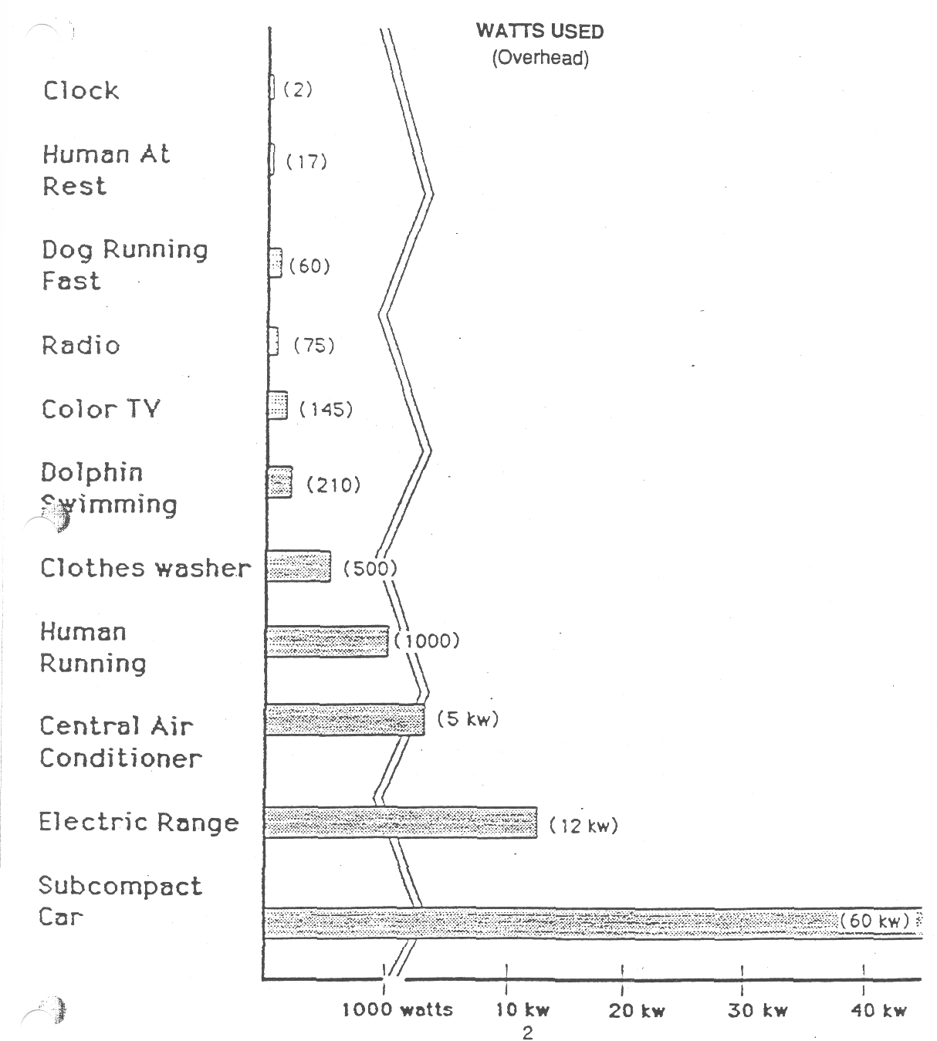

SIMPLE MACHINES, WORK AND POWER 4B1F

FOCUS ON PHYSICS
POWER
(Discussion)

Suppose two identical stacks of bricks were carried to the roof of a building by two different workers who were helping to build a chimney. Even if one person took half the time of the other, they would still be doing the same work because they both picked up an equal weight the same height. There is, however, a difference between these two people, and that difference is in how quickly each does the work. This rate of doing work is called power. Power is calculated by dividing the work done by the time it takes to do the work (P=W/t). The unit of power is the Watt. The more powerful someone is, the more work he or she can do each second.

Definition

The term horsepower (745.7 watts) was invented by the engineer James Watt. Watt lived from 1736 to 1819 and is most famous for his work on improving the performance of steam engines. We are also reminded of him every day when we talk about 60-watt light bulbs.

The story goes that Watt was working with ponies lifting coal at a coal mine, and he wanted a way to talk about the power available lab le from one of these animals. He found that, on average, a mine pony could do 2 2,000 foot-pound of work in a minute He then in increased that number by 50 percent and pegged the measurement of horsepower at 33,000 foot-pound of work in one minute. It is that arbitrary unit of measure that has made its way down through the centuries and now appears on your car, your lawn mower, your chain saw and even in some cases your vacuum cleaner!

What horsepower means is this: In Watt's judgment, one horse can do 33,000 foot-pounds of work every minute. So, imagine a horse raising coal out of a coal mine. A horse exerting 1 horsepower can raise 220 pounds of coal 1,000 feet in one minute, or 1,000 pounds 33 feet in one minute. You can make up whatever combination of feet and pounds you like. As long as the product is 33,000 foot-pounds in one minute, you have a horsepower.

You can probably imagine that you would not want to load 33,000 pounds of coal in the bucket and ask the horse to move it 1 foot in a minute because the horse couldn't budge that big a load. You can probably also imagine that you would not want to put 1 pound of coal in the bucket and ask the horse to run 33,000 feet in one minute, since that translates into 375 miles per hour and horses can't run that fast. However, if you have read How a Block and Tackle Works, you know that with a block and tackle you can easily trade perceived weight for distance using an arrangement of pulleys. So you could create a block and tackle system that puts a comfortable amount of weight on the horse at a comfortable speed no matter how much weight is actually in the bucket

Dragsters A typical drag-racing engine has a displacement of 8.9 liters, is supercharged and produces about 6,000 horsepower. It can burn close to a gallon (4 liters) of nitro methane per second!

SIMPLE MACHINES, WORK AND POWER 3B2

WHAT IS THE TRADE-OFF FOR A SMALLER FORCE (LEVERS)?

Materials: balance beam 1/2 kg mass spring scale meter sticks string

1. How much force does it take to slowly lift your 1/2 kg mass-? Read the spring scale. This will be the output force in each of the situations below:

2. Set up the lever system as shown for each of the following situations. Use loops or string to hold the spring scale and 1/2 kg mass. RECORD the output force, output distance, input force, and input distance in Table 1.
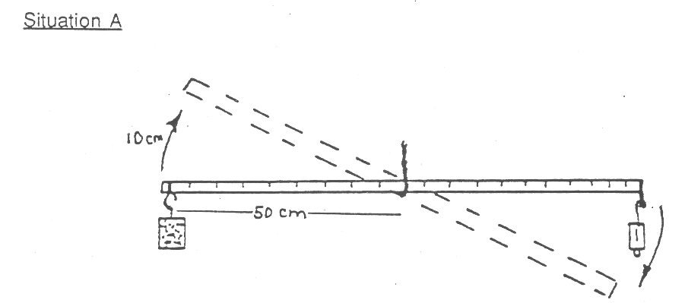

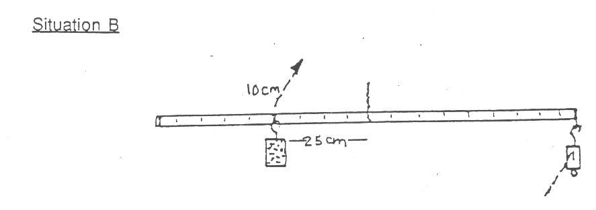

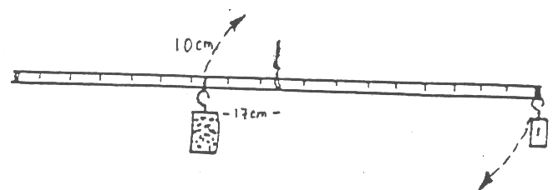
Situation C

3. Copy your results in the table below.

TABLE 1
Situation | Input Force | Input Distance | Output Force | Output Distance
A
B
C

SIMPLE MACHINES, WORK AND POWER 3B2

WHAT IS THE TRADE-OFF FOR A SMALLER FORCE (LEVERS)? 2

4. List the patterns OBSERVED in the measurements recorded in Table 1.
_____________________________________________________________________________________________
_____________________________________________________________________________________________
5. What is the "trade-off" for reducing the input force? Refer to Table 1.
_____________________________________________________________________________________________
_____________________________________________________________________________________________
6. CALCULATE the following and RECORD it in Table 2.

Input Work (Work input = Force input x distance input)

Output Work (Work output = Force output x distance output)

TABLE 2
Situation | Input Work | Output Work
A
B
C
7. How does the work output relate to the work input in each of the situations?
_____________________________________________________________________________________________
_____________________________________________________________________________________________

EXTENSION:

8. If the work output was different than the work input, why do you think it was so?
_____________________________________________________________________________________________
_____________________________________________________________________________________________

9. CALCULATE the following and RECORD it in Table 3.

Mechanical Advantage (M.A. = Force output/force input)

Efficiency (Efficiency = Work output/work input)

TABLE 3
Situation | Mechanical Advantage | Efficiency
A
B
C

10. What does the mechanical advantage of a lever tell you about what it can do?
_____________________________________________________________________________________________
_____________________________________________________________________________________________
11. Can you expect the efficiency of a machine to be over 100%? Why or why not?
_____________________________________________________________________________________________
_____________________________________________________________________________________________
SIMPLE MACHINES, WORK AND POWER 3B2

WHAT IS THE TRADE-OFF FOR A SMALLER FORCE (LEVERS)? 3

Table 1
 | Input | Input | Output | Output | Input | Output | Mechanical
Situation | Force | Distance | Force | Distance | Work | Work | Advantage |  | Efficiency
 | (N) | (m) | (N) | (m) | (J) | (J)
A
B
C

Input Work = Input Force x Input Distance

Output Work = Output Force x Output Distance

How does the work output relate to the work input

Mechanical Advantage = Force Output / Force Input

What does the mechanical advantage of a lever tell you about what it can do

Efficiency = Work Output / Work Input

Can you expect the efficiency of a machine to be over 100%? Why? Why not?
SIMPLE MACHINES, WORK AND POWER 3B2TN

WHAT IS THE TRADE-OFF FOR A SMALLER FORCE (LEVERS)?

IDEA: PROCESS SKILLS:
In an ideal system input work Infer
equals output work, e.g. F*D = F*D. Synthesize
In real machines input work is Justify
greater than output work because
of resistive forces.

LEVEL: UU DURATION: 30 Min
.
STUDENT BACKGROUND: Familiar with use of force scale and ability to
measure distance.

ADVANCE PREPARATION: Materials per group: (Probably 3 or 4 per group)

1 block (any mass about 200 - 1000 g) 1 force scale (maximum should be more than 3 or 4 times the weight of the block) 1 long uniform lever/balance, suspended -from center - a meter stick will work with a hole drilled through the center at the 50 cm mark. You may need to drill holes in the heavy side if the density of the wood is not uniform to get the stick to balance horizontally.

Before each trial, make sure the meter stick is balanced and level when no weights are suspended from its ends. The string supporting the meter stick should be securely tied so that the meter stick does not slip or slide during the experiment, but is free to rotate.

RESPONSES TO
SOME QUESTIONS: 2. A. Expect the input force to be about equal to the output force and the distance to be about 5 cm.
B. Expect the input force to be about half the output force and the distance to be about 10 cm.
C. Expect the input force to be about a third of the output force and the distance to be about 15 cm.
POINTS TO EMPHASIZE IN
THE SUMMARY DISCUSSION: The smaller the input force, the larger must be the input distance to do the same amount of work.Work input equals work output if there are no resistive forces. Work input is greater than work output if there are resistive forces; however, there is still a "force" advantage to using the machine.
A smaller force (exerted over a greater distance) is required with the machine than without it.

A smaller force (exerted over a greater distance)
is required with the machine than without it.

POSSIBLE EXTENSIONS: Use settings other than 1, 1/2, and 1/3 of side from the pivot point (fulcrum) for gifted and talented and for upper level students.
SIMPLE MACHINES, WORK AND POWER 3B5D

WHO DOES MORE WORK?
(Discussion)

The teacher may need some sticks and carts handy to help make the context of this discussion concrete.

Present the following situation and talk through and/or illustrate the situation.
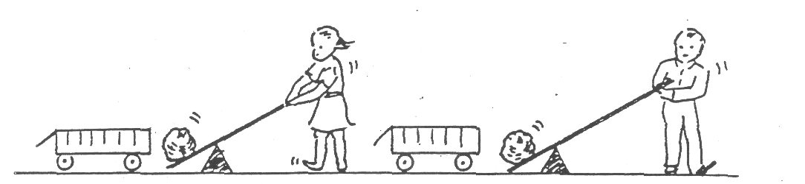
Ellen and Bill are each going to use levers to raise rocks of the same weight 1 foot upward in order to load them on a wagon. Each places the fulcrum (pivot point) two feet from the rock, and each pushes down on the end of the lever, but Bill has the longer lever. Assume that the levers don't bend and that they don't have appreciable mass.

Ask and discuss the following questions:

Who must move the lever through the greater distance?

______ Ellen must push her end down further.
______ Bill must push his end down further.
______ They both push the ends of their respective levers down equal distances.

Who must exert the greater downward force?

Ellen exerts the greater force. Bill exerts the greater force. They exert equal force.

Who does more work?

Ellen does more work. Bill does more work. They do equal amount of work.

Emphasize that distance, force, and work are ideas related to, but different from each other. There are trade-offs in accomplishing the same work different ways.

SIMPLE MACHINES, WORK AND POWER 3F2F

FOCUS ON PHYSICS
INPUT/OUTPUT DISTANCES WITH THE
LEVER AND THE WHEEL AND AXLE.
(Discussion)

The method presented in several texts for finding the input and output distances of levers is somewhat confusing. When calculating work, the force and distance must be in the same direction. Since the forces on a lever are generally perpendicular to the lever, then the distances they move are the arcs of the circles the forces sweep out, as shown in figure 1. These distances can be used to calculate work input, work output, IMA, and AMA.

Several books describe the lever arms as the input and output distances. The lever arm is the distance from the fulcrum to the point where the force is. applied. Since this distance is perpendicular to the force, it cannot be used to calculate the work that the force does. However, the lever arm distances can be used to calculate the IMA. The IMA is the input distance divided by the output distance. Because of the geometry of a circle, the longer the lever arm (radius), the longer the arc on the circumference will be. If the input lever arm is twice as long-as the output lever arm, then the input distance will be twice as long as the output distance. Therefore, the ratio of the lever arms is the same as the ratio of the input and output distances, and either ratio can be used to calculate the IMA.
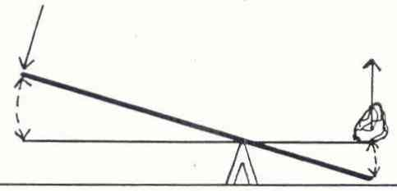

Figure 1

A similar situation occurs with the wheel and axle. The input and output distances are the circumferences of the circle that the input and output forces travel times the number of turns that are made. To calculate the work input and work output, these distances must be used. To calculate the IMA, however, the wheel radius is often divided by the axle radius. Since the circumference of a circle is 2 TT r, one can see that the ratio of the circumferences is the same as the ratio of the radii. gee figure 2.
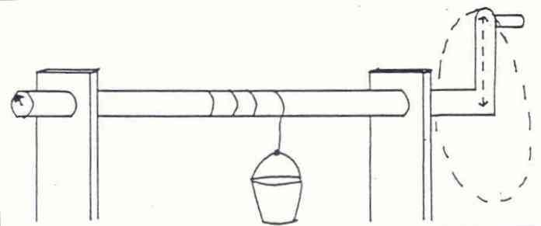

Figure 2

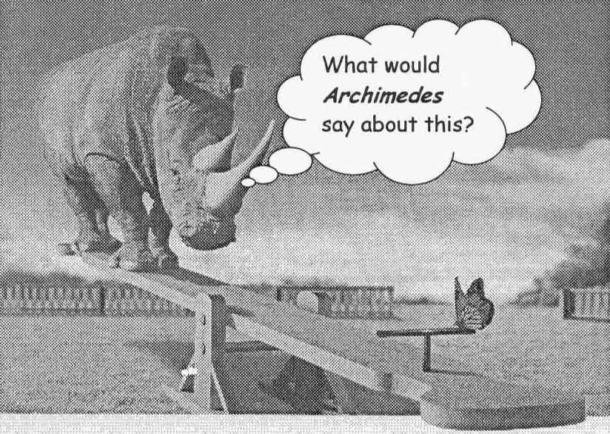

SIMPLE MACHINES, WORK AND POWER 4A1

HOW MUCH HORSEPOWER CAN YOU PRODUCE?

Materials: metric ruler
stopwatch or wristwatch that will measure seconds
bathroom scale

Procedure: Gathering Data

Data Table 1. Determine the vertical distance through which you will lift your weight.
height of stairs _____________ m
a. MEASURE the height of one stair in cm.
name mass time b. COUNT the number of stairs.
_______ _______kg _______s c. Multiply the number of stairs times the height of one stair.
d. Change this to meters.
e. RECORD the height of the flight of stairs in meters on the Data Table.

2. Find your mass in kilograms. RECORD this on the Data Table next to your name.

3. Find the time it takes you to climb the stairs.

a. Have -a fellow student with a stopwatch MEASURE the time it takes you to climb the stairs.

b. RECORD the time in seconds on the Data Table.

4. Repeat steps 1-3 for several other students.

Using the Data:

1. Find the force of gravity acting on your body by multiplying your mass in kg times 9.8, because the earth pulls every kilogram of matter with a force of about 9.8 N near the surface of the earth. This is the force in Newtons you must exert to move your body upward. RECORD this force in the Calculation Table.

2. Find the work in Joules that you do in climbing the stairs by multiplying the force in Newtons times the height of the stairs in meters. RECORD this work in the Calculation Table.

3. Find the power in Watts that you produced by dividing the work in Joules by the time in seconds. RECORD the power in the Calculation Table.

4. There are 746 watts in one horsepower. Divide your power in Watts by 746 to find your horsepower. RECORD the horsepower in the Calculation Table.
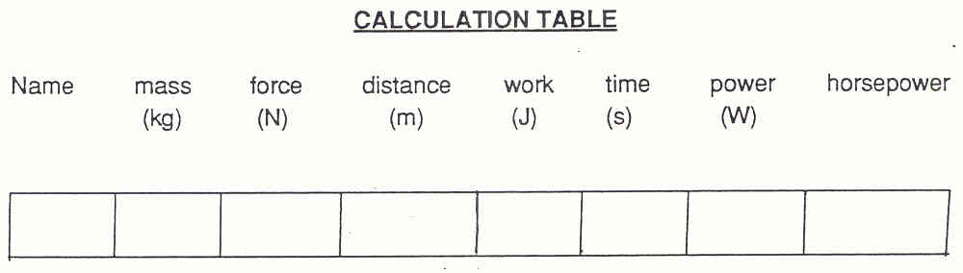
SIMPLE MACHINES, WORK AND POWER 4A1

HOW MUCH HORSEPOWER CAN YOU PRODUCE? 2

Discussion:

1. Share your results with your classmates.

2. DETERMINE which students developed a lot of horsepower. What did they have in common?
____________________________________________________________________________________________
____________________________________________________________________________________________

3. DETERMINE which students developed little horsepower. What did they have in common?
____________________________________________________________________________________________
____________________________________________________________________________________________

4. DETERMINE which factors affect horsepower. How do they affect horsepower?
____________________________________________________________________________________________
____________________________________________________________________________________________

SIMPLE MACHINES, WORK AND POWER 4A1TN

HOW MUCH HORSEPOWER CAN YOU PRODUCE?

IDEA: PROCESS SKILLS:
Power is the rate of doing work: Measure
power = work/time. Record
Determine
LEVEL: U DURATION: 30 Min.

STUDENT BACKGROUND: The students should be familiar with the concepts of force, work and power.
The students should have been introduced to the units in which force, work and power are measured in the metric system. Students should be aware that horsepower is the unit of power in the English system.

ADVANCE PREPARATION: Secure the materials:

A stopwatch is the easiest way to measure time. Try to secure a stopwatch or wristwatch that will allow time measurement to at least the tenth of a second.

Any bathroom scale will work. It is most effective to have a scale calibrated in kilograms. If your scale is calibrated in pounds -- the mass in kilograms can be found by dividing pounds by 2.2.

Find a flight of stairs which will be relatively free from traffic when you do the lab.

MANAGEMENT TIPS: Students might need to be reminded that this is a lab and not just fun time. Each student should go to the stairs with paper and pencil to record his or her own data.

The timekeeper should be position ed at the top of the stairs so that he/she can accurately time the finish. The timekeeper should give the signal
“Ready, set, go.”

You may wish to make rules for the run up the stairs. For example, decide if the students must step on every stair, if they may use the handrail, or if everyone must do it.

Students with physical limitations on running up the stairs can be included in the lab as timekeepers. Students enjoy having the teacher and/or principal participate in the lab also.

Students will often ask “How much does he weigh?” This is a good opportunity to respond that the mass of the student is _______ kilograms.
RESPONSES TO
SOME QUESTIONS:

POINTS TO EMPHASIZE IN
THE SUMMARY DISCUSSION: Power is affected by the force on an object, the distance traveled and the time.

Discuss which factors vary in this case and which remain the same.

SIMPLE MACHINES, WORK AND POWER 4A1TN

HOW MUCH HORSEPOWER CAN YOU PRODUCE? 2

For students of similar masses, the difference in their times was the only factor affecting the difference in horsepower. The greater the time needed to climb the stairs, the lower the horsepower (an inverse relationship).

For students with similar times, the difference in their masses was the only factor affecting horsepower. The greater the mass, the greater the horsepower.

Greater mass means greater force which means more work which means more power.

Review the units that are used to measure mass, force, work, and power.

Discuss why we measured the height of the staircase. (Since to climb the stairs it was necessary to overcome gravity and to exert a force upward, distance must be measured in the same upward direction.)

POSSIBLE EXTENSIONS: Consider where the energy came from in running up the stairs.
Consider where the energy comes from in driving a car. Ask students to gather information about horsepower of cars and gas mileage. What relationship, if any, exists between horsepower and mileage? Students can graph the data, if you wish.

SIMPLE MACHINES, WORK AND POWER 3A1

IS WORK ALWAYS THE SAME?

Materials: board-2 meters
cart
spring scale appropriate to weight cart
string

Introduction:

In this activity you will be asked to compare the work of moving -an object up an incline plane to the work of lifting the object the same height. First you are to collect data under a variety of conditions, then you are to draw conclusions based on your data.
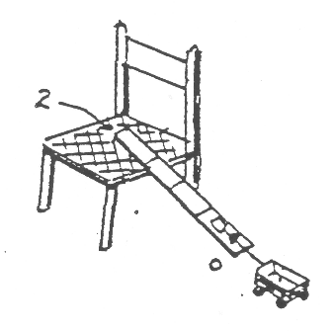
1. Mark the board in sections starting with zero at one end, and at 1.25 meters, 1.5 meters, 1.75 meters and 2 meters along the length.

2. Place the board as shown at right with the "zero" end on the floor and the 2 meter mark at the edge of the chair. Enter this 2 meter distance in "distance" column of Table 1 - try 1.

3. Attach the spring scale to one end of the cart.

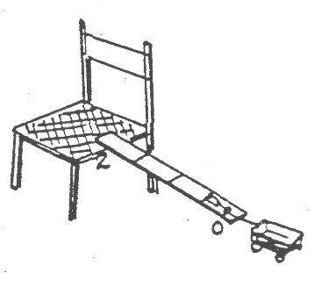
4. Using a gentle, steady effort, pull the cart up the board to the chair seat. (Keep the spring scale parallel to the board as you pull.) Note the scale reading during the pull and enter in the appropriate column, Table 1-try 1.

5. Move the board so that the 1.75 meter mark is even with the chair. Enter this distance for try 2 in Table 1. Repeat pulling the cart to the chair seat, read the scale and enter the data for try 2.

6. Change the board position to 1.5 meters, pull up the cart and record the results in Table 1 - try 3.

7. Change the board position to 1.25 meters, pull up the cart and record the results in Table 1 - try 4.

TABLE 1
INPUT (WHAT YOU DID)

Scale Reading Distance Input Work (f x d)
1st Try _______________ _______________ __________________
2nd Try _______________ _______________ __________________
3rd Try _______________ _______________ __________________
4th Try _______________ _______________ __________________

Calculate how much work was done to lift the cart to the chair in each case.

8. How does the force change as the angle gets steeper?
_________________________________________________________________________________________
9. How does the distance change as the angle gets steeper?
_________________________________________________________________________________________
SIMPLE MACHINES, WORK AND POWER 3A1

IS WORK ALWAYS THE SAME? 2

10. How does the input work change as the angle gets steeper?
_________________________________________________________________________________________
11. Measure the distance from the floor to the seat of the chair (in meters). Record this in Table 2 -try 1.

12. Lift the cart with the spring scale directly from the floor to the chair seat. Note the scale reading during the lift and record it in the appropriate column of Table 2.

TABLE 2
OUTPUT (WHAT HAPPENED)

Scale Reading Distance Output Work (f x d)
_______________ _______________ ________________
_______________ _______________ ________________

13. Calculate the output work done, and enter it in Table 2.

Examine the data table to answer the following questions:

14. How does the output work compare to the input work in each case?
_________________________________________________________________________________________
_________________________________________________________________________________________

15. How does an incline plane affect input work? Output work?
_________________________________________________________________________________________
_________________________________________________________________________________________

15. How does the output work compare to the input work in each case?
_________________________________________________________________________________________
_________________________________________________________________________________________

16. How does an incline plane effect input work? Output work?
_________________________________________________________________________________________
_________________________________________________________________________________________
SIMPLE MACHINES, WORK AND POWER 3A1TN

IS WORK ALWAYS THE SAME?

IDEA: PROCESS SKILLS:
A useful way to analyze a Measuring
machine is to compare the work Recording data
put in to the machine (input) Analyzing data
and the work done by the
machine (output).
LEVEL: U DURATION: 30 Min.

STUDENT BACKGROUND: Students should have completed activities defining force and have previously used an incline plane.

ADVANCE PREPARATION: Materials are need for each student group. The recommended group size is two, it should not be more than three. Each group needs a 2 meter
board, scale and cart

MANAGEMENT TIPS: Students should review the set up of the, lab prior to beginning. Be sure each team has enough space to manipulate the board and cart with out tripping over other furniture.

A critical point of this lab is the measurement on the scale. Students should use an even force and should repeat each measurement several times
until they feel they have it correct. You should ask questions such as: "How many times did you try it under those conditions?" "Were the results always
the same?" "How can you tell which result is best?"

RESPONSES TO
SOME QUESTIONS: 8. It increases.

9. It decreases.

10. It remains the same (within the limits of experimental uncertainty).

14. The input work is always greater than output work. In a case with experimental error, and with little force lost to "running the machine," the amount of output work may nearly equal the incline work.

15. The incline plane reduces the input force, but increases the input distance. In all cases, if the height of the incline plane is not changed, the output work remains the same.
POINTS TO EMPHASIZE IN
THE SUMMARY DISCUSSION: Students should realize that if they lift the same object to the same height each time, the same amount of work will be done. Questions 8, 9 and 10 ask students to generalize data from Table 1.

The expected result is that the measured input work will be greater than the measured output work. (Within the limits of experimental uncertainty).

POSSIBLE EXTENSIONS: This activity could be done with a wooden block or other object pulled up the plane. Students could collect data for Table 1 using a block that slides
relatively easily along the board, and/or one that is more resistive to sliding. The more resistive the object to moving along, the greater the input work
will be.

SIMPLE MACHINES, WORK AND POWER 2B2D

IS THE HAND DOING WORK?
(Demonstration/Discussion)

Set up apparatus as diagrammed below. Hold your hand still and allow the weight to swing the distance from A to B.
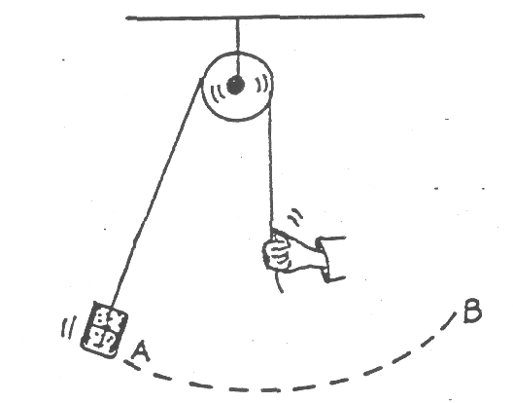

Demo/Discussion: My hand has been exerting a force on the string to support the object and the object moved from A to B.

Interpret Q: Has my hand done work? How do you decide?
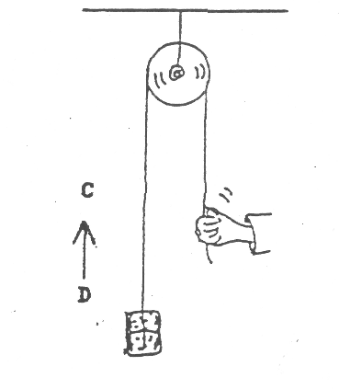

Compare: Now I keep my hand at the same place and slowly pull in the
string (twist over fingers) raising the object from C to D
(newton-meter).

Interpret Q: Has my hand done work in this case? How do you decide?
Both situations involve my hand exerting a force and the object
moves a distance of one meter.

Explanation: While the hand is exerting a force in both cases, it is only in the
second case when the hand is pulling in a 1 meter length of
string, pulling the string in the direction the object moves that
work is done. (Remember, the pulley simply allows you to
change the direction, not the force, in this case).

SIMPLE MACHINES, WORK AND POWER 1C3

WHICH WAY SHOULD YOU PULL?

Materials: pulley and clamp hardware
spring scale
a weight
string

1. Record the force readings for each position shown below:
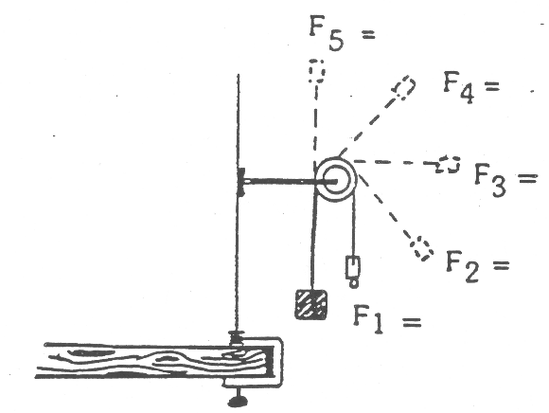

2. What does using a pulley to change string direction do the force?
_______________________________________________________________________________________________
_______________________________________________________________________________________________

SIMPLE MACHINES, WORK AND POWER 1C3TN

WHICH WAY SHOULD YOU PULL?

IDEA: PROCESS SKILLS:

Machines can change the direction of a force Measuring
needed to do work. Inferring a rule
LEVEL: LJU DURATION: 20 Min.

STUDENT BACKGROUND: Facility with use of force scale.
ADVANCE PREPARATION: Set out (or set up) equipment for each group see
Student Activity Sheet.

Perhaps hand out the Student Activity Sheet.

MANAGEMENT TIPS: The force scale readings should come out
approximately the same. They may differ slightly
due to the weight of the spring scale itself helping
to pull down on the string. This probably can be
minimized by using a light weight force scale and a
large mass > 1 kg.
RESPONSES TO
SOME QUESTIONS:

POINTS TO EMPHASIZE IN
THE SUMMARY DISCUSSION: A pulley can be used to change the direction
without changing the size of a force exerted to do
work.

POSSIBLE EXTENSIONS: None.

SIMPLE MACHINES, WORK AND POWER 1B1

HOW STRONG A FORCE DO YOU NEED?
(Pulley System “Tug-of-War”)

Materials: 2 Large pulleys (one with a strap so that a rope can be attached at either end -- see figure 3).
1 Long rope, approximately 10-20 meters
2 Short ropes, approximately 2 meters
2 Pairs of gloves

Introduction:

In this activity, a participant will use a pulley system to move one or more other participants. This activity can take place in the classroom or out in the school yard.

Procedure,:

1. Two participants that have about the same strength (this can be determined by a simple tug-of-war), should set up the pulley system as shown in figure 1. Wearing gloves, they should begin to pull at the same time. DESCRIBE the force on each participant.
_______________________________________________________________________________________________
_______________________________________________________________________________________________

DESCRIBE the distance each student moves.
_______________________________________________________________________________________________
_______________________________________________________________________________________________

How does this COMPARE to a simple tug-of-war?
_______________________________________________________________________________________________
_______________________________________________________________________________________________
What is the pulley doing?
_______________________________________________________________________________________________

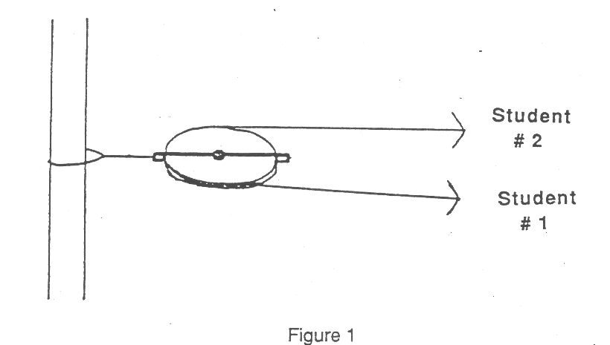

2. Set up the pulley system as shown in figure 2. DESCRIBE the force on each student.
_______________________________________________________________________________________________
_______________________________________________________________________________________________

SIMPLE MACHINES, WORK AND POWER 1B1

HOW STRONG A FORCE DO YOU NEED? 2

DESCRIBE the distance each student moves.
_______________________________________________________________________________________________
_______________________________________________________________________________________________

COMPARE this to the first procedure.
_______________________________________________________________________________________________
_______________________________________________________________________________________________
What is the pulley doing?
_______________________________________________________________________________________________
_______________________________________________________________________________________________
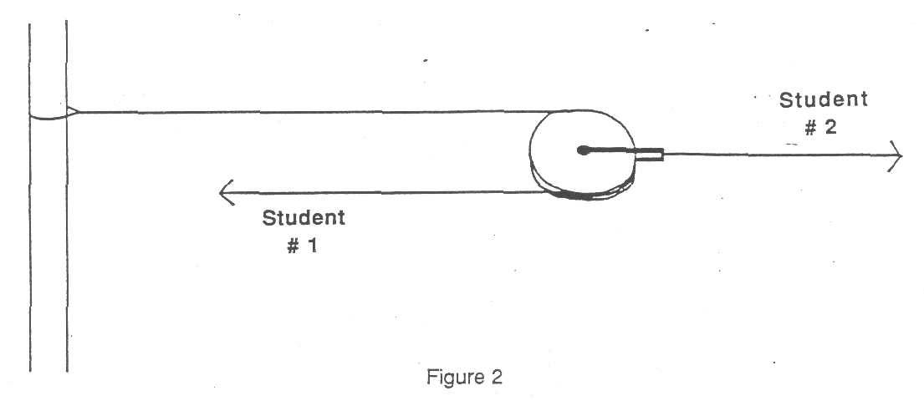

3. Set up the pulley system as shown in figure 3. DESCRIBE the force on each student.
_______________________________________________________________________________________________
_______________________________________________________________________________________________

DESCRIBE the distance each student moves.
_______________________________________________________________________________________________
_______________________________________________________________________________________________
COMPARE this to the other two systems.
_______________________________________________________________________________________________
_______________________________________________________________________________________________
What are the pulleys of this system doing?
_______________________________________________________________________________________________
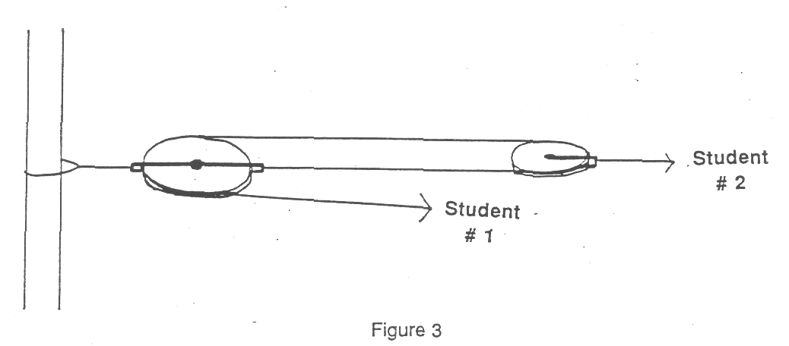
_______________________________________________________________________________________________

SIMPLE MACHINES; WORK AND POWER 1B1TN

HOW STRONG A FORCE DO YOU NEED?
(Pulley System “Tug-of-War”)

IDEA: PROCESS SKILLS:
To demonstrate that simple machines can Observe
change the direction of a force, the amount Describe
of force *or the distance moved. (This is a Compare
good introduction to 3B1). Measure
Design Experiments

LEVEL: L DURATIO14: 30 Min.

STUDENT BACKGROUND: None.
ADVANCE PREPARATION: Gather the equipment. If this is done as a participant participation demonstration, only one set is needed. If the extension is done, double pulleys will be needed.

MANAGEMENT TIPS: 1. Stress safety in this activity. Do not allow participants to wrap the rope around their hands, and require that they wear gloves. Be sure the anchor point is solid (tree, large swing set, strong pipe).
2. Have the participants hold the rope in one place, and not move their hands along the rope. This will allow them to tell which one moved the most.
3. It is a good idea to have the participants trade places (particularly if one is stronger) to determine if the pulley system is really doing something.
4. The purpose of this activity is to give participants a “feel” for what machines can do. For more accurate measurements, Activity 3B1 scales down this demonstration. It is suggested that this would be an excellent introduction to that activity.
RESPONSES TO
SOME QUESTIONS: 1. The forces should be about the same, and the distance each person moves will be equal. This is the same as a simple tug-of-war. What
the pulley does is change the direction of pull.
2. The machine multiplies the force of participant 1, but participant 1 had to move farther than - participant 2. This machine changes both the amount of force and the distance, but not the direction.
3. The machine multiplies the force of participant 1, but participant 1 had to move farther than participant 2. This system also changes the
direction of the force of participant 1. This machine is a combination of the first two. It changes the amount of force, the distance, and the direction.
POINTS TO EMPHASIZE IN
THE SUMMARY DISCUSSION: Machines can change the amount of both force and distance, as well as the direction of a force. It might be pointed out that as the force is increased, the trade-off is that the distance is decreased.

POSSIBLE EXTENSIONS: 1. For systems 2 and 3, it is interesting to see how many participants it would take to hold off participant 1. (it should be two because this
machine has a mechanical advantage of two)
.
2. If double pulleys are available, participants can design their own systems. Care should be used as more participants are pulling on
the rope.

SIMPLE MACHINES, WORK AND POWER 1C1D

GRAVITY AND SIMPLE PULLEY
(Demonstration/Discussion)
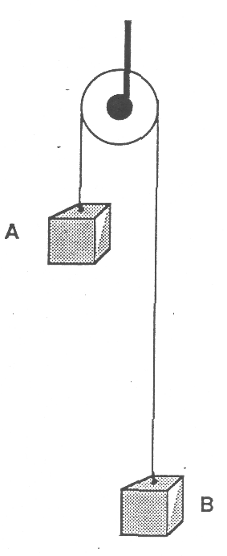
Many people believe that gravity will exert very different forces at slightly different elevations. This demonstration helps to dispel this notion, and serves as a good preliminary to working with simple machines. Set up the demonstration apparatus as diagrammed.

Teachers should hold both A & B or have each of two students hold one of the weights while teacher introduces the question/problem to the class.

Be sure string is very light in comparison to the masses A & B. Otherwise, the additional weight of the string on side B could make that side go down.

Prediction Q: “When I let go of these two identical masses what will happen? Write or draw your prediction on paper, but don't say your answer yet.

(Have students, write or draw their predicted result to get them to commit their thinking.)

Justification Q: “Without talking about it yet, think how you decided that's what will happen.”

Discussion 1: Now let's talk about our predictions and our reasons for those predictions.”

(Discussion, then do the demo.)

Observation Q: “What did happen?”

(Help students classify their observations, if necessary.)

Interpretation 0: “What does the result tell us?”

Discussion 2 Allow students to express themselves fully during Discussion 1. Then during Discussion 2, -call on students who had reasonably clear justifications for correct predictions to report and elaborate on their ideas. Allow other students who would like to elaborate on the explanations or who have alternative explanations to speak fully. Allow students who have rational objections to speak.

Summarize the most defensible interpretation from the class. Perhaps something like, “The weights pull equally hard on the string, whether they are high or low.”

“Gravity seems to pull about equally hard on the two masses, regardless of how high they are above the floor” (in the room at least).

Listen to the kids for possible extensions. e.g. “Would the result be different outside?” or “What if mass B was here and A was up as high as a mountain?”

(This would need to be a thought experiment and it turns out that weight -- the gravitational pull exerted by the earth in-this case -would change gradually as the object is moved farther and farther away from the surface of the earth. To be half as heavy, for example, the object would need to be more than 1500 miles above the earth.)

SIMPLE MACHINES, WORK AND POWER 3E1

DOES THE PULLEY GIVE A WORK ADVANTAGE?
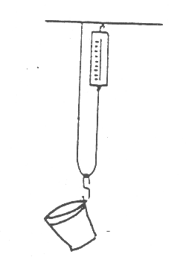
Materials: 5 paper clips
string
plastic cups
force scale
sand

1 Attach a paper clip handle to a plastic cup with -a rubber band or fasten paper clips directly to the cup to hold it. Fill the cup with sand until it is about 2-cm deep.

MEASURE its weight with a force scale. This is the resistance that your pulley will have to move. RECORD this as the output force in the Data Table.
____________________________________________________________________________________________
____________________________________________________________________________________________
2. Suspend a cup from a moveable paper clip pulley, as shown. Using the force scale, MEASURE the input force required to hold the cup just off of the table. RECORD this as the effort force in the Data Table.

COMPARE this to the output force (weight of the cup).
____________________________________________________________________________________________
____________________________________________________________________________________________
EXPLAIN how this holding input force can support the weight of the cup.
____________________________________________________________________________________________
____________________________________________________________________________________________
3. Lift the cup. MEASURE the input force required to lift the cup (while it is moving). RECORD your result in the Data Table.

COMPARE the holding input force to the lifting input force.
____________________________________________________________________________________________
____________________________________________________________________________________________
EXPLAIN why they are not the same.
____________________________________________________________________________________________
____________________________________________________________________________________________
4. Lift the cup 10 cm from the floor (this is the output distance). RECORD this in the Data Table.

MEASURE the distance that you must pull your hand to lift the cup (this is the input distance). RECORD this in the Data Table.

5. DETERMINE the amount of work output that the paper clip pulley does as it lifts the resistance. RECORD your result in the Data Table.

6. DETER MINE the amount of work input you must do. RECORD your result in the Data Table.

7. DETERMINE the efficiency of the pulley. RECORD your result in the Data Table.

8. Does the pulley give a force advantage? EXPLAIN your answer.
____________________________________________________________________________________________
____________________________________________________________________________________________
SIMPLE MACHINES, WORK AND POWER 3E1

DOES THE PULLEY GIVE A WORK ADVANTAGE? 2

Does the pulley give a work advantage? EXPLAIN your answer.
____________________________________________________________________________________________
____________________________________________________________________________________________

DATA TABLE

Output force __________________ Output distance __________________
Work output __________________
Holding input force __________________
Lifting input force __________________ Input distance __________________
Work input __________________
Efficiency __________________

SIMPLE MACHINES, WORK AND POWER 3E1TN

DOES THE PULLEY GIVE A WORK ADVANTAGE?

IDEA: PROCESS SKILLS:
The efficiency of a machine is Measure
calculated by dividing output Record
work by input work. Explain
Compare
Determine
LEVEL: LJU DURATION: 20 Min.

STUDENT BACKGROUND: Students should have been introduced to the terms input and output.
Students doing the entire lab should have the math skills needed (whole number multiplication, division and fractions.)

ADVANCE PREPARATION: Gather materials:

A 100 g mass may be used instead of the plastic cup filled with sand. If a plastic cup is used, it should be tapered so that the rubber band will not slip off the side of the cup.

A ring stand or other support system is required. The string may be taped or tied to the bottom of the student's desk.

The force gauge may be a student made version with rubber bands and paper clips or one purchased from a scientific supply house.

MANAGEMENT TIPS: For younger students the measurements should be
made to the nearest whole unit. This will greatly
simplify the computations. As the math skills of
the students increase, measurements may be
made to the nearest 0.1.
RESPONSES TO
SOME QUESTIONS: 2. The input force is about half of the output force because half of the weight is supported by the spring scale and the other half is supported by the stationary end of the string.

3. They are not the same because more input force is required to lift the object than to hold the object. The extra force is required to overcome
friction as the string is pulled around the paper clip. The diameter and texture of the string will affect the outcome.

5. Workout = output force x output distance.
Example: 10 force units x 10 cm.
Work out = 100 work units.

6. Work in = lifting input force x input distance.
Example: 7 force units x 20 cm.
Work in = 140 work units.

7. Efficiency = work out Example: 100 work units = 5
work in 140 work units = 7

The machine does only 5/7 of the work that you do.

SIMPLE MACHINES, WORK AND POWER 3E1TN

DOES THE PULLEY GIVE A WORK ADVANTAGE? 2

8. Yes, the pulley gives a force advantage. Example: 7 units of force were required to lift 10 units of force. No, the pulley does not give a work advantage. Example: While 140 work units were put into the pulley, it did only 100 units of work. The difference of 40 work units was lost as the string slid around the paper clip.

POINTS TO EMPHASIZE IN

THE SUMMARY DISCUSSION: Simple machines can be compared. List the simple machines. List in order, the events that will occur. Events can cause other things to happen.

POSSIBLE EXTENSIONS: 1. Discuss compound words to extend the idea of simple things combined to form more complex things. Compound words can be broken down in the say way a compound machine can be broken down.
2. Have the students create their own machine as a home project.

SIMPLE MACHINES, WORK AND POWER 3B1

WHAT IS THE TRADE-OFF FOR A SMALLER FORCE (PULLEYS)?

Materials: 1 or 2 pulleys
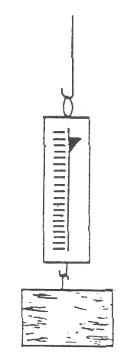
1/2 kg mass
1 force scale (spring scale, newton scale)
string
meter stick

1. How much force does it take to slowly lift the mass? Read the force on the spring scale. This will be the output force in each of the situations below.

2. Set up the pulley system as shown for each of the following situations and RECORD the output force, output distance, input force and input distance in Table 1. Keep the output distance constant for each situation.
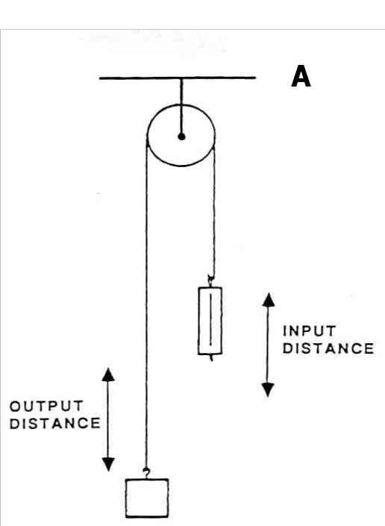
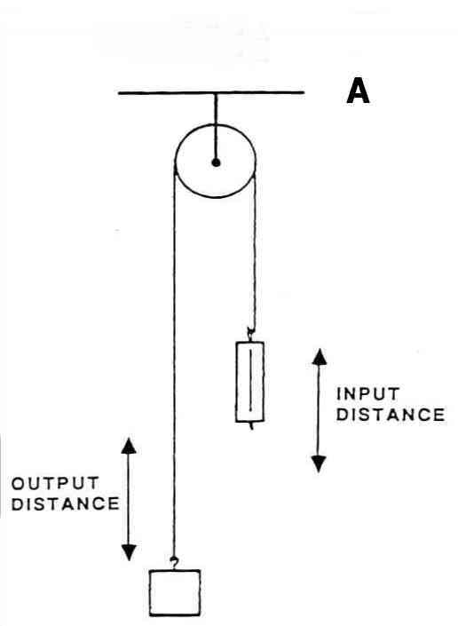
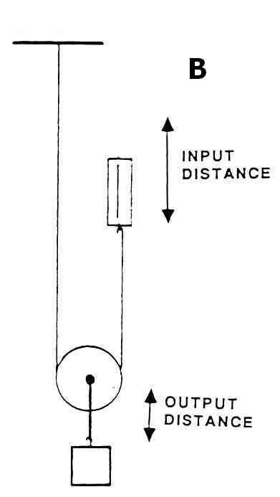
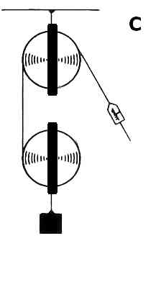

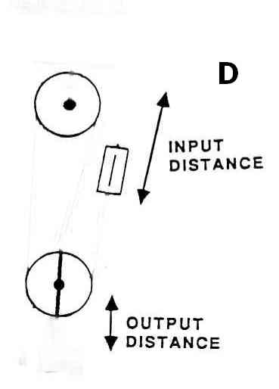
SIMPLE MACHINES, WORK AND POWER 3B1

WHAT IS THE TRADE-OFF FOR A SMALLER FORCE (PULLEYS)? 2

3. RECORD your results in the table.

4. List the patterns OBSERVED in the measurements recorded in Table 1.
_______________________________________________________________________________________________
_______________________________________________________________________________________________
5. What is the “trade-off” for reducing the input force? Refer to Table 1.
_______________________________________________________________________________________________
_______________________________________________________________________________________________

6. CALCULATE the following and RECORD your results in the table..
Input Work (Work input = Force input x distance input)
Output Work (Work output = Force output x distance output)

7. How does the work output relate to the work input in each of the situations?
_______________________________________________________________________________________________
_______________________________________________________________________________________________

8. If the work output was different than the work input, why do you think it was so?
_______________________________________________________________________________________________
_______________________________________________________________________________________________

EXTENSION:

9. CALCULATE the following and RECORD your results in the Table..

Ideal Mechanical Advantage (I.M.A. = distance input/distance output)

Actual Mechanical Advantage (A.M.A. = Force output/force input)

Efficiency (Efficiency = Work output/work input)

10. How does the number of strings on the moveable pulley affect the mechanical advantage?

11. Does there seem to be a relationship between the complexity of a machine and the efficiency? If so, what is the relationship?

 | Input | Input | Output | Output | Input | Output | Mechanical
Situation | Force | Distance | Force | Distance | Work | Work | Advantage | Efficiency
 | (g) | (cm) | (g) | (cm) | (g-cm) | (g-cm) | Actual | Ideal
A |  |  |  |  |  |  | |
B |  |  |  |  |  |  | |
C |  |  |  |  |  |  | |
D |  |  |  |  |  |  | |
SIMPLE MACHINES, WORK AND POWER 3B1TN

WHAT IS THE TRADE-OFF FOR A SMALLER FORCE (PULLEYS)?

IDEA: PROCESS SKILLS:
In an ideal system input work equals output Infer
work, eg. F*D = F*D. In real machines input Synthesize
work is greater than output work because Justify
of resistive forces.

LEVEL: UU DURATION: 30 Min.

STUDENT BACKGROUND: Use of force and distance scales.

ADVANCE PREPARATION: Set up at least one of each of the stations as per Situation A, B, C,
or b on the Student Activity Sheet.

Materials/Station:
1 or 2 pulleys
1 spring scale (at least capable of measuring weight of a 1/2 kg mass)
A 1/2 kg mass with a hook
1 or 2 rulers (30 cm or more)

MANAGEMENT TIPS: Because the system is so movable, you may want to mount the systems against a wall or a chalkboard so they don't swing around Perhaps use paper or a chalkboard on the wall so that students can make measurements of distance on the wall.

Careful measurements are very important. Be sure
to zero the spring scale, pull it straight, and read it
at eye level. Measure the input distances from the
hook of the spring scale and not the body of it. (The
body moves as the spring stretches). These
systems are usually very efficient and if
measurement error is large, it could make it look
like work output is larger than work input. It would
be good to discuss measurement uncertainty
before doing the activity.
SIMPLE MACHINES, WORK AND POWER 3B1TN

WHAT IS THE TRADE-OFF FOR A SMALLER FORCE (PULLEYS)? 2

RESPONSES TO
SOME QUESTIONS: 2. A. Expect the input force to be about equal to
the output force (input F = Output F) and
output distance equal to the input distance.

B. Expect the input force to be about half the
output force, and input distance about twice
the output distance.

C. Expect the same results as in Situation B.

D. Expect the input force to be about a third the
output force and input distance about three
times the input distance.

4. As input force decreased, input distance increased.

5. Trading of distance for force.

7. Work output is less than or equal to work input
(within measurement uncertainty).

8. Work was lost to heat energy due to friction.

10. As the number of strings on the moveable pulley increases, the mechanical advantage increases.

11. Complexity usually causes more friction. Therefore, the efficiency usually decreases.

POINTS TO EMPHASIZE IN
THE SUMMARY DISCUSSION: DISCUSSION:

Q: Does the amount of force needed to lift the weight just depend an the number of pulleys?

(No, because Situations B and C required about the same force, but had different numbers of pulleys. It depends on the number of ropes supporting the moveable pulley).

Q: How can you tell? (i.e. by which experiments)

(Experiments B and C where results were about the same with 1 or 2 pulleys.)

POSSIBLE EXTENSIONS: Have students calculate mechanical advantage
(MA) and Efficiency of their pulley systems.

SIMPLE MACHINES, WORK AND POWER 3D3

STRAW MACHINE

Materials: 2 pop cans string
2 flexible straws tape
4 paper clips paper or plastic cup
1 larger straw, length = a little more than diameter of pop can

1. Make a working model of a wheel and axle.

Fill one of the cans with sand or water. Tape the two cans together with the filled can at the bottom. Tape the larger straw to the top of the cans. Join the two straws together as shown in the diagram and place as shown. Attach 3 paper clips to the top of the cup. Connect these 2 paper clips to a 4th paper clip. Tie a piece of string to this paper clip and fasten the other end to the straw as shown. Fill the cup with sand about 1 cm deep. Hold the cans in your hand and lift the resistance by turning the crank.

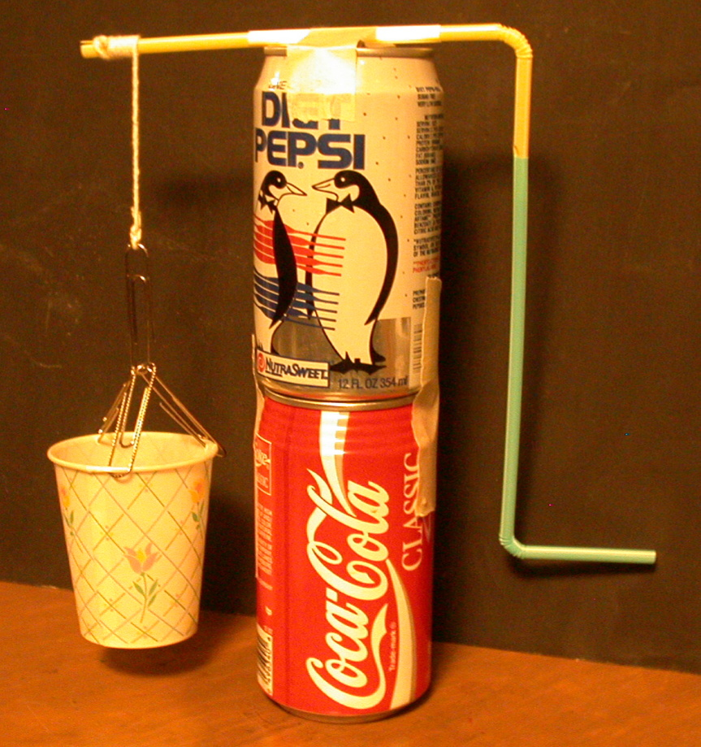
2. The ideal mechanical advantage (IMA) of a machine is the ratio of the input distance to the output distance. The input distance is usually the circumference of the wheel, and the output distance is the circumference of the axle. Since the ratio of the circumferences are equal to the ratio of the of the radius or the ratio of diameters, either one can be used to find the IMA.

3. MEASURE and RECORD the radius or diameter of the straw. (This is the diameter of the axle).
____________________________________________________________
____________________________________________________________
4. MEASURE and RECORD the radius or diameter of the circle your hand travels. (This is the diameter of the wheel).

5. CALCULATE the IMA of your wheel and axle.

IMA = input distance = diameter of wheel = radius of wheel
output distance diameter of axle radius of axle

6. EXPLAIN how you could change the IMA of your wheel and axle.
____________________________________________________________________________________________
____________________________________________________________________________________________

SIMPLE MACHINES, WORK AND POWER IllD3TN

STRAW MACHINE

IDEA: PROCESS SKILLS:
Mechanical advantage is force Measure
out divided by force in. Record
Explain

LEVEL: IJU DURATION: 20 Min.

STUDENTBACKGROUND: Students should be able to recognize the wheel and axle as a simple machine. Students should be familiar with the “force advantage” of using simple machines. They should also be familiar with the difference between IMA and AMA.

ADVANCE PREPARATION: Make a straw machine yourself before doing this activity with students.

MANAGEMENT TIPS: Students should be able to figure out the assembly of the wheel and axle from the diagram. The teacher may need to assist students in this process.
RESPONSES TO
SOME QUESTIONS: 3. Answers will vary - example: 0.6 cm.

4. Answers will vary - example: 19 cm.

5. Answers will vary - example: 12 cm = 32 0.6 cm

6. The IMA may be increased by raising the soda straw handle or reduced by lowering the handle.

POINTS TO EMPHASIZE IN
THE SUMMARY DISCUSSION: The wheel and axle is a simple machine. The IMA is a measure of the force advantage gained by using a simple machine. Note the IMA -- the ideal mechanical advantage does not take into account any frictional losses that reduce the efficiency of the machine. It considers the performance of the machine in an ideal situation where there is not frictional loss.

POSSIBLE EXTENSIONS: This activity could be expanded to measure input force, output force, input distance, and output distance with work input and work output, as well as calculating efficiency. A spring scale used to measure the input force would have to move in the circle of the input distance.

Energy <–> M & M’s <–> Energy
Adaptation by Dick Heckathorn
A. Consuming Energy

1. Eat some M & M’s. Keep track of the number. Should you not wish to eat any, pick a number of M & M’s you might eat.

2. Obtain the following data: Mass in grams of one serving __________ grams
Food Calories in one serving _________ Calories
Number of M&M’s in one serving __________
Energy in one M&M __________ Calories
Using : 1 food Calorie (large) = 1000 calories (small) and 1 calorie = 4.19 Joules
Calculate Energy in one M&M ____________Joules

3. Estimate the number of step-up on a chair you would have to make to consume the energy of the M & M’s you ate. Assume that all of the energy of the M & M’s was converted into useful work.

4. Fill in the information on the top of the data sheet and bottom of this sheet. Remove the bottom of this sheet and turn it in to your instructor.

B. Using Energy by Doing Work

1. Place a chair out in the open where you can easily step from the floor onto the chair and back to the floor. Have someone hold the chair as you step up on the chair and back to the floor. Make sure that you stand upright on the chair before going back to the floor. (Optional: You may use a step rather that a chair, (less height).

2. Do a minimum of 10 reps. A rep is going from the floor to chair and back again. Feel free to do more if you wish to. Keep track of the number of reps you make as well as the time it takes to complete the reps. Do this a minimum of 3 trials.

4. Make a neat, organized and well labeled table including: trial number, weight, height of chair, number of reps, time to complete the reps.

5. Calculate the work (in Joules) done and the power (in watts) for each trial. Include this in your table. Report only the average for data that can be averaged.

6. Each person is to complete their own laboratory write-up including: title, purpose, data table and conclusion.. A sloppy report will not be accepted. (This is not required of BW Students)

C. Analysis of the Information

1. Calculate the information asked for in Part B of the Energy Analysis sheet using the data recorded in Part A.

2. When completed, turn the sheet into your instructor. He will then check your calculations based on the same information you turned in earlier.

------------------------------------------------------------------------------------------------------------------------------

Name _______________________
1. ____________ kg Your mass.
2. ____________ m Height of chair seat
3. ____________ Number of M & M’s eaten or will be eaten. (Must be different than your partner’s.)
4. ____________ Estimated number of step-ups to consume the energy of the M & M’s eaten.
5. ____________ sec Average time for one complete step
Energy Analysis of M & M’s Part A Name ___________________________

1. ___________ kg Your mass.

2. ___________ m Height of chair seat

3. ___________ Number of m & m’s eaten.

4. ___________ Estimated number of steps to use up m & m’s energy.

6. ___________ sec Average time for one chair step

1 kilogram = 9.8 Newtons
Mass in grams of one serving __________ grams
Food Calories in one serving _________ Calories
Number of M&M’s in one serving __________
Energy in one M&M __________ Calories
Using : 1 food Calorie (large) = 1000 calories (small) and 1 calorie = 4.19 Joules
Energy in one M&M ____________Joules

Energy Analysis of M & M’s Part B

5. ___________ N Your weight

6. ___________ s Average time for one “chair-step”

7. ___________ J Work done to complete one step.

8. ___________ J Energy used to complete the step

9. ___________ C Energy of all m & m’s eaten in food (CALORIES).

10. ___________ c Energy of all m & m’s eaten in (calories).

11. ___________ J Energy of all m & m’s eaten in (Joules).

12. ___________ Total number of steps to use all m & m’s energy.

13. ___________ s Time to use all of m & m’s energy in (seconds).

14. ___________ m Time to use all of m & m’s energy in (minutes).

15. ___________ h Time to use all of m & m’s energy in (hours).
SIMPLE MACHINES, WORK AND POWER IVA3D

HOW DO I BUILD A POWER LAB?
(Discussion)

It is possible to design a laboratory activity so that students can compare the amount of work done in a time period. The lab activity you are to design will use locally available materials and the students will provide the “power” required. The laboratory can be designed to build upon the motivating effect of the student being the “power” measured. The laboratory you are to design should provide for a competitive element and should serve to integrate the topics studied in this unit.

Power Lab Development Steps:

The steps below are assigned to assist the workshop leader guide participants through the process of designing a power lab. It is suggested that participants be organized into groups of three people to complete this activity.

1. Provide participants with an overview of the intended lab. Students will be asked to lift uniform objects to the same height. Students will need a sufficient number of objects, for example bricks, to lift them to the predetermined height. The variables students will be measuring include the weight of objects lifted, the height to which objects were lifted, the time the activity took. Students will be asked to calculate and compare output work, power, and to compare changes in the energy distribution in the system.

2. Have participants brainstorm about materials and locations in their school which could be used. Give participants the desirable conditions (eg. the objects should be of the same or similar weight, there should be a platform to which a student can reach and set the lifted-objects, etc.). You may wish to give some examples, such as bricks to a picnic table, books to a library shelf, or folded chairs to a stage platform.

3. Discuss in small groups or as a large group the suggested materials. Be sure that the suggested materials mean that the same task is being done repeatedly. For example, bricks, flat on the ground and lifted to a table when each brick is placed flat on the table is good. Bricks stacked in a pile to start is not as good. Books that are all the same size are good, a mixed set is not.

4. Participants should draw a sketch of the starting and final position of the task and should develop a data table format. At a minimum the data table should show the weight of the object lifted, the number of objects lifted, the total weight lifted, the height of the lift, the time taken, the work done, and the power used.

5. Each teacher or team should decide on what they want students to investigate. Sample ideas could be suggested:

a. Do girls and boys use the same power?

b. Who generates the most power?

c. What happens to power when the task changes? Increase the lift to two, three or four times as high. Lift two, three or four objects at once. Start with objects located a horizontal distance away. Work in teams with students alternating turns at lifting.

d. What happens to the power with lighter, heavier objects?

6. Each team should consider the specific design they will use. It is possible to always have students do the same task, and measure the time. Or the time period could be fixed, and the amount of work done could be determined. A single lab might do both.

7. Design students lab activity sheets. These sheets should have the instructions to the teacher, a “picture” of the task, blank data tables and key summary questions. The summary questions should focus on three things -- Did students know what they did in the lab? What was the data and how did they interpret it? Can they relate what they did to what they know about work, power?

SIMPLE MACHINES, WORK AND POWER 4A3D

HOW DO I BUILD A POWER LAB? 2

8. Extension activities: The following types of questions might be useful in a follow-up discussion with students:

a. Do the lifted objects have more energy than at the start? Explain.
b. You put in more work than the work output? What was the “extra” work?

c. Which is the “best way?” Lift single, light objects many times or several light objects all at once? If you have to carry the objects horizontally, would you do it the same way? Why?

d. Considering the task you did, how is a human body like a machine?

SIMPLE MACHINES, WORK AND POWER VA2D

WHAT HAPPENED?
(Discussion)

In the workshop activities to this point we have looked at the simple machines and the work they do. Activities used a variety of simple machines including pulleys, levers, and incline planes. In using these materials we have considered the variables of force and distance and how they determine work. We have studied the concept of power, or the rate of doing work. Yet, there rema:ins the question of what we get out of doing work other than the immediate task accomplished. The following questions are suggested as part of a consideration of energy changes when-work is done and as a summary review of workshop activities.

1. Ask students for examples of work done by simple machines. Answers may
include moving an object, lifting an object, allowing an object to pierce through something, compressing a spring, pushing to speed something up, etc.

2. Ask students if they can think of examples of work that give us the potential of doing work later. For example, if we lift an object and place it at a height, we could drop the object later (eg. Rube Goldberg) to get work done. The system would have potential energy stored in it. Students may be aware of power plants that pump water uphill and store the water so that the water can run downhill and produce power when it is needed.

I Pick one or more of the activities that you have done earlier in the unit with students. Ask them to review what happened. Ask them if there is more potential energy after the work than before the work was done. How do they know?* So far in three activities, the increased potential to do work will occur only when an object has been lifted.

4. Can you think of other-ways to work that increase the potential to do work? This could be with a compression device (e.g., a “loaded spring”) or a bow and arrow.

5. Continue to review other completed activities in terms of whether or not they increased the potential of an object to do work.

Note 1: This topic is meant ro establish the concept that energy changes occur when work is done. However, it is not necessary to discuss this topic deeply or to do a full accounting of energy changes.

Note 2: Solicit participant responses. This is an important activity for you to learn if participants have understood the content focus of this workshop.
Stop
Printing
Here
SIMPLE MACHINES, WORK AND POWER 5B1F

FOCUS ON PHYSICS
WORK AND ENERGY
(Discussion)

Energy is the ability to do work. When we use some of our body's chemical energy to put work into a simple machine, this energy is not lost. The simple machine transfers this energy into the object on which we are doing work. For example, when we use a pulley system to pick up a heavy object, it gains gravitational potential energy.' It now has the ability to do work on something else, as shown in figures 1 through 4 in activity 5A1D D.

Simple machines can transfer energy to many different forms. Your arm is a lever. When it is used to pull back an arrow in a bow, the chemical energy from your body is transferred to the elastic potential energy in the bow. When a hockey stick is used as a lever to hit a puck, the chemical energy of the player is transferred to the kinetic energy of the puck. When a wheel and axle are used to turn the shaft of a generator, it transfers the work input into electrical energy.

When a machine is less than 100% efficient, not all of the energy that is put into it is transferred to the object that it does work on. Because of friction, some of it turns into thermal energy. When two objects rub together, the molecules collide with each other, causing their kinetic energies to increase. These molecules bounce around in all different directions. This random kinetic energy of the molecules is thermal energy.

Simple Machines
Science and Technology Indicators,

Grade Four

Understanding Technology

1. Explain how technology from different areas (e.g., transportation, communication, nutrition, healthcare, agriculture, entertainment, manufacturing) has improved human lives.

2. Investigate how technology and inventions change to meet peoples' needs and wants.

Abilities To Do Technological Design

3. Describe, illustrate and evaluate the design process used to solve a problem.

Doing Scientific Inquiry

1. Select the appropriate tools and use relevant safety procedures to measure and record length weight, volume, temperature and area in metric and English units

3. Develop, design and conduct safe, simple investigations or experiments to answer questions

Grade Five

Abilities To Do Technological Design

2. Revise an existing design used to solve a problem based on peer review.

Doing Scientific Inquiry

1. Select and safely use the appropriate tools to collect data when conducting investigations and communicating findings to others(e.g., thermometers, timers balances, spring scales, magnifiers, microscopes and other appropriate tools).

Grade Six

Understanding Technology

1. Explain how technology influences the quality of life.

3. Describe how automation (e.g., robots) has changed manufacturing including manual labor being replaced by highly-skilled jobs.

4. Explain how the usefulness of manufactured parts of an object depend on how well their properties allow them to fit and interact with other materials.

Simple Machines
Science and Technology Indicators 2

Grade Six (con’t)

Abilities To Do Technological Design

5. Design and build a product or create a solution to a problem given one constraint (e.g., limits of cost and time for design and production, supply of materials and environmental effects).

Doing Scientific Inquiry

2. Choose the appropriate tools or instruments and use relevant safety procedures to complete scientific investigations

Grade Seven

Abilities To Do Technological Design

4. Design and build a product or create a solution to a problem given two constraints (e.g., limits of cost and time for design and production, supply of materials and environmental effects).

Doing Scientific Inquiry

3. Formulate and identify questions to guide scientific investigations that connect to science concepts and can be answered through scientific investigations.

4. Choose the appropriate tools and instruments and use relevant safety procedures to complete scientific investigations.

7. Use graphs, tables and charts to study physical phenomena and infer mathematical relationships between variables (e.g., speed, density).

Grade Eight

Abilities To Do Technological Design

3. Design and build a product or create a solution to a problem given more than two constraints (e.g., limits of cost and time for design and production, supply of materials and environmental effects).

4. Evaluate the overall effectiveness of a product design or solution.

Doing Scientific Inquiry

1. Choose the appropriate tools or instruments and use relevant safety procedures

Ramp

Work = Force x Distance

1) Place a chair on the desk and measure the distance from the desktop to the chair seat
.
Distance _________________________ cm

2) Pick up the object with the spring scale hook (cart and all) and record its weight in (N)

Force _________________________ (N)

3) Calculate the work required to lift the cart from the desktop to the chair. (NO RAMP)

Work Force x Distance

______________ = __________________ N x ___________________ cm

4) Calculate the work required to pull the cart from your desktop to the chair. The ramp should be 60 cm long.

Work Force x Distance

______________ = ___________________N x _______60____________ cm

5) Calculate the work required to pull the cart from your desktop to the chair. The ramp should be 80 cm long.

Work Force x Distance

______________ = ___________________N x _______80____________ cm

6) Calculate the work required to pull the cart from your desktop to the chair. The ramp should be 100 cm long.

Work Force x Distance

______________ = ___________________N x _______100___________ cm

How does the force required to move the can change as the angle decreases?
_____________________________________________________________________________________________
_____________________________________________________________________________________________
How does the force required to move the can change as the distance increases?
_____________________________________________________________________________________________
_____________________________________________________________________________________________
Mechanical Advantage

Mechanical Advantage = tells you how much your force is multiplied. In other words it compares the input force with the output force.

MA = output force/input force
V
Input Force = Force you applied as you moved the cart up the ramp
Output Force = Force object actually weights

What is the Mechanical Advantage of the 60 cm ramp?
What is the Mechanical Advantage of the 1.00 meter ramp?
Which of the three ramps has the greatest mechanical advantage?
What is the relationship between a ramps length and Mechanical advantage?

Efficiency

Efficiency = work out put/work input

The work you did pulling the cart up a ramp is called INPUT WORK

WORK OUTPUT is how much work you would do lifting the can with no friction. (a perfect world)

Which ramp is the most efficient?

How does the output work compare to the input work in each case? Why?

Mike is leaving home & going to Harvard Law School. He is packing up all of his cherished belongings and loading them into the back of a truck. Mike will need a ramp for his stuff, which weighs 1500N. The height of the truck bed is 1 meter. Mike has calculated the following forces required for each ramp:

A ramp 2 meters long requires: 750N of Force

A ramp 3 meters long requires: 50ON of Force

A ramp 5 meters long requires: 30ON of Force

How much force will a ramp 4 meters long require? ____________________ N

How much is required for each ramp? _____________________ Joule

What is the advantage of using a ramp? ________________________________________________

What is the disadvantage of using a ramp? ______________________________________________

Work & Power
1. Work = Force x Distance Work = F x d

2. Work = Mass x Gravity x Height Work = mgh

3. A Joule is the unit to measure work. It takes one joule of energy to lift one apple one meter!

4. How much work are you doing to walk up the steps?

5. First you must calculate your mass. To do this simply divide your body weight in pounds by 2.2

This number will be your mass in kilograms.

___________________ Body Wt. Pounds / 2.2 = ____________________ kg

6. How high are the steps? ______________________ meters

7. Simply multiply Mass x Gravity x Height.

_____________ J = ________________ kg x ______10 m/s²_______ x _____________ m
Work mass Gravity Distance

8. You can also use the formula below to calculate work. To convert your weight from pounds to Newtons simply multiply by 4.45

______________________Body Wt. Pounds x 4.45 = __________________ N

________________ J = ______________ N x ________________ m
Work Force Distance

How much work are you doing if you try unsuccessfully to push a car out of snow bank? Explain
_____________________________________________________________________________________________
_____________________________________________________________________________________________
Power
Power is simply work divided by time. P = W/t

A Watt is the unit to measure power.

9. To calculate your power run up the steps and we will time how long it takes.

10. Use your work value calculated from side one.
____________________ Joules ÷ ___________________ Sec. = ________________ Watts

To convert Watts to horsepower divide watts by 746.

11. What is your Horsepower? ____________________________________________

Think of powerful objects what do they have in common?
_______________________________________________________________________________________________
_______________________________________________________________________________________________
Perspective.
Lawnmower = 8 HP Family Car = 110 - 140 HP Dodge Viper = 500 HP
18 Wheelers = 400 HP Dragster = 6000+ HP NASCAR = 750 HP
Farm Tractor = 200 HP
Pulley Time

,W=FxD

MA = Resistance Force / Effort Force

1. Pick up the can with the spring scale and record its weight in Newtons _______________________ N.
This will represent the resistant force for each of the situations below.

2. Calculate the work required to pickup the can 1 10 cm or. 1 m. To calculate work simply multiply Newtons x Distance. The unit to express work is the joule.
________________ x ___________________ = _____________________ Joule
Newton Distance Work

The above numbers will represent the OUTPUT FORCE RESISTANCE, OUTPUT
DISTANCE, & WORK for this rest of the lab RECORD IN TABLE IA.

3. Set up the pulley system as shown for each of the following situations and record the output force, output distance, input force and put distance in table 1. Remember keep the output distance 110 cm or . 1 m.

4. Record the result below:

Table I A (OUTPUT)

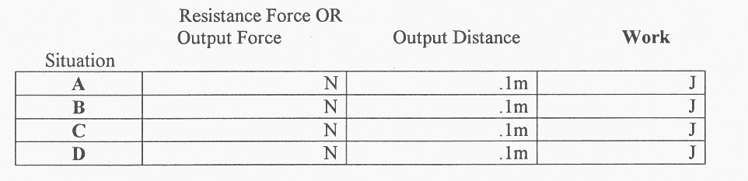

Table I B (INPUT)

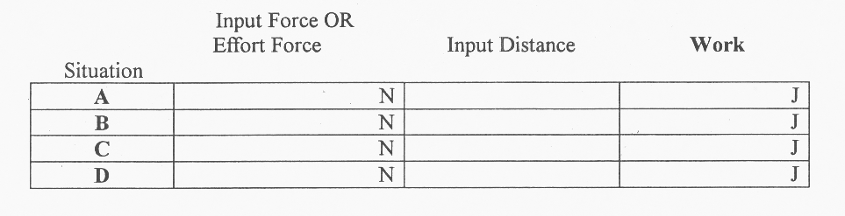

Pulley Time 2

5. List the patterns OBSERVED in the measurements recorded in table 1 A & B.
_______________________________________________________________________________________________
_______________________________________________________________________________________________
_______________________________________________________________________________________________
_______________________________________________________________________________________________
6. What is the “trade oil” for reducing the “effort” or input force? Refer to TABLE 1
_______________________________________________________________________________________________
_______________________________________________________________________________________________
_______________________________________________________________________________________________
7. How does the work output compare to the work input for each situation? Refer to TABLE 1.
_______________________________________________________________________________________________
_______________________________________________________________________________________________
_______________________________________________________________________________________________
8. If the work output was different than work input, why do you think so?
_______________________________________________________________________________________________
_______________________________________________________________________________________________
9. Calculate Mechanical Advantage and record in table 2.

Refer to Table 1 and plug the numbers in the following formula:

MA = Resistance Force / Effort Force

(note the resistance force should be what you calculated in step 1 for all situations)

10. Efficiency = Work output/work input. Simply refer to table 1 and divide work output/work input.

(note the work output should be what you calculated in step 2 for all situations)

Table 2
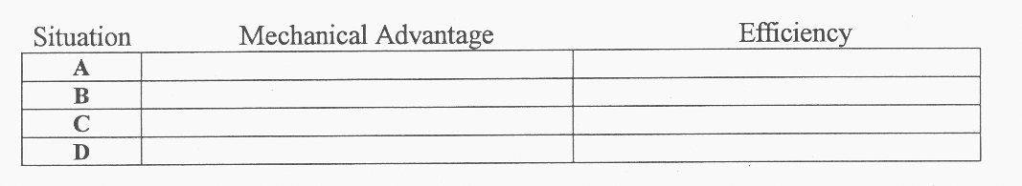
11. How does the number of strings on the movable pulley affect the mechanical advantage?
_______________________________________________________________________________________________
_______________________________________________________________________________________________
_______________________________________________________________________________________________
12. Does there seem to be a relationship between the complexity of a machine and the efficiency? If so, what is the relationship?
_______________________________________________________________________________________________
_______________________________________________________________________________________________
_______________________________________________________________________________________________
The Bricklayer

1998 Urban Legend

Accident Report

This one needs an introduction, so you won't be lost at the beginning. This man was in an accident at work, so he filled out an insurance claim. The insurance company contacted him and asked for more information. This was his response:

“I am writing in response to your request for additional information, for block number 3 of the accident reporting form. I put poor planning as the cause of my accident. You said in your letter that I should explain more fully and I trust the following detail will be sufficient.”

“I am an amateur radio operator and on the day of the accident, I was working alone on the top section of my new 80-foot tower. When I had completed my work, I discovered that I had, over the course of several trips up the tower, brought up about 300 pounds of tools and spare hardware. Rather than carry the now unneeded tools and material down by hand, I decided to lower the items down in a small barrel by using the pulley attached to the gin pole at the top of the tower. Securing the rope at ground level, I went to the top of the tower and loaded the tools and material into the barrel. Then I went back to the ground and untied the rope, holding it tightly to ensure a slow decent of the 300 pounds of tools.”

“You will note in block number 11 of the accident reporting form that I weigh only 155 pounds. Due to my surprise of being jerked off the ground so suddenly, I lost my presence of mind and forgot to let go of the rope.”

“Needless to say, I proceeded at a rather rapid rate of speed up the side of the tower. In the vicinity of the 40-foot level, I met the barrel coming down. This explains my fractured skull and broken collarbone. Slowed only slightly, I continued my rapid ascent, not stopping until the fingers of my right hand were two knuckles deep into the pulley.”

“Fortunately, by this time, I had regained my presence of mind and was able to hold onto the rope in spite of my pain. At approximately the same time, however, the barrel of tools hit the ground and the bottom fell out of the barrel.”

“Devoid of the weight of the tools, the barrel now weighed approximately 20 pounds. I refer you again to my weight in block number 11. As you might imagine, I began a rapid descent down the side of the tower. In the vicinity of the 40-foot level, I met the barrel coming up. This accounts for the two fractured ankles, and the lacerations of my legs and lower body. The encounter with the barrel slowed me enough to lessen my injuries when I fell onto the pile of tools and, fortunately, only three vertebrae were cracked.”

“I am sorry to report, however, that as I lay there on the tools, in pain, unable to stand and watching the empty barrel 80 feet above me, I again lost my presence of mind. I let go of the rope...”

Wishing Well
(Straw Machine)

Materials: 2 large cups string or thread
2 flexible straws tape-masking and clear
3 paper clips weight to put in small cup
I small cup ruler
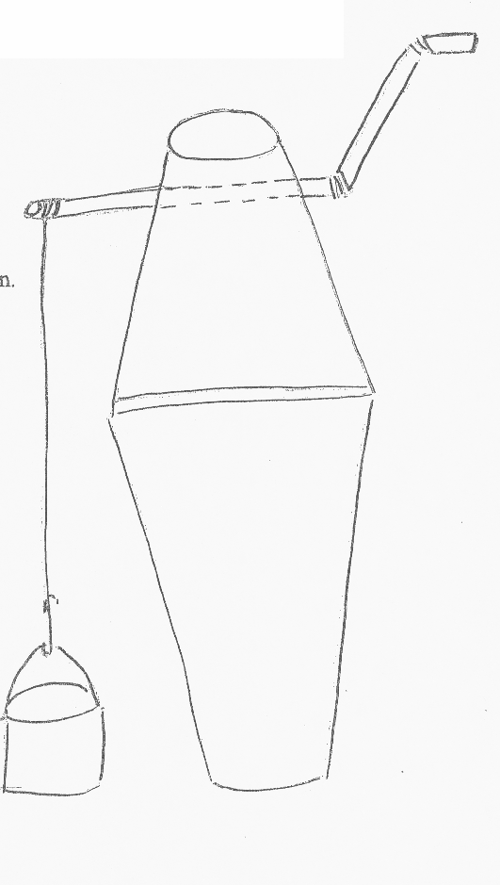
Objective: Make a working model of a wheel and axle. Determine the mechanical advantage of the wheel and axle.

Make 2 holes directly opposite of each other in the bottom of one of the 2 large cups. Join the two straws together with the short end of one straw inserted into the long end of the other straw. See the diagram. You may need to fold the end of one straw in order to get it to fit into the other. Insert the long end of the first straw into the two holes you made in the large cup. Bend the straws as show

Use masking tape to join the open ends of the two large cups together. Measure a piece of thread or string to a length about the distance from the straw to the table. Tape the thread near the end of the straw that goes through the cup.

Make a paper clip handle for the smaller cup. Tie the loose end of the thread to the paper clip handle. The small cup will hold the load/resistance.

Turn the handle of the wishing well to raise and lower the cup.

To determine the mechanical advantage of your Wishing Well, measure the diameter of the axle (the diameter of the straw). Measure the radius of the, wheel by measuring the distance between the bend where the two straws are joined and the bend of the straw where you turn the wheel. Multiply the radius of the wheel by 2 to get the diameter.

Axle diameter _________________ Wheel radius x 2 = _________________ = wheel diameter.

Mechanical Advantage = wheel diameter divided by axel diameter

____________ divided by ____________ = ______________ Mechanical Advantage

